SAVA AND DRINA RIVERS CORRIDORS INTEGRATED DEVELOPMENT PROJECT

STAKEHOLDER ENGAGEMENT PLAN

FOR BOSNIA AND HERZEGOVINA

February 2020/July 2022

Table of Contents

1 INTRODUCTION 6

1.1 Objectives and Scope of this Stakeholder Engagement Plan 6

1.2 Brief Description the Project 7

1.2.1 Objectives 7

1.2.2 Components 7

1.2.3 Subprojects in Bosnia and Herzegovina 8

1.2.4 Implementation arrangements for the Entire Project 9

1.2.5 Timeline and Budget for the Entire Project 10

1.2.6 Summary of Potential Environmental and Social Impacts 10

2 REGULATORY REQUIREMENTS FOR STAKEHOLDER ENGAGEMENT IN BiH 11

3 WORLD BANK ENVIRONMENTAL AND SOCIAL STANDARD ON STAKEHOLDER ENGAGEMENT 14

4 PREVIOUS STAKEHOLDER ENGAGEMENT 16

4.1 Lessons Learned on Stakeholder Engagement from Previous Flood Protection Projects 16

5 ENGAGEMENT DURING PROJECT PREPARATION - STAKEHOLDER IDENTIFICATION AND ANALYSIS 17

5.1 Introduction 17

5.2 Stakeholder Identification and Mapping 17

5.3 Disadvantaged/ Vulnerable Individuals and Groups 20

5.4 Stakeholder Analysis 20

5.5 Gender Analysis, Actions and Indicators 26

5.6 Stakeholder Expansion 26

5.7 Planned Stakeholder Engagement Activities 27

6 STAKEHOLDER ENGAGEMENT ACTIVITIES 33

6.1 Details on Engagement Methods to Be Used 33

6.1.1 Project Outreach Methods 33

6.1.2 Mass/Social Media Communication 33

6.1.3 Communication Materials 33

6.1.4 Grievance Mechanism 33

6.1.5 Information Desks 34

6.1.6 Citizen/PAP Perception Survey and Feedback 34

6.1.7 Trainings and Workshops 34

6.1.8 Proposed Strategy to Incorporate the View of Vulnerable Groups 34

6.2 Information Disclosure 34

6.3 Stakeholder Engagement Log 35

6.4 Transboundary Communication 35

7 IMPLEMENTATION ARRANGEMENTS AND INSTITUTIONAL ANALYSIS FOR STAKEHOLDER ENGAGEMENT 36

7.1 Project Enabling Efforts from Lessons Learned 36

7.2 Roles and Responsibilities 36

8 GRIEVANCE MECHANISM 37

8.1 Raising Grievances 38

8.2 Grievances Administration 38

8.3 Grievance and Beneficiary Feedback Reporting 39

8.4 Grievance Log 39

8.5 Grievance Admission Channels 39

8.6 Monitoring and Reporting on Grievances 40

8.7 World Bank Grievance Redress System 40

9 SEP MONITORING AND REPORTING 42

9.1 Monitoring Reports during Construction 42

9.2 Reporting Frequency 43

9.3 Involvement of Stakeholders in Monitoring Activities 43

9.4 Reporting Back to Stakeholder Groups 43

10 DISCLOSURE AND CONSULTATION REQUIREMENTS 44

11 ESTIMATED BUDGET 46

Annex A. Project Grievance Form 47

List of Definitions for Terms Used in This Document

|  |  |
| --- | --- |
| **CONSULTATION** | The process of sharing information and getting feedback and/or advice from stakeholders and taking these views into account when making project decisions and/or setting targets and defining strategies. |
| **ENVIRONMENTAL AND SOCIAL STANDARDS** | The 10Environmental and Social Standards (ESSs) set out the requirements that apply to all new World Bank investment project financing enabling the World Bank and the Borrower to manage environmental and social risks of projects. |
| **PAP** | “Project Affected Person” is any person who, as a result of the implementation of a project, loses the right to own, use, or otherwise benefit from a built structure, land (residential, agricultural, or pasture), annual or perennial crops and trees, or any other fixed or moveable asset, either in full or in part, permanently or temporarily. |
| **PROJECT** | Refers to the Sava and Drina Rivers Corridors Integrated Development Project |
| **STAKEHOLDERS** | Refers to individuals or groups who: (a) are affected or likely to be affected by the project (*project-affected parties*); and (b) may have an interest in the project (*other interested parties*). |
| **STAKEHOLDER ENGAGEMENT** | A continuous process in which the Project builds and maintains constructive and sustainable relationships with stakeholders impacted over the life of a project. It includes a range of activities and interactions over the life of the project such as stakeholder identification and analysis, information disclosure, stakeholder consultation, negotiations and partnerships, grievance management, and reporting to stakeholders and management functions |
| **STAKEHOLDER ENGAGEMENT PLAN** | A plan which assists the Borrower to effectively engage with stakeholders throughout the life of the project and specifying activities that will be implemented to manage or enhance engagement. |
| **VULNERABLE GROUPS** | People, especially those below the poverty line, the landless, the elderly, women and children, or other displaced persons who may not be protected through national land compensation legislation, who by virtue of gender, ethnicity, age, physical or mental disability, economic disadvantage, or social status may be more adversely affected by resettlement than others and who may be limited in their ability to claim or take advantage of resettlement assistance and related development benefits. |

Abbreviations

|  |  |
| --- | --- |
| BD | Brcko District |
| BiH | Bosnia and Herzegovina |
| CPF | Country Partnership Framework |
| CGD | Central Grievance Desk |
| ESF | Environmental and Social Framework |
| ESMF | Environmental and Social Management Framework |
| ESMP | Environmental and Social Management Plan |
| ESSs | Environmental and Social Standards |
| EU | European Union |
| ESSs | Environmental and Social Standards of World Bank |
| FBiH | Federation of Bosnia and Herzegovina |
| FMAWMF | Federal Ministry of Agriculture, Water Management and Forestry |
| FY | Fiscal Year |
| GM | Grievance Mechanism |
| GRS | Grievance Redress System |
| LGD | Local Grievance Desks |
| LMP | Labor Management Procedures |
| MAFWM | Ministry of Agriculture, Forestry and Water Management |
| MoFTER | Ministry of Foreign Trade and Economic Relations |
| M&E | Monitoring and Evaluation |
| OIPs | Other interested parties |
| PAP | Project Affected People |
| PIU | Project Implementation Unit |
| RS | Republika Srpska |
| SDIP | Sava and Drina Rivers Corridors Integrated Development Program |
| SEP | Stakeholder Engagement Plan |
| SEL | Stakeholder Engagement Log |
| WB | World Bank |

# INTRODUCTION

The development objective of the Sava and Drina Rivers Corridors Integrated Development Program is to improve flood protection and enable transboundary water cooperation in the Sava and Drina Rivers Corridors. The Project consists of four components, will be implemented over a period of 10 years, organized in two phases. The sub-projects in Bosnia and Herzegovina will be managed by PIUs at entity/Brcko District level.

## Objectives and Scope of this Stakeholder Engagement Plan

Pursuant to the World Bank requirements, stakeholder engagement is an inclusive process implemented throughout project life-cycle, and it is most effective if launched at early stage of project development. Engagement should begin as early as possible at project preparation, as timely identification of and consultation with the stakeholders enable views and opinions of these groups to be taken into account in the project design and implementation.

Stakeholder engagement is continuous and iterative process through which the Borrower identifies, communicates and facilitates two-way dialogue with persons affected by project decision and activities, as well as with other stakeholders interested in the project. Different needs of various groups and individuals, particularly the disadvantaged and vulnerable ones, are taken into account.

In order to address adequately need of different groups, communication and information channels for all identified stakeholders are designed in line with their needs. Participatory process would be used to get comments and proposals for Project design, which may help improve the Project design and bring more advantages at local level.

Stakeholder requests, needs and expectations would be identified before Project design development, while PIUs would be obliged to establish sustainable communication with stakeholder groups, namely to inform them regularly on the project and to report on potential changes.

The objective of this Stakeholder Engagement Plan (SEP) is to improve and facilitate Project-related decision-making and create opportunities for active involvement of all stakeholders in a timely manner, and to provide possibilities for all stakeholders to voice their opinions and concerns that may influence Project decisions. The purpose of this SEP is, therefore, to enhance stakeholder engagement throughout the life cycle of the Project, and to carry out stakeholder engagement in line with the laws of BiH, as well as the requirements of the World Bank (WB) Environmental and Social Standards (ESSs).

The SEP shall be applicable to all activities planned under the Project in Phase I, while the adequacy of this SEP shall be assessed and update as the case may be prior to commencement of Phase II. The stakeholder engagement will be an integral part of the project’s environmental and social performance and project design and implementation.

The document comprises 11Chapters. Chapter 1introduces the Project and its objectives, followed by Chapter 2 listing the regulatory framework in BiH (FBiH, RS and BD BiH), which provides the framework for SEP in addition to the World Bank ESS10 presented in Chapter 3. A summary of stakeholder engagement held so far is presented in Chapter 4. Stakeholder identification, mapping and analysis are described in Chapter 5. The Stakeholder engagement activities are presented in Chapter 6. Implementation arrangements for implementing the SEP are presented in Chapter 7. Description of the Project’s Grievance Mechanism (GM) follows in Chapter 8. Monitoring, documentation and reporting are presented in Chapter 9, disclosure and consultation requirements in Chapter 10, while the budget needed for implementation of the SEP is discussed in Chapter 11.

## Brief Description the Project

### Objectives

**The Higher-level Objective** of the Sava and Drina Rivers Corridors Integrated Development Program (SDIP) is to strengthen transboundary water cooperation and improve navigability and flood protection in the Sava and Drina Rivers Corridors.

**The Development Objective** of the SDIP (Phase 1 of the Program) is to improve flood protection and enable transboundary water cooperation in the Sava and Drina Rivers Corridors.

### Components

This project will implement subprojects with high implementation readiness and relevance to the program objectives, with detail designs and tender documents likely ready by Effectiveness in Montenegro, Bosnia and Herzegovina (BiH) and Serbia, while simultaneously preparing subprojects that will be implemented during the second phase of the Regional Program. The project consists of four components as described below:

Component 1: Integrated Management and Development of the Sava Rivers Corridors

Sub-component 1.1: **Flood protection, environmental management and climate change adaptation**. This sub-component will finance construction and rehabilitation of embankments at selected priority areas along the Sava River Corridor as well as nature-based solutions to re-vitalize selected protected areas of ecological significance to the Western Balkans. Upgraded flood protection capacity (at or above 1 in 100-year event) also enhance climate adaptation capacity of protected areas.

Sub-component 1.2: **Waterway improvements**. Under this sub-component, grant financing will be mobilized to finance demining activities along the Sava’s right bank within BiH, as a pre-requisite to the execution of civil works—planned for Phase II of the program—to increase the navigational capacity of the Sava river. The preparatory documentation for these Phase II works (engineering designs, environmental and social safeguards instruments, expected climate change impacts on navigability, bidding documents) will also be finalized during the project. The project-supported demining efforts are also an operational pre-requisite to the planned improvements to Sava river ports under Phase II. Demining activities are proposed as a no-regret investment that will help unlock the river’s economic potential for generations to come.

Component 2: Integrated Management and Development of the Drina River Corridor

Sub-component 2.1: **Flood protection and environmental management**. This sub-component will finance infrastructure works, studies, surveys, consultations and preparation of detailed design of interventions related to the management of environmental assets (the protection of local ecosystems that act as carbon sinks) along the Drina Corridor. The on-going GEF-SCCF-financed Drina River Basin Management project as well as the ESMAP technical assistance, are conducting studies that will identify the additional actions needed for flood protection, bank stabilization, drainage and river training works, and reservoir management in the Drina Corridor. Upgraded flood protection capacity (at or above 1 in 100-year event) also enhance climate adaptation capacity of protected areas.

Sub-component 2.2: **Integrated development of Drina watershed**. This sub-component will finance improved watershed management in the Lim and Grncar River basins of Montenegro, as well as works related to flood protection, drainage and irrigation measures within the Lim River Basin (a tributary of the Drina River) to mitigate flood risks and promote sustainable use of natural resources. These measures include: river bank stabilization; river training works; flood protection embankments and dykes. The detailed designs of these investments are under preparation through the ongoing GEF-SCCF project. This sub-component will further finance the preparation of selected priority investments in line with the project development objective.

Component 3: Project preparation and management

Sub-component 3.1: **Project preparation**. This sub-component will finance preparation of project documentation for phase II of the program, including environmental and social assessments.

Sub-component 3.2: **Institutional strengthening and project management**. This sub-component will finance activities to increase institutional capacity and inter-sectoral coordination in the participating countries to ensure more efficient decision making and program management at regional level. This sub-component will promote joint action and decision making in river basin management and flood risk management among riparian countries, thus enhance the climate adaptation capacity of the region.

Component 4: Regional activities

This component will support policy dialogue, consultations, preparation of plans and studies, and investments to strengthen the nexus between water services and connectivity with the regional development and economic cooperation objectives of the Sava and Drina Corridor. An advocacy and communication plan will be prepared and implemented to promote regional cooperation. Regional studies (i.e., hydrological, sediment, climate changes adaptation, etc.) in the Sava and Drina Rivers Corridors will improve the understanding of the Basin’s unique characteristics and opportunities to boost regional cooperation and integrated management.

### Subprojects in Bosnia and Herzegovina

The proposed SDIP components and sub-components that will be implemented in BiH are briefly described in the table below.

| Component | Sub-component | Sub-component description |
| --- | --- | --- |
| Component 1: Integrated Management and Development of the Sava River | Sub-component 1.1: Flood protection and environmental management | Construction and rehabilitation of embankment and dykes in Republika Srpska  Reforestation in Vrbanja, Vrbas and Sava River basin  Protection of ecological environment and biodiversity of Una River  Purchase of equipment in Republika Srpska  Protection of Sava dykes in flood area in Central Posavina (FBiH) – 6 locations  Regulation of Bosna riverbed – 2 locations  Regulation of river Zeljeznica – 2 locations  Rehabilitation of Modrac lake dam – IV phase  Regulation of the portion of Jala riverbed downstream from regulated portion to the border with Municipality Lukavac |
| Sub-component 1.2: Waterway Improvements | Grant financing will be mobilized to finance demining activities along the Sava Right bank within BiH.  Dredging and training work of river Sava in Novi Grad/Odžak on the stretch: Jaruge (RH) - Novi Grad/Odžak (FBIH) – preparation for phase II  Dredging under the bridge near Šamac – preparation for phase II  Construction of the quay on river Sava in Novi Grad (dock for small boats)  Construction of the small port on river Sava in Orasje (port for small boats) |
| Component 2: Integrated Management and Development of the Drina River Corridor | Sub-component 2.1: Flood protection and environmental management | River training in Goražde city within the Federation of Bosnia and Herzegovina |
| Component 3: Project preparation and management | Sub-component 3.1: Project preparation | Preparation of project documentation for phase II of the program, including E&S risk assessments. |
| Sub-component 3.2: Institutional strengthening and project management | PIU and project management, Phase I  Implementation and Operations Cost, Phase I |
| Component 4: Regional activities | Regional Dialogues and Studies | Policy dialogue, consultations, and the preparation of plans and studies for the Sava river basin.  Preparation of an advocacy and communication campaign |

### Implementation arrangements for the Entire Project

SDIP will be implemented through a sequential and simultaneous multiphase programmatic approach with five participating countries: BiH, Croatia, Montenegro, Serbia and Slovenia. Slovenia will be the only non-borrowing program beneficiary; it will participate in the regional studies, regional dialogue, capacity building tools, and related activities under Component 3. Subprojects will be implemented at national level and will have cumulative regional benefits.

SDIP will be implemented by participating countries in a coordinated manner through two levels of coordination. At the regional level, a regional committee consisting of the existing International Sava River Basin Commission (ISRBC) members and senior officials from key sectors such as water, transport, energy and tourism will facilitate dialogue and cooperation in the region. This committee will also provide strategic oversight and guidance for the implementation of regional activities in addition to national subprojects, ensuring stronger dialogue, integration and knowledge sharing. During implementation, other sectors will be coopted as and when the need arises.

At the national level, implementation will be undertaken by PIUs within line ministries of each country/entity. In each country/entity, PIUs will be established comprising of the required technical and managerial expertise to support project implementation. In the Federation of BiH, the existing PIU within the FBiH Ministry of Agriculture, Water Management and Forestry will be responsible for implementation of the activities in FBiH. The Federal Ministry of Transport and Communications, Water Agency Sava and other institutions responsible for particular sectors (navigation, flood protection, tourism) will provide technical support. In Republika Srpska, the existing PIU within the RS Ministry of Agriculture, Forestry and Water Management will implement the project, and technical support will be provided from the Ministry of Transport and Communications, Ministry of Spatial Planning, Construction and Ecology, Water Agency and other relevant institutions. In Brcko District, a new PIU will be established for project implementation. At the BiH state level, for the purposes of implementing component 1.2, upon approval of grant funds for the financing of activities, a PIU will be established, which will consist of members from MKT and BHMAC and will be responsible for the implementation of activities.

### Timeline and Budget for the Entire Project

The program will be implemented over a period of 10 years, organized in two phases. Phase I will focus on flood protection and river basin management activities in the Sava and Drina Rivers Corridors. Phase II will build on Phase I and strengthen river port connectivity and environmental management. Countries will proceed to Phase II based on the readiness of jointly identified priority interventions prepared during Phase I. The estimated program cost for both phases is US$338 million.

### Summary of Potential Environmental and Social Impacts

Potential environmental and social impacts of the project, as identified in the ESMF based on the environmental and social assessment there under, which need to be the focus of stakeholder engagement activities, include:

* Potential impacts on landscapes and views due to construction and maintenance activities,
* Permanent and temporary acquisition of land,
* Temporary restriction to access to land,
* Labor influx and Gender based violence stemming from the influx,
* Temporary diversions and closure of routes and roads,
* Erosion and topsoil loss due to land clearing and vegetation removal and/or excavation, machinery operations, excavations of materials,
* Potential impacts on air quality due to movement of vehicles and equipment, earthworks, open piles of topsoil and spoil, and the operation of combustion engines and/or,
* Noise, dust, waste generation and traffic disturbance from construction vehicles and machinery,
* Physical or economic displacement, loss of assets, loss of livelihood and related compensation procedures,
* Generation of local income through the recruitment of workers from local communities to the project.
* The Project`s added value and community benefits and support.

# REGULATORY REQUIREMENTS FOR STAKEHOLDER ENGAGEMENT IN BiH

Public participation in BiH is regulated at FBiH, RS and BD levels. However, it is necessary to mention that BiH acceded to the **Aarhus Convention on Access to Information, Public Participation in Decision Making and Access to Justice in Environmental Matters** in 2008. The Aarhus Convention grants the public rights regarding access to information, public participation and access to justice, in governmental decision-making processes on matters concerning the local, national and transboundary environment. Article 2(c) of the Convention states that the Convention applies not only to government at all levels, but also to “any other natural or legal persons having public responsibilities or functions, or providing public services, in relation to the environment, under the control of [a public authority].” In line with the Convention, Borrowers are required to:

* **Respond to requests from the public for environmental information** (any member of the public can make a request, regardless of citizenship, nationality or domicile)
* **Regularly collect and disclose environmental information to the public** and notify the public that the information is available; and provide information for emergencies.

In FBiH, RS and BD, public consultations are legally required within the procedure for developing spatial planning documentation, as well as issuing of Environmental Permits and Construction Permits. Table 1below contains legal requirements for the public participation relevant for this Project.

*Table 1: FBiH, RS and BD BiH legal requirements for the public participation relevant for this Project*

|  |  |
| --- | --- |
| Federation of Bosnia and Herzegovina | |
| *Law on Free Access to Information* in FBiH[1] | **Free Access to Information**  This Law ensures the rights of citizens to information and stipulates that all citizens and legal entities have the right to access information in the control of a public authority, and each public authority has a corresponding obligation to disclose such information. |
| *Law on Environmental Protection of FBiH[2]* | **Public consultations during Environmental Impact Assessment (EIA) procedure**  This Law stipulates that every person and every organization must have adequate access to information regarding the environment which is at the disposal of public authorities, including information on hazardous materials and activities in their communities, and be enabled to participate in the decision-making process. This Law also regulates the Environmental Impact Assessment (EIA) procedure and prescribes that public hearings must be organized for projects that require an Environmental Impact Assessment. The EIA must be made available to the public and a copy sent to relevant authorities and other interested parties, allowing 30 days for submitting comments, after which a public hearing is organized, and the public invited via printed (or electronic) media/radio/TV, at least 15 days in advance. The Environmental Permit is issued after the EIA is revised and all the relevant comments received from interested parties are taken into consideration. |
| *Decree on Single Methodology for Developing Spatial Planning Documents*[3] | **Public consultations for spatial planning documents**  In line with this Decree, public participation must be ensured during all stages of development of spatial planning documents. Spatial plan developers are required to prepare a Public Participation Program, which includes provisions for public involvement at all stages. In addition, spatial planning documents must contain evidence of public consultations, such as minutes from public hearings, etc. |
| *Law on Physical Planning and Land Use at FBiH Level[4]* | **Public consultations during the issuing of construction permits**  According to this Law*,* prior to issuing of Construction Permits, Federal Ministry of Physical Planning has to provide public access to the Main Design, and inform the public by means of a public announcement. The public is allowed 15 days for submission of comments. |
| Republika Srpska | |
| *Law on Free Access to Information*[5] | **Free Access to Information**  This Law ensures the rights of citizens to information and stipulates that all citizens and legal entities have the right to access information in the control of a public authority, and each public authority has a corresponding obligation to disclose such information. |
| *Law on Environmental Protection[6]* | **Public consultations during Environmental Impact Assessment (EIA) procedure**  Some of the basic principles which this law promotes are: public participation, access to information and decision making on issues which aim to protect the environment. Environmental impact assessment procedure is conducted in two stages with public involvement possible only in the second stage (in the form of public hearings on the EIA Study). Public Hearings must be no later than 60 days from the application date. They may be attended by all interested parties, competent authorities, organizations, NGOs and others. After the Public Hearing the documents have to be available for review for another 30 days and subject to written comments from interested parties. The Developer/Project Manager must submit their preliminary expert opinions on the comments within 15 days. The Competent Ministry must then within 15 days provide their opinion and recommended amendments to the EIA Study.  The application for Environmental Permit is subject to public disclosure for 30 days which is announced by the Competent Ministry in the daily newspaper and on the community bulletin boards in municipalities. During this period, interested public can provide their comments. This is reflected in the Environmental Impact Assessment and the Environmental Permit processes. |
| **Public consultations during Strategic Environmental Impact Assessment (SEIA) procedure**  Strategic environmental impact assessment (SEIA) of spatial plans and programs is regulated by this Law and includes involvement of the public and public hearing announced in the daily newspaper. |
| *Law on Physical Planning and Construction[7]* | **Public consultations for spatial planning documents**  This Law regulates the development and adoption of spatial and urban plans, which are all subject to a public disclosure and consultation process. The disclosure and consultation requirements in the Law are summarized below:   * The institution managing the development of the plan is obliged to consult all relevant stakeholders (from various sectors such as: chamber of commerce, planning institutes, water authorities, traffic authorities, health authorities, environment protection and agriculture authorities, etc.) and obtain their opinions and agreements on the draft plan. * The draft plan has to be publically disclosed, for at least 30 days, during which grievances can be submitted in writing and during which public consultations areheld. * Public disclosure is announced in at least two daily newspapers, at least two times during the consultation period (at least 8 days in advance, and 15 after thebeginning of public consultation) and is organised in each affected municipality. * The institution developing the plan (and the plan council, if one is appointed by the relevant assembly) processes grievances, incorporating into the draft plan those that are accepted and providing explanations regarding those that are not accepted. The explanations as to why certain grievances were not accepted are submitted with the draft plan to the relevant assembly. * The adopted plan is a public document and is permanently disclosed by the urban planning administration. * Land Sub-division plans and Urban and technical requirements for construction are not subject to consultations prior to the adoption, only a discussion at the local municipal assembly session |
| Brcko District | |
| *Law on Free Access to Information in BiH[8]* | **Free Access to Information**  According to this Law every natural and legal person has the right to access to information in control of a public authority, and every public authority has the obligation to disclose such information. This right of access is subject only to formal actions and restrictions which are explicitly defined by the Law on Free Access to Information in BiH. |
| *Law on Environmental Protection[9]* | **Public consultations during EIA procedure**  This Law regulates that every person and every organization must have adequate access to information regarding the environment which is at the disposal of public authorities, including information on hazardous materials and activities in their communities, and be enabled to participate in the decision-making process. It regulates in detail the access to information during EIA procedure. According to this Law, after the Investor submits the EIA Study to the department for Spatial Planning and Property Affairs of BD (DSPPA BD), the Department makes the EIA Study available to the public, allowing 30 days for receiving comments. The Department of Spatial Planning and Property Affairs is obliged to organize a public hearing as near as possible to the sub-project location, and to invite the public to consultations. After completion of the public consultation and after the EIA Study is evaluated and all the relevant comments received form interested parties incorporated, the DSPPA BD approves the EIA Study within 30 days from EIA Study receipt, and issues the Environmental Permit (within 30 days following the approval of the EIA Study). |
| *Rulebook on the content, manner of drafting and adoption of spatial planning documents in BD BiH[10]* | **Public consultations for spatial planning documents**  Pursuant to this Rulebook, public participation must be ensured after drafting spatial planning documents. The spatial plan developer defines with a conclusion the draft version of the spatial planning document. This conclusion contains time and venue as well as the way of presenting the draft spatial planning document to the public. The public disclosure lasts for 30 days. The public must be informed about the presentation of the draft spatial planning document via media and in the premises of the affected local communities. The spatial plan developer has to inform the public about the venue and time of the public hearing which must be organized in the last third of the time the draft spatial plan is disclosed. |

# WORLD BANK ENVIRONMENTAL AND SOCIAL STANDARD ON STAKEHOLDER ENGAGEMENT

The World Bank has, in its Environmental and Social Framework (“the Framework”) which became effective in October 2018, committed to taking the path that leads to sustainable development. The Framework specifies the mandatory requirements in the form of 10 standards that borrowers must apply.

One of those 10 standards is the Stakeholder Engagement and Information Disclosure 10 (“ESS10“) which addresses stakeholder engagement. This standard recognizes the importance of open and transparent engagement between the Borrower and project stakeholders as an essential element of good international practice. Effective stakeholder engagement can improve the environmental and social sustainability of projects, enhance project acceptance, and make a significant contribution to successful project design and implementation.

Objectives of ESS10 are the following:

* To establish a systematic approach to stakeholder engagement that will help Borrowers identify stakeholders and build and maintain a constructive relationship with them, in particular project-affected parties.
* To assess the level of stakeholder interest and support for the project and to enable stakeholders’ views to be taken into account in project design and environmental and social performance.
* To promote and provide means for effective and inclusive engagement with project-affected parties throughout the project life -cycle on issues that could potentially affect them.
* To ensure that appropriate project information on environmental and social risks and impacts is disclosed to stakeholders in a timely, understandable, accessible and appropriate manner and format.
* To provide project-affected parties with accessible and inclusive means to raise issues and grievances, and allow Borrowers to respond to and manage such grievances

According to the definition provided in the ESS10, “stakeholder” refers to individuals or groups who:

* Are affected or likely to be affected by the project (project-affected parties); and
* May have an interest in the project (other interested parties).

The standard contains a list of activities within the stakeholder engagement process which need to be implemented by the Borrowers. The stakeholder engagement will involve the following:

* stakeholder identification and analysis;
* planning how the engagement with stakeholders will take place;
* disclosure of information;
* consultation with stakeholders;
* addressing and responding to grievances; and
* reporting to stakeholders.

Under ESS10, borrowers are required to develop and implement a Stakeholder Engagement Plan (SEP) proportionate to the nature and scale of the project and its potential risks and impacts. A draft of the SEP will be disclosed as early as possible, and before project appraisal, and the Borrower will seek the views of stakeholders on the SEP, including on the identification of stakeholders and the proposals for future engagement. Borrowers are required to update the SEP if significant changes are made to the SEP.

The SEP describes the timing and methods of engagement with stakeholders throughout the life-cycle of the project as agreed between Bank and Borrowers, distinguishing between project-affected parties and other interested parties. The SEP also describes the range and timing of information to be communicated to project-affected parties and other interested parties, as well as the type of information to be sought from them. According to ESS10 the information will be disclosed in relevant local languages and in a manner that is accessible and culturally appropriate, taking into account any specific needs of groups that may be differentially or disproportionately affected by the project or groups of the population with specific information needs.

Borrowers are required to develop within the SEP a procedure on addressing and responding to grievances (grievance mechanism to receive and facilitate resolution of PAPs concerns and grievances). Borrowers are required to implement the grievance mechanism and respond to concerns and grievances of project-affected parties related to the environmental and social performance of the project in a timely manner.

# PREVIOUS STAKEHOLDER ENGAGEMENT

The Project’s financial intervention is targeted towards flood protection, reconstruction of water infrastructure and facilities. The specific nature of the Project yet leaning on to completed and on-going sector interventions within the water agenda required a broad engagement with various project stakeholders and is ongoing since early 2019. The specific stakeholder engagement activities that have taken place during Project preparation include:

* Numerous dialogues with government agencies at the BiH, FBiH, RS, BD BiH and local level;
* Detailed discussions with relevant ministries and implementation agencies in each country, in joint meetings with stakeholders from multiple sectors including water, transportation, environment, and energy, and agreed to the completeness and readiness of the subproject list as well as the proposed implementation arrangements,
* Review of project preparation status with representatives from the Ministry of Foreign Trade and Economic Relations of BiH, Federal Ministry of Agriculture, Water Management and Forestry, Ministry of Agriculture, Forestry and Water Management of RS, Government of BD BiH, FBiH and RS Ministries of Finance, BD BiH Directorate for Finance, Sava River Watershed Agency, Public Institution “Vode Srpske”, including safeguard documentation,
* Meeting with the secretariat of the International Sava River Basin Commission (ISRBC) and agreed to the regional activities,
* Public Debate with the citizens on the Environmental Impact Study for the Closing of Landfill.

Once the engagement advances together with the Project architecture stakeholder engagement activities will be updated and concerns and issues raised reflected together with how they have been addressed and feedback to stakeholders provided.

The Stakeholder consultation for the Additional Finance activities mirrored/repeated in form consultation and engagement during the preparation of the Parent project. The consultative process during the preparation of parent project was with both central and local government bodies and agencies in all participating countries. Same issues were discussed with both central and local level bodies but also with the Secretariate and in the public debates with citizens facilitated by local governments.

## Lessons Learned on Stakeholder Engagement from Previous Flood Protection Projects

Previous World Bank support has been provided in a fragmented manner to the sector and mainly at national level without transboundary effects. The World Bank has been a long-standing partner in this region contributing immensely to the knowledge and decision support agenda. There has been extensive work covering a wide range of studies and policy dialogue activities, at different levels, with the Sava and Drina riparian countries, as well as technical assistance provision in different sectors, since 2007. However, these fragmented engagements failed to create the much needed enabling platform for collaborative sustainable management and development of the shared natural resources across the basin. Project visibility matters for uptake and adaptive design. For effective implementation, project activities need to be discussed with stakeholders at preparation and launch, lessons learned during implementation of each phase need to be shared. Effective form of the engagement proved to be public debates facilitated by the local governments, which format was used also for the engagement activities in the preparation of the AF.

# ENGAGEMENT DURING PROJECT PREPARATION - STAKEHOLDER IDENTIFICATION AND ANALYSIS

## Introduction

ESS 10 recognizes two broad categories of stakeholders: 1) Project Affected Parties and 2) Other Interested parties. **Project-affected parties** include those likely to be affected by the project because of actual impacts (positive and negative) or potential risks to their physical environment, health, security, cultural practices, well-being, or livelihoods. These stakeholders may include individuals or groups, including direct project beneficiaries and local communities. They are the individuals or households most likely to observe/feel changes from environmental and social impacts of the project. The term **“Other interested parties”** (OIPs) refers to: individuals, groups, or organizations with an interest in the project, which may be because of the project location, its characteristics, its impacts, or matters related to public interest. For example, these parties may include regulators, government officials, the private sector, the scientific community, academics, unions, women’s organizations, other civil society organizations, and cultural groups.

## Stakeholder Identification and Mapping

Stakeholder mapping is done vertically (across the administrative space) and horizontally (within an individual space). The first step involves universal mapping. Each stakeholder group is rated for their relative importance and influence - starting from rating from 1 to 5, the weighting derived from cross-referencing interest and power of the stakeholders. The stakeholders of high (5*) and substantial significance (4*) are stakeholders to be included into all engagement activities and require continuous and undisrupted engagement. This helps in assigning importance for further analysis. The universal mapping, interest and the relative importance are presented below.

*Table 2: Stakeholder Segmentation by their Areas of Influence*

| Stakeholders | Area of Influence | Significance  ***** |
| --- | --- | --- |
| BiH Level | | |
| Ministry of Foreign Trade and Economic Relations | Implementing agency for the Sava and Drina Rivers Corridor Integrated Development Program and Main counterpart of the WB for Project implementation at BiH level | **** |
| Ministry of Finance and Treasury | Loan oversight at BiH level | ***** |
| State BiH Ministry of Transport and Communication (MTC), |  |  |
| BiH Mine Action Center (BHMAC) | Accreditation competent authority for the demining activities |  |
| World Bank | Loan Approval, Loan implementation support and monitoring of compliance to covenants | **** |
| National media (Radio, TV, Newspaper) | Enables wide and regular dissemination of information related to the Project, ensures its visibility and facilitates stakeholder engagement | **** |
| Social media (Twitter, Facebook etc.) | Enables wide and regular dissemination of information related to the Project, ensures its visibility and facilitates stakeholder engagement | **** |
| FBiH Level | | |
| FBiH PIU housed by the Federal Ministry of Agriculture, Water Management and Forestry (FMAWMF) | Project management and implementation, oversight, reporting, implementation program, environmental and social risk management, grievance management, SEP implementation and coordination, and procurement and financial management activities in FBiH | ***** |
| Federal Ministry of Finance | Loan oversight at FBiH level | ***** |
| Federal Ministry of Transport and Communications | Provision of technical support to FBiH PIU | **** |
| Federal Ministry of Environment and Tourism | Main authority for environmental protection and environmental permitting at the FBiH level | ***** |
| Federal Ministry of Spatial Planning | Main authority for spatial planning and construction permitting at the FBiH level | ***** |
| Sava River Watershed Agency | Provision of technical support to PIU, and issuance of water permitting at FBiH level | ***** |
| Cantonal ministries for water management | Water permitting at Cantonal level | ***** |
| Cantonal ministries for environmental protection and spatial planning | Environmental and construction permitting at Cantonal level | ***** |
| FBiH level media (Radio, TV, Newspaper) | Enables wide and regular dissemination of information related to the Project, ensures its visibility and facilitates stakeholder engagement | **** |
| RS Level | | |
| RS PIU housed by the Ministry of Agriculture, Forestry and Water Management (MAFWM) | Project management and implementation, oversight, reporting, implementation program, environmental and social risk management, grievance management, SEP implementation and coordination in RS |  |
| Ministry of Finance | Loan oversight at RS level | ***** |
| Ministry of Transport and Communications | Provision of technical support to RS PIU | **** |
| Ministry of Spatial Planning, Construction and Ecology | Provision of technical support to RS PIU, main authority for environmental protection, spatial planning and environmental and construction permitting | ***** |
| Agriculture Project Coordination Unit (APCU) housed by the Ministry of Agriculture, Forestry and Water Management | Procurement and financial management activities in RS | ***** |
| Public Institution “Vode Srpske“ | Provision of technical support to RS PIU and main authority for water permitting | ***** |
| RS level media (Radio, TV, Newspaper) | Enables wide and regular dissemination of information related to the Project, ensures its visibility and facilitates stakeholder engagement | **** |
| BD BiH Level | | |
| BD BiH PIU hosted by the Government of BD BiH | Project management and implementation, oversight, reporting, implementation program, environmental and social risk management, grievance management, SEP implementation and coordination, and Procurement and financial management activities in BD BiH | ***** |
| Directorate for Finance | Loan oversight at BD BiH level | ***** |
| Department of Spatial Planning and Property Affairs | Main authority for environmental protection, spatial planning and environmental and urban permitting | ***** |
| Department of Public Safety | Main authority for construction and use permitting | ***** |
| Department for Agriculture, Forestry and Water Management | Main authority for water management and water permitting | ***** |
| BD BiH level media (Radio, TV, Newspaper) | Enables wide and regular dissemination of information related to the Project, ensures its visibility and facilitates stakeholder engagement | **** |
| Local and Community Level | | |
| People affected by land acquisition | Affected by loss of assets attributable to the implementation needs of the Sub-projects | ***** |
| People residing in the project areas | Individuals and household likely to observe changes from the environmental and social impacts of the Sub-Projects during their implementation stemming from civil works These PAPs are likely to be affected by disturbances caused by the Project’s heavy vehicles traffic, construction impacts, etc., but may also benefit from project-related employment opportunities. | ***** |
| Local Governments (Municipalities and Cities - including line departments: land management, economic development, environment, and Local Communities) | Serve as first point of contact, conduct field outreach, disseminate project related materials, facilitate public meetings and consultations, liaison between targeted groups and PIUs.  Administratively manage the land acquisition process. Responsible for Sub-Project GM set up, management and monitoring. | ***** |
| Local media (radio, TV, Newspaper) | Enable wide and regular dissemination of information related to the Project to ensure its visibility, facilitate stakeholder engagement on the local level, regional and national level | ***** |
| Education and research institutions, community organizations | Provide knowledge and research on the latest developments in the agricultural sector | *** |
| Low-skilled, semi-skilled and high-skilled workers | Positive externalities beneficiaries through potential employment | *** |

## Disadvantaged/ Vulnerable Individuals and Groups

Disadvantaged / vulnerable individuals or groups are potentially disproportionally affected and less able to benefit from opportunities offered by the project due to specific difficulties to access and/or understand information about the project and its environmental and social impacts and mitigation strategies. Such groups are also more likely to be excluded from the consultation process.

The project area includes villages often affected by floods in the recent past and are classified as vulnerable due to flood risks. Additional disadvantaged / vulnerable individuals or groups in the project area include “low-income households; women; youth; women-headed households; elder-headed households (≥ pension age) without any other household member bringing in income; Internally Displaced People - IDP ;persons with limited mobility; or persons with disabilities; Roma groups, individuals and habitat communities. Various types of barriers may influence the capacity of such groups to articulate their concerns and priorities about project impacts. For each Sub-Project a vulnerability assessment will be conducted as part of the project preparation and shall inform both the Resettlement Plan if needed and the need to adapt the engagement methods and approaches as designed in this SEP to bridge any engagement barriers stemming from vulnerability.

## Stakeholder Analysis

The stakeholders of high and substantial significance (ranked 5* and 4* during universal mapping) are analyzed in the Table below. The analysis includes the current status of the stakeholder, concerns and issues raised during consultations, their expectations from the project, significance of the risk of unmet expectations and enabling conditions required to mitigate those risks. The stakeholder risk is moderate due to the need to coordinate with multiple stakeholders throughout the Project period.

*Table 3: Stakeholder Analysis by the Level of Engagement*

| Subgroup[11] | Current Status | Concerns and issues | Expectations | Risks | Enabling Qualifiers |
| --- | --- | --- | --- | --- | --- |
| BiH Level | | | | | |
| Ministry of Foreign Trade and Economic Relations (MoFTER) | Experienced in oversighting WB flooding project implementation | MoFTER to be adequately staffed to oversight and follow large-scale projects and subprojects with ESF | Maintain institutional capacity in following and oversighting the World Bank funded project in the flood protection and prevention sector, hiring competent staff to coordinate the project at all levels | Low | Within MoFTER relevant expertise in staff in project oversight and coordination, capacity building for MoFTER throughout Project implementation |
| World Bank | Loan Approval, Loan implementation support and monitoring of compliance to covenants and achievement of Project Development Objectives | Implementation readiness, effectiveness and disbursement delays | Meeting the timelines for Project Approval and implementation in line with goals as set forth in the Project documents. | Low | Approval of Loan, Project Operations Manual and 0ther project specific documents prepared by the Borrower i.e. PIUs |
| Ministry of Finance and Treasury | BiH budget financial management, inclusion of BiH guarantees, authorized persons for disbursement | Potential disbursement cap | Maintain the BiH guarantees, and execute the Loan Agreement as per condition of the finance contract | Moderate | Disclosure of draft budgetary documents and analysis of final docs on financial performance |
| FBiH Level | | | | | |
| FMAWMF/FBiH PIU | Has experience in WB projects and is experienced in implementing the WB ESF  Procurement and financial management activities housed in FMAWMF, experience in implementing WB financed Projects | PIU to be adequately staffed to manage large-scale projects and subprojects with ESF.  Potentially insufficient number of staff to manage multiple WB Projects | Maintain institutional capacity in implementing World Bank funded project in the flood protection and prevention sector, hiring competent staff to manage the project at all levels  Establish and maintain excellent communication and coordination with other relevant stakeholders | Moderate  Moderate | Within FMAWMF a PIU with relevant expertise in staff in project management, procurement, financial management, environmental and social safeguards, M&E, capacity building for FMAWMF/PIU throughout Project implementation  Project will strengthen FMAWMF capacity by hiring fiduciary staff as needed additional |
| Federal Ministry of Finance | FBiH budget financial management, inclusion of FBiH guarantees, authorized persons for disbursement | Potential disbursement cap | Maintain the FBiH guarantees, and execute the Loan Agreement as per condition of the finance contract | Moderate | Disclosure of draft budgetary documents and analysis of final docs on financial performance |
| Federal Ministry of Environment and Tourism | Experienced in environmental permitting and EIA procedures at FBiH level | Delays in issuing permits due to incomplete applications for permits | Maintain efficiency and cooperation level during permitting and EIA procedures to avoid delays | Moderate | Timely communicate with the PIU on the necessary documentation to be submitted within the application for permits issuance |
| Federal Ministry of Spatial Planning | Experienced in construction permitting at FBiH level | Delays in issuing permits due to incomplete applications for permits | Maintain efficiency and cooperation level during permitting to avoid delays | Moderate | Timely communicate with the PIU on the necessary documentation to be submitted within the application for permits issuance |
| Sava River Watershed Agency | Experienced in water permitting at FBiH level | Delays in issuing permits due to incomplete applications for permits | Maintain efficiency and cooperation level during permitting and EIA procedures to avoid delays | Moderate | Timely communicate with the PIU on the necessary documentation to be submitted within the application for permits issuance |
| Cantonal ministries for water management | Experienced in water permitting at Cantonal level | Delays in issuing permits due to incomplete applications for permits | Maintain efficiency and cooperation level during permitting and EIA procedures to avoid delays | Moderate | Timely communicate with the PIU on the necessary documentation to be submitted within the application for permits issuance |
| Cantonal ministries for environmental protection and spatial planning | Experienced in environmental and construction permitting at Cantonal level | Delays in issuing permits due to incomplete applications for permits | Maintain efficiency and cooperation level during permitting to avoid delays | Moderate | Timely communicate with the PIU on the necessary documentation to be submitted within the application for permits issuance |
| RS Level | | | | | |
| RS PIU housed by the Ministry of Agriculture, Forestry and Water Management (MAFWM) | Has experience in WB projects and is experienced in implementing the WB ESF | PIU to be adequately staffed to manage large-scale projects and subprojects with ESF. | Maintain institutional capacity in implementing World Bank funded project in the flood protection and prevention sector, hiring competent staff to manage the project at all levels | Moderate | Within MAFWM a PIU with relevant expertise in staff in project management, procurement, financial management, environmental and social safeguards, M&E, capacity building for MAFWM/PIU throughout Project implementation |
| Ministry of Finance | RS budget financial management, inclusion of RS guarantees, authorized persons for disbursement | Potential disbursement cap | Maintain the RS guarantees, and execute the Loan Agreement as per condition of the finance contract | Moderate | Disclosure of draft budgetary documents and analysis of final docs on financial performance |
| Ministry of Spatial Planning, Construction and Ecology | Experienced in environmental and construction permitting | Delays in issuing permits due to incomplete applications for permits | Maintain efficiency and cooperation level during permitting to avoid delays | Moderate | Timely communicate with the PIU on the necessary documentation to be submitted within the application for permits issuance |
| Public Institution “Vode Srpske“ | Experienced in water permitting | Delays in issuing permits due to incomplete applications for permits | Maintain efficiency and cooperation level during permitting and EIA procedures to avoid delays | Moderate | Timely communicate with the PIU on the necessary documentation to be submitted within the application for permits issuance |
| Agriculture Project Coordination Unit (APCU) housed by the MAFWM RS | Procurement and financial management activities housed in APCU, experience in implementing WB financed Projects | Potentially insufficient number of staff to manage multiple WB Projects | Establish and maintain excellent communication and coordination with MAFWMRS/PIU and other relevant stakeholders | Moderate | Project will strengthen APCU capacity by hiring fiduciary staff as needed additional |
| BD BiH Level | | | | | |
| BD BiH PIU hosted by the Government of BD BiH | Has no experience in WB projects and in implementing the WB ESF | PIU to be adequately staffed to manage large-scale projects and subprojects with ESF. | Maintain institutional capacity in implementing World Bank funded project in the flood protection and prevention sector, hiring competent staff to manage the project at all levels | Moderate | Within Government of BD BiH a PIU with relevant expertise in staff in project management, procurement, financial management, environmental and social safeguards, M&E, capacity building for Government of BD BiH /PIU throughout Project implementation |
| Directorate for Finance | BD BiH budget financial management, inclusion of BD BiH guarantees, authorized persons for disbursement | Potential disbursement cap | Maintain the RS guarantees, and execute the Loan Agreement as per condition of the finance contract | Moderate | Disclosure of draft budgetary documents and analysis of final docs on financial performance |
| Department of Spatial Planning and Property Affairs | Experienced in environmental and urban permitting | Delays in issuing permits due to incomplete applications for permits | Maintain efficiency and cooperation level during permitting to avoid delays | Moderate | Timely communicate with the PIU on the necessary documentation to be submitted within the application for permits issuance |
| Department of Public Safety | Experienced in construction and use permitting | Delays in issuing permits due to incomplete applications for permits | Maintain efficiency and cooperation level during permitting to avoid delays | Moderate | Timely communicate with the PIU on the necessary documentation to be submitted within the application for permits issuance |
| Local and Community Level | | | | | |
| Local Governments (Municipalities and Cities - including line departments: land management, economic development, environment, and Local Communities) | Variable experience in WB projects in implementing the WB ESF | Adequate and timely response to requests for implementation of measures designed in the ESMF, SEP RPF, RP etc. | Maintain excellent communication and coordination with PIUs | Moderate | Timely commencement of engagement and integration into the Project processes by the PIUs |

## Gender Analysis, Actions and Indicators

The Projects proposed interventions will not deliver their intended economic and social returns in full unless all members of the target populations and end-user beneficiaries, irrespective of gender, can participate in the decision-making process and access improved facilities. The sub-project consultation will actively involve community members, irrespective of gender, to ensure effective public participation. At the same time, enterprise surveys have shown that women-headed businesses incur higher logistics costs than male-headed businesses. The nature of this gap as it relates to the Sava River Basin will be further explored during Phase 2 preparation, to better understand the needs and risk exposure of women-headed businesses and to promote interaction between these businesses and the river port authorities of the Sava corridor. In the BiH CPF for the period FY2016-20 some gender gaps have been highlighted that could be addressed commensurate to the force of the Project. Women in BiH, particularly the less well-off, have low access to economic opportunities. Gender inequalities persist in many dimensions, especially related to women’s access to jobs. These gender gaps in the labor market are estimated to cause an aggregate income loss of 16.4 percent for BiH. Low labor market participation among women is particularly pronounced among the bottom 40% of the population. Gender gap in the labor force participation among bottom 40% of the population is large: only 15 percent of women are active, compared to 42 percent of men. The gap is especially large in rural areas. Women face many barriers to work in BiH related to social norms on the role of women in the household, lack of access to child care services, access to productive inputs (including land and credit), and others[12].

The Project will promote access to employment and service provision opportunities. On the objective area of supporting development of more efficient land and property markets it is noted that properties are almost invariably registered to males, making it difficult for female household members to participate in the benefit sharing and decision making related to displacement. The project Development Indicators (PDIs) include the number of people benefiting from enhanced flood protection measures disaggregated by gender.

## Stakeholder Expansion

This Project will have prevalent number of groups of people and economically differentiated groups who are interested in the project on different levels. The Project may need to revisit the list of stakeholders and verify if there is a need to expand the list and engage with other stakeholders in course of the Project. This will be facilitated by filling out the stakeholder expansion questionnaire below at critical points during Project implementation (e.g. after first call for proposal, mid-term, substantial project design changes, etc.). A potential update will be part of the Monitoring & Evaluation (M&E) segment of the Project.

*Table4:Expansion and update questionnaire*

| STAKEHOLDER EXPANSION AND UPDATE QUESTIONNAIRE | |
| --- | --- |
| □ YES  □NO  *If No the Project needs to expand the Stakeholder list* | Is our current list focused on relevant stakeholders who are important to our current and future efforts?  (*Answers should be based on knowledge of the Project, feedback received and grievances registered tackling inadequate outreach, and feedback from Extension Services and TA during their Engagement)* |
| □ Yes  □ No  *If No the Needs assessment should be revisited or a supplementary conducted and Stakeholder list revisited* | Do we have a good understanding of where stakeholders are coming from, what they may want, whether they would be interested in engaging with the Project, and why?  *(The answers should be based on the frequency of stakeholders approaching through communication channels other than the Projects, with suggestion for inclusion of groups or eligible activities etc.)* |
| □ Yes  □ No  *If No the Stakeholder list should be revisited as well as admission and evaluation criteria should be revisited* | Does the current engagement strategy focus adequately on potential beneficiaries of the Project from vulnerable groups?  *(Answers should be based on the Stakeholder engagement log relative to the gender aspects and grievances received by women focusing on insufficient inclusion and/or access to Project benefits)* |

## Planned Stakeholder Engagement Activities

Stakeholder engagement activities need to provide specific stakeholder groups with relevant information and opportunities to voice their views on topics that matter to them. The table below presents the stakeholder engagement activities envisaged under the project. The activity types and their frequency are adapted to the three main project stages:

1. RAP preparation, implementation and project design;
2. Construction;
3. Post-construction and Operation phase.

For a more detailed explanation of the stakeholder engagement methods to be used, please refer to the Chapter6 of this SEP.

*Table 5: Summary of proposed strategy for consultation*

| Project stage | Target stakeholders | Topic(s) of engagement | Method(s) used | Location/frequency | Responsibilities |
| --- | --- | --- | --- | --- | --- |
| *RAP, SEP, LMP and ESMP preparation and implementation; Detailed Design* | **Project Affected Parties**   * People affected by land acquisition; * People residing in project area; * Vulnerable households | * Land acquisition process; * Assistance in gathering official documents for early land registration; * Compensation rates and methodology; * Project scope and rationale; * Project E&S principles; * Resettlement and livelihood restoration options; * Grievance mechanism process, * Potential Labor influx stemming from construction works * Awareness raising on Gender Based Violence (GBV) * Community Health and Safety * Environmental and Social risks (other than resettlement) and mitigation measures * Labor Management Procedures (applicable to the Project) for potential job-seekers. * Consultation related to safety information on demining for both workers and community members | * Public meetings, trainings/workshops, separate meetings specifically for women and vulnerable; * Mass/Social Media Communication - Facebook; * Disclosure of written information - Brochures, posters, flyers, website * Information desks - In Municipalities and PIUs; * Grievance mechanism * PAP survey –prior to completion of resettlement | * Project launch meetings in municipalities; * Monthly meetings in affected municipalities and villages; * Survey of PAPs in affected villages; * Communication through mass/social media (as needed); * Information desks with brochures/posters in affected municipalities (continuous). | * PIUs (Environment & Social (E&S) Consultants) * Land acquisition department of Municipalities; * RAP consultant; * Municipal grievance committee. |
| **Other Interested Parties (External)**   * Municipalities and Cities * Cadaster offices | * Land acquisition process; * Registration of land plots; * Resettlement and livelihood restoration options; * Project scope, rationale and E&S principles; * Grievance mechanism process | * Face-to-face meetings; * Joint public/community meetings with PAPs. | Weekly (as needed) | * PIUs (Environment & Social (E&S) Consultants) * Land acquisition department of Municipalities; * RAP consultant. |
| **Other Interested Parties (External)**   * Press and media; * NGOs; * Businesses and business organizations; * Workers' organizations; * Academic institutions; * BiH, FBiH and RS Ministries, and BD BiH Departments; * Local Government (Municipalities and Cities) Departments; * General public, tourists, jobseekers | * Land acquisition process; * Grievance mechanism process; * Project scope, rationale and E&S principles | * Public meetings, trainings/workshops; * Mass/Social Media Communication - Facebook, * Disclosure of written information - Brochures, posters, flyers, public relations kits, website; * Information desks - In Municipalities and PIUs; * Grievance mechanism; * Project tours for media, local representatives | * Project launch meetings; * Monthly meetings in affected municipalities and villages; * Communication through mass/social media (as needed); * Information desks with brochures/posters in affected municipalities (continuous) | * PIUs (Environment & Social (E&S) Consultants) * Land acquisition department of Municipalities. |
| **Other Interested Parties (External)**   * Other Government Departments from which permissions/clearances are required; * Other project developers reliant on or in the vicinity of the Project and their financiers | * Project information - scope and rationale and E&S principles; * Coordination activities; * Land acquisition process; * Grievance mechanism process. | * Face-to-face meetings; * Invitations to public/community meetings | As needed | * PIUs (Environment & Social (E&S) Consultants) * Land acquisition department of Municipalities. |
| **Other Interested Parties (Internal)**   * Other PIUs Staff; * Supervision Consultants; * Contractors, sub-contractors, service providers, suppliers and their workers | * Project information - scope and rationale and E&S principles; * Training on ESIA and other sub-management plans; * Grievance mechanism process. | * Face-to-face meetings; * Invitations to public/community meetings | As needed | * PIUs (Environment & Social (E&S) Consultants) * Land acquisition department of Municipalities. |
| *Construction (mobilization, construction, demobilization)* | **Project Affected Parties**   * People affected by land acquisition; * People residing in project area; * Vulnerable households | * Land acquisition process (land registration; compensation rates and methodology; livelihood restoration) * Grievance mechanism process; * Health and safety impacts (Construction-related safety measures); * Employment opportunities; * Environmental concerns; * Gender Based Violence (GBV) awareness-raising. * Consultation related to safety information on demining for both workers and community members | * Public meetings, trainings/workshops, separate meetings specifically for women and vulnerable; individual outreach to PAPs * Mass/Social Media Communication - Facebook; * Disclosure of written information - Brochures, posters, flyers, website * Information desks - In Municipalities and PIUs; * Grievance mechanism * Citizen/PAP survey - Upon completion of resettlement and/or construction | * Monthly/quarterly meetings in all affected municipalities and villages with ongoing construction; * Communication through mass/social media (as needed); * Information desks with brochures/posters in affected municipalities (continuous) | * PIUs (Environment & Social (E&S) Consultants) * Land acquisition department of Municipalities; * Supervision and RAP consultants; * Contractor/sub-contractors; * NGOs/trainers; * Municipal grievance committee. |
| **Other Interested Parties (External)**   * Municipalities and Cities * Cadaster offices | * Land acquisition process; * Registration of land plots; * Resettlement and livelihood restoration options; * Project scope, rationale and E&S principles; * Grievance mechanism process | * Face-to-face meetings; * Joint public/community meetings with PAPs | Weekly (as needed) | * PIUs (Environment & Social (E&S) Consultants) * Land acquisition department of Municipalities; * Supervision and RAP consultants; * Contractor/sub-contractors. |
| **Other Interested Parties (External)**   * Press and media; * NGOs; * Businesses and business organizations; * Workers' organizations; * Academic institutions; * BiH, FBiH and RS Ministries, and BD BiH Departments; * Local Government (Municipalities and Cities) Departments; * General public, tourists, jobseekers | * Project information - scope and rationale and E&S principles; * Coordination activities; * Land acquisition process; * Health and safety impacts; * Employment opportunities; * Environmental concerns; * Grievance mechanism process. | * Public meetings, trainings/workshops; * Mass/Social Media Communication - Facebook; * Disclosure of written information - Brochures, posters, flyers, public relations kits, website; * Information desks - In Municipalities and PIUs; * Grievance mechanism; * Project tours for media, local representatives | * Monthly/quarterly meetings in all affected municipalities with ongoing construction and headquarters; * Communication through mass/social media (as needed); * Information desks with brochures/posters in affected municipalities (continuous) | * PIUs (Environment & Social (E&S) Consultants) * Land acquisition department of Municipalities. |
| **Other Interested Parties (Internal)**   * Other PIUs Staff; * Supervision Consultants; * Contractor, sub-contractors, service providers, suppliers and their workers | * Project information - scope, rationale and E&S Principles; * Training on ESIA and other sub-management plans; * Grievance mechanism process | * Face-to-face meetings; * Trainings/workshops; * Invitations to public/community meetings | * As needed | * PIUs (Environment & Social (E&S) Consultants); * Land acquisition department of Municipalities; * Supervision and RAP consultants; * Contractor/sub-contractors; |
| *Post-construction and Operation phase*  *(within life of the Project and defect liability period)* | **Project Affected Parties**   * People affected by land acquisition; * People residing in project area; * Vulnerable households | * Satisfaction with engagement activities and GRM; * Grievance mechanism process; * Community health and safety measures during operation phase; * Accessing resettlement compensation and completing land transfer (for PAPs who have not yet received it, if any) | * Public meetings, trainings/workshops, individual outreach to PAPs * Mass/Social Media Communication - Facebook; * Disclosure of written information - Brochures, posters, flyers, website * Information desks - In Municipalities and PIUs; * Grievance mechanism * PAP survey - Upon completion of resettlement | * Meetings in affected municipalities and villages (six-monthly); * Survey of citizens/PAPs in affected villages; * Communication through mass/social media (as needed); * Information desks with brochures/posters in affected municipalities (continuous) | * PIUs (Environment & Social (E&S) Consultants) * Land acquisition department of Municipalities. |
| **Other Interested Parties (External)**   * Press and media; * NGOs; * Businesses and business organizations; * Workers' organizations; * Academic institutions; * BiH, FBiH and RS Ministries, and BD BiH Departments; * Local Government (Municipalities and Cities) Departments; * General public, tourists, jobseekers | * Grievance mechanism process; * Community health and safety measures during operation phase. | * Public meetings, trainings/workshops; * Mass/Social Media Communication - Facebook; * Disclosure of written information - Brochures, posters, flyers, public relations kits, website; * Information desks - In Municipalities and PIUs; * Grievance mechanism; * Project tours for media, local representatives. | * Meetings in affected municipalities (six-monthly); * Communication through mass/social media (as needed); * Information desks with brochures/posters in affected municipalities (continuous) | * PIUs (Environment & Social (E&S) Consultants) * Land acquisition department of Municipalities. |

# STAKEHOLDER ENGAGEMENT ACTIVITIES

Various stakeholder engagement activities are proposed to ensure awareness and meaningful consultations about Project activities. The outreach and stakeholder engagement will be gender appropriate, taking into consideration the after-hour chores of women. Targeted messaging will encourage the participation of women, those living in areas with risks from flooding in FBiH and RS, near the Brcko landfill and Port of Brcko, and highlight Project characteristics that are designed to respond to their needs and increase their access to Project benefits.

## Details on Engagement Methods to Be Used

### Project Outreach Methods

At the beginning of the Project, PIUs will organize project launch meetings in each of the where the Sub-Projects identified at appraisal stage are located. Such engagement will then continue whenever new Sub-Projects are agreed to be developed. The PIUs will rely on the support from the respective Municipalities to help organize community meetings/sensitization sessions in all settlements throughout the Project’s lifecycle. Launch meetings shall be the first step in the Sub-Project preparatory activities. The Project will include targeted outreach to women and disadvantaged groups ahead of these meetings to ensure their integration in the engagement activities.

### Mass/Social Media Communication

The PIUs shall engage a social expert who shall be inter alia responsible to assist the PIUs in disclosure, dissemination of information and communication with the local population. The media for communication shall be as seen fit for each community taking into consideration the type and sensitivity of stakeholders.

### Communication Materials

Written information will be disclosed to the public via a variety of communication materials including brochures, flyers, posters, etc. A public relations kit will be designed specifically and distributed both in print and online form. PIUs will also update their websites regularly (at least on a quarterly basis) with key Project updates and reports on the Project’s environmental and social performance both in English and local language. The websites will also provide information about the grievance mechanism for the project (see next sub-section).

### Grievance Mechanism

In compliance with the World Bank’s ESS10 requirement, a specific grievance mechanism (GM) will be set-up for the project. Dedicated communication materials (GM pamphlets, posters) will be created to help local residents familiarize themselves with the grievance redress channels and procedures. A GM guidebook/manual will also be developed and suggestion boxes installed in each affected municipality and village. In order to capture and track grievances received under the project, a dedicated GM Management Information System/database is planned. GM committees at the municipal level will benefit from training on how to receive, respond to, address and close grievances in line with best international practices. Internal GM training will also take place for Municipal and contractor staff. The PIUs` websites will include clear information on how feedback, questions, comments, concerns and grievances can be submitted by any stakeholder and will include the possibility to submit grievances electronically. It will also provide information on the way the GM committee works, both in terms of process and deadlines.

The GRM will be enhanced for the uptake of the SH/SEA related grievances. The Project GRM will have info that in addition to any Project related grievance would be able to receive the grievances related SH/SEA. Given the complexity the PIU will list take a stock of all NGOs that provide support and advice to victims of the SH/SEA and will assess the possibility to collaboration for the cases of SH/SEA complaints submitted to the project GRM. The SH/SEA related complaints will be recorded as anonymous without any specific data that might reveal any aspect of identity of the victim.

### Information Desks

The PIUs will set up at affected Municipalities Information Desks, in the premises of each affected Municipality where they can meet and share information about the project with PAPs and other stakeholders. Information Desks will provide local residents with information on stakeholder engagement activities, construction updates, contact details of the PIUs. Brochures and flyers on various project related social and environmental issues will be made available at these Information Desks.

### Citizen/PAP Perception Survey and Feedback

Six months after each launch meeting the PIUs will conduct sample-based stakeholder satisfaction surveys to collect feedback on following:

* Engagement process and the quality and effectiveness of methods
* Level of inclusiveness in the engagement process,
* Quality of the communication and dialogue with the internal stakeholders (PIUs, Contractors, GM etc.) during construction works.

The survey results will be soliciting feedback on the effectiveness of the project activities that will be used for communication level improvements. This will allow the PIUs to identify potential design issues related to access and implementation of the matching grant program and the effectiveness of advisory services. The survey data will be disaggregated by age, gender and location. Survey results with proposed corrective measures will be published on PIUs’ websites and discussed at consultation meetings.

### Trainings and Workshops

Trainings on a variety of social and environmental issues will be provided to each contractor staff and possibly relevant local government stakeholder. Issues covered will include a sensitization to gender-based violence risks.

### Proposed Strategy to Incorporate the View of Vulnerable Groups

The Project will take special measures to ensure that disadvantaged and vulnerable groups have equal opportunity to access information, provide feedback, or submit grievances. The deployment of social specialist will help to ensure proactive outreach to all population groups. Training and awareness raising sessions will be conducted in villages rather than municipal centers to ensure higher participation of targeted population. Focus groups or individual consultation meetings dedicated specifically to vulnerable groups will be conducted to gauge their views and concerns including for Roma communities, households and individual to identify any cumulative vulnerability stemming from their alienation from the society and under integration and the impacts attributable to project.

## Information Disclosure

The websites of PIUs will be used (in FBiH the website of the Federal Ministry of Agriculture, Water Management and Forestry: <https://fmpvs.gov.ba/>, in RS the website of the Ministry of Agriculture, Forestry and Water Management: <http://www.vladars.net/sr-SP-Cyrl/Vlada/Ministarstva/mps/Pages/default.aspx>, and in BD BiH the website of the BD BiH Government: <http://www.vlada.bdcentral.net/>),and any respective local Municipality will be used to disclose project documents, including those on environmental and social performance in both local language and English. PIUs will create a webpage on the Project on their existing websites. All future Project related environmental and social monitoring reports, listed in the above sections will be disclosed on these webpages. Project updates (including news on construction activities and relevant environmental and social data) will also be posted on the homepage of the PIUs’ websites. An easy-to-understand guide to the terminology used in the environmental and social reports or documents will also be provided on the websites. All information brochures/fliers will be posted on the websites. Details about the Project Grievance Mechanism will be posted on the websites including the electronic grievance submission form will also be made available on PIUs’ websites. Contact details of the PIUs, the Contractor(s) as appointed, the Supervision Consultant as appointed, the GM will also be made available on the websites. PIUs will update and maintain the websites regularly (at least once a quarterly basis). Further, PIUs will create a dedicated project Facebook page for PAPs and other stakeholders.

## Stakeholder Engagement Log

The PIUs will maintain and disclose a Stakeholder Engagement Log (SEL) as documented record of all stakeholder engagement activities, including group and individual meetings, planned or spontaneous meetings, formal or informal, phone conversations, written exchanges etc. Each log entry shall contain details of stakeholders engaged, date, time and place of meeting/method of communication, short description of the topics discussed, information gathered, a summary of the feedback received, if any, and a brief explanation of how the feedback was taken into account, or the reasons why it was not. The log may be supported by multimedia (photo, video) records of the meetings if available, and written documents that were discussed or issued in relations to the engagement.

The SEL will be a valuable tool providing an overview of key engagement phases, and actions within, facilitating monitoring of SEP, Sub-Project and Resettlement Plans implementation, resettlement process feedback, evaluation of empowerment of PAPs while agreeing the compensation packages as designed in the Resettlement Plan Framework and Sub-Project Specific Plans.

The SEL shall be managed by the Social Specialist of the PIUs.

## Transboundary Communication

The Higher-level Objective of the Sava and Drina Rivers Corridors Integrated Development Program (SDIP) is to facilitate integrated transboundary water resources management and development along the Sava and Drina Rivers Corridors. Governmental bodies of each country part of the riparian countries will agree and develop River basin management plan, Integrated data management system operational and provides information for decision making and agree on a Platform for transboundary collaboration established /operational.

## STAKEHOLDER ENGAGEMENT PROGRAM FOR DEMINING OF THE RIGHT BANK OF THE SAVA RIVER[13]

### Introduction

ESS 10 recognizes two broad categories of stakeholders: 1) Project Affected Parties and 2) Other Interested parties.

**Project-affected parties (PAPs)** include those likely to be affected by the project because of actual impacts (positive and negative) or potential risks to their physical environment, health, security, cultural practices, well-being, or livelihoods. These stakeholders may include individuals or groups, including direct project beneficiaries and local communities.

The term **“Other interested parties (OIPs)”** refers to: individuals, groups, or organizations with an interest in the project, which may be because of the project location, its characteristics, its impacts, or matters related to public interest. For example, these parties may include regulators, government institutions/ministries/institutes and commissions, business and professional associations, trade unions, local non-governmental organizations (NGOs) and media.

### Stakeholder identification

For the project of demining the right bank of the Sava River in accordance with ESS10, stakeholders are identified below, i.e. PAPs and OIPs.

**The key PAPs are:**

* Ministry of Transport and Communications BiH-PIU,
* BHMAC-regional offices and head office in Sarajevo,
* Accredited demining organizations (contractors/ providers of demining services),
* People living in the project areas,
* Owners of mined land in the project area,
* Legal entities in the project areas,
* Responsible departments for civil protection in local communities,
* Responsible directorates for civil protection (at the level of FBiH and RS, and Posavina Canton),
* People potentially suffering from restrictions in access to natural resources and/or land in project areas.

**The key OIPs are:**

* World Bank,
* Ministry of Civil Affairs of BiH/Demining Commission,
* Ministry of Finance of Bosnia and Herzegovina,
* Agency for Watershed of Sava River and the Public Institution Vode Srpske,
* Subcontractors, suppliers,
* Responsible ministries for environment/nature protection in FBiH and RS,
* Responsible Ministry for Environmental/Nature Protection in Posavina Canton,
* Republic Institute for the Protection of Cultural, Historical and Natural Heritage of the Republika Srpska,
* Local NGOs,
* Business and professional associations,
* Media (TV, radio, electronic).

According to currently available information from the field and from 9 local communities, there are no vulnerable individuals or groups in the Project area.

### Principles of stakeholder engagement

In order to meet best practice approaches, the project will apply the following principles of stakeholder engagement:

* *Openness and life-cycle approach*: public consultations for the project will be arranged during the whole life-cycle, carried out in an open manner, free of external manipulation, interference, coercion or intimidation;
* *Informed participation and feedback*: information will be provided to and widely distributed among all stakeholders in an appropriate format; opportunities are provided for communicating stakeholders’ feedback, for analyzing and addressing comments and concerns;
* *Inclusiveness and sensitivity*: stakeholder identification is undertaken to support better communication and build effective relationships. The participation process for the projects is inclusive. All stakeholders at all times encouraged to be involved in the consultation process. Equal access to information is provided to all stakeholders. Sensitivity to stakeholders’ needs is the key principle underlying the selection of engagement methods. Special attention is given to vulnerable groups.

### Information disclosure

Table below briefly describes what kind of information will be disclosed, in what formats, and the types of methods that will be used to communicate this information to target the wide range of stakeholder groups. **Annex F** Table for documenting stakeholder engagement provides a template for documenting stakeholder engagement activities.

Table 24 Information disclosure on the project

| **Target stakeholders** | **Information/documents to be disclosed** | **Disclosure channel** | **Timing/ Frequency** | **Responsibilities** |
| --- | --- | --- | --- | --- |
| **All stakeholders** | * Project documents (ESMP, LMP). | * Website of MCT BiH - PIU; BHMAC; responsible departments for civil protection in 9 local communities where mined areas are located . | Upon completion of the documents | * MCT BiH - PIU (consultants for environmental and social issues); * BHMAC; * Responsible departments for civil protection in 9 local communities where mined areas are located. |
| * Brief reports on project progress; * Summaries of stakeholder engagement activities. | * Website of MCT BiH - PIU; BHMAC ; responsible departments for civil protection in 9 local communities where mined areas are located. | Quarterly | * MCT BiH - PIU (consultants for environmental and social issues); * BHMAC; * Responsible civil protection departments in 9 local communities where mined areas are located. |
| * Project announcements; * Invitations to public consultations; * Information on planned meetings or availability of project information. | * Website of MCT BiH -PIU; BHMAC; responsible departments for civil protection in 9 local communities where mined areas are located; * Publications via electronic media and press releases. | Regularly in line with project dynamics | * MCT BiH - PIU (consultants for environmental and social issues); * BHMAC; * Responsible civil protection departments in 9 local communities where mined areas are located. |
| **All PAPs** | * Information about the Grievance Redress Mechanism (GRM) together with a grievance submission form * Contact details for grievances | * Website of MCT BiH - PIU; BHMAC; responsible departments for civil protection in 9 local communities where mined areas are located; * Notice boards / info-desks in 9 local communities where mined areas are located; * Leaflet containing information on GRM. | Before start of works | * MCT BiH - PIU; * BHMAC; * Responsible civil protection departments in 9 local communities where mined areas are located. |
| **PAPs**   * People living in the project areas; * Owners of mined land in the project area . | * Traffic management plan; * Community health and safety measures. | * Website of MCT BiH - PIU; BHMAC; responsible departments for civil protection in 9 local communities where mined areas are located; * Notice boards / info desks in 9 local communities where mined areas are located. | Before start of works/activities | * MCT BiH - PIU; * BHMAC; * Responsible departments for civil protection in 9 local communities where mined areas are located . |
| **PAPs**   * Deminers in accredited demining organizations (contractors/ providers of demining services ). | * Labor GRM together with a grievance submission form; * OHS measures in accordance with the standards and SOPs of BHMAC, waste and hazardous materials management precautions etc. * Works site management plan/protection measures in accordance with the standards and SOPs of BHMAC; * Traffic management plan; * Waste management plan. | * Website of MCT BiH - PIU; BHMAC; responsible departments for civil protection in 9 local communities where mined areas are located; * Hard copies of Project documents at the contractor's premises /works sites. | Before start of works /services | * MCT BiH - PIU; * BHMAC; * Responsible civil protection departments in 9 local communities where mined areas are located. |
| **OIPs**   * Subcontractors, suppliers and their employees. | * Labor GRM together with a grievance submission form; * OHS measures in accordance with the standards and SOPs of BHMAC, waste and hazardous materials management precautions etc. * Works site management plan/protection measures in accordance with the standards and SOPs of BHMAC; * Traffic management plan; * Waste management plan. | * Website of MCT BiH - PIU; BHMAC; responsible departments for civil protection in 9 local communities where mined areas are located; * Hard copies of Project documents at the subcontractor's premises /works sites. | Before start of works /services | * MCT BiH - PIU; * BHMAC: * Responsible departments for civil protection in 9 local communities where mined areas are located; |
| **PAPs**   * Responsible departments for civil protection in local communities * Responsible directorates for civil protection (at the level of FBiH and RS, and Posavina Canton); * People potentially suffering from restrictions on access to natural resources and/or land in project areas. | * Invitations to meetings; * Invitations to public consultations; * Project documentation. | * Email/Fax | As needed | * MCT BiH - PIU; * Responsible departments for civil protection in 9 local communities where mined areas are located . |
| **OIPs**   * Agency for Watershed of Sava River and the Public Institution Vode Srpska; * Representatives of the responsible ministries for environmental/nature protection in FBiH and RS; * Representatives of the responsible ministry for environmental/nature protection in Posavina Canton; * Republic Institute for the Protection of Cultural, Historical and Natural Heritage of the Republic of Srpska; * Local NGOs; * Business and professional associations. | * Invitations to meetings; * Invitations to public consultations; * Project documentation. | * Email/Fax | As needed | * MCT BiH - PIU; * Responsible civil protection departments in 9 local communities where mined areas are located. |
| **OIPs**   * Media (TV, radio, electronic)). | * Project announcements (time schedule of project activities and related information); * Invitations to public consultations; * Information on planned meetings; * Other relevant project information that needs to be published in media. | * Email/Fax | Regularly in line with project dynamics | * MCT BiH - PIU; * Competent civil protection departments in 9 local communities where mined areas are located. |

### Grievance redress mechanism

The complaints mechanism (or Grievance Redress Mechanism-GRM) for the demining project on the right bank of the Sava River in FBiH and RS will be fully compatible with the mechanism established under the overarching Save and Drina Rivers Integrated Corridor Development Program (SDIP).

MCT BiH will establish complaints register and will ensure that individuals affected by the project are fully informed about the complaints mechanism by providing information on the availability of the register, its function, contact persons, and the procedure for filing complaints in the affected areas.

A sample complaint form is provided in **Annex D** of this ESMP.

The MCT BiH will ensure that at least one staff member from the involved municipality is dedicated to managing complaints. This staff member will be responsible for acknowledging receipt of complaints within 7 calendar days, assigning the complaint to the appropriate person for review and resolution, and promptly sending a response or closure letter to the complainant with acknowledgment of receipt. The responsible staff member at the municipal level will need to provide regular updates to the MCT BiH on received complaints and report any extraordinary or urgent events.

MCT BiH or local government unit staff can be notified of any comments or concerns either verbally or in writing (by mail or email), or by completing a complaint form, without any cost to the complainant. Complaints may also be submitted anonymously.

MCT BiH will keep the register. All complaints will be recorded in a register and assigned a number, with acknowledgment of receipt provided within 7 calendar days. Each complaint will be logged in the register with the following information:

* Description of the complaint,
* Date of acknowledgment of receipt sent to the complainant,
* Description of actions taken (investigation, corrective measures),
* Date of resolution and closure/feedback provided to the complainant.

The MCT BiH or local government unit staff will make all reasonable efforts to resolve the complaint upon receipt. If the Competent Sector or local government staff are unable to address the issues raised in the complaint with immediate corrective measures, a long-term corrective action will be determined. The complainant will be informed of the proposed corrective measure and the monitoring of its implementation within 25 calendar days after acknowledgment of receipt of the complaint.

If a particular issue raised through the complaints mechanism cannot be resolved or if no action is deemed necessary, the complainant will be provided with a detailed explanation of the reasons why the issue was not addressed. The response will also include an explanation of how the person or organization that submitted the complaint can further pursue the complaint if they are not satisfied with the outcome.

If the complainant is not satisfied with the implemented corrective action and/or the explanation for why a corrective action was deemed unnecessary, the complaint will be referred to the Complaints Committee/Grievance Committee. The Complaints Committee will include at least:

* One member from the MCT BiH,
* One member from the relevant municipality/city,
* Two representatives from the project affected parties (PAPs).

The Complaints Committee/Grievance Committee will reassess the previously implemented corrective action and/or the explanation for why no corrective action was necessary and will consider alternatives for resolving the complaint in a satisfactory manner. The complainant will be informed of the proposed alternative corrective action and the monitoring of its implementation within 3 months after acknowledgment of receipt of the complaint.

Complainants can seek other legal remedies at any time in accordance with the legal framework of BiH, FBiH, and RS.

**Contact details for inquiries and complaints at the BiH level:**

|  |
| --- |
| **Attention**: Meliha Lepara, Ministry of Communication and Transport of BiH, PIU  Address: Trg BiH 3, 71 000 Sarajevo  Phone: 033/707-666  E-mail: [meliha.lepara@mkt.gov.ba](mailto:meliha.lepara@mkt.gov.ba) |

### Planned stakeholder engagement activities

Stakeholder engagement activities need to provide specific stakeholder groups with relevant information and opportunities to voice their views on topics that matter to them. The table below presents the stakeholder engagement activities envisaged under the project. The activity types and their frequency are adapted to the main project stages:

1. Planning phase
2. Phase of realization/implementation of demining activities
3. The phase after the completion of demining activities.

To ensure adequate representation and participation of the different stakeholders, the Project will rely on different method and techniques. The methods that will be used during the project implementation to consult with key stakeholder groups, considering the needs of the final beneficiaries are described in table below.

Table 25 Summary of proposed activities for the stakeholder consultations

| **Project stage** | **Target stakeholders** | **Topic(s) of engagement** | **Method(s) used** | **Location/Frequency** | **Responsibilities** |
| --- | --- | --- | --- | --- | --- |
| ***Project planning phase*** | **PAPs**   * Ministry of Transport and Communications BiH-PIU; * BHMAC-regional offices and head office in Sarajevo; * Accredited demining organizations (contractors/ providers of demining services); * People living in the project areas; * Owners of mined land in the project area; * Legal entities in the project areas; * Responsible departments for civil protection in local communities; * Responsible directorates for civil protection (at the level of FBiH and RS, and Posavina Canton); * People potentially suffering from restrictions in access to natural resources and/or land in project areas. | * Preparation and disclosure of project documentation; * Project scope and rationale; * Project E&S principles (ESMP); * Community health and safety; * E&S risks, OHS risks and mitigation measures; * LMP (applicable to the project); * GRM. | * Working meetings; * Interviews in the local community before the start of works; * Public consultations/hearings; * Public and separate consultation meetings for citizens/legal entities - only if needed; * Mass/Social Media Communication; * Disclosure of written information on the websites of the MCT BiH, BHMAC, 9 local communities (municipalities/cities) and the Posavina Canton, and responsible directorates for civil protection; * Information boards in the premises of 9 local communities (municipalities/cities) and Posavina Canton; * GRM. | * Project launch meetings in BHMAC offices, project affected local communities (municipalities/cities/ Posavina Canton), responsible directorates for civil protection; * Communication through mass/social media and official websites; * Information boards in the premises of the project-affected local communities (municipalities/cities) and Posavina Canton (continuous). | * MCT BiH - PIU (consultants for environment and social issues); * BHMAC; * Accredited demining organizations; * Representatives of responsible departments for civil protection in 9 local communities (municipalities/cities) and Posavina Canton and responsible directorates for civil protection. |
| **OIPs (Internal)**   * Subcontractors, suppliers and their employees | * Project scope and rationale; * Project E&S principles (ESMP); * Information and training on ESF/ESMP requirements and other sub-management plans; * GRM; * E&S risks, OHS risks and mitigation measures; * LMP (applicable to the project); * Feedback on subcontractor reports. | * Public consultation meetings; * Trainings / workshops; * Face-to-face meetings - only if needed; * Submission of required reports. | * As needed | * MCT BiH - PIU (consultants for environment and social issues); * BHMAC; * Accredited demining organizations; * Representatives of responsible departments for civil protection in 9 local communities (municipalities/cities) and Posavina Canton. |
| **OIPs (External)**   * Agency for Watershed of Sava River and the Public Institution Vode Srpske; * Responsible ministries for environment/nature protection in FBiH and RS; * Responsible Ministry for Environmental/Nature Protection in Posavina Canton; * Republic Institute for the Protection of Cultural, Historical and Natural Heritage of the Republika Srpska; * Local NGOs; * Business and professional associations. | * Project scope and rationale; * Project E&S principles (ESMP); * Coordination activities; * E&S risks, OHS risks and mitigation measures; * GRM. | * Working meetings; * Face-to-face meetings - only if needed; * Public consultations/hearings; * Mass/Social Media Communication; * Disclosure of written information on the websites, portals, etc.; * Information boards in the premises of 9 local communities (municipalities/cities) and Posavina Canton; * GRM. | * Project launch meetings in project affected local communities (municipalities/cities/ Posavina Canton); * Communication through mass/social media and official websites (as appropriate); * Information boards in the premises of the project-affected local communities (municipalities/cities) and Posavina Canton (continuous). | * MCT BiH - PIU (consultants for environment and social issues); * BHMAC; * Representatives of responsible departments for civil protection in 9 local communities (municipalities/cities) and Posavina Canton. |
| **OIPs**   * Media (TV, radio, electronic). | * Project documents disclosure; * Project scope, rationale and E&S principles. (ESMP). | * Mass/Social Media Communication; * Disclosure of written information on the websites, portals, etc.; * Project tours for media, local representatives, etc. | * Communication through mass/social media and official websites (as appropriate); * Publication of information in the media in line with project dynamics. | * MCT BiH - PIU (consultants for environment and social issues); * BHMAC; * Representatives of responsible departments for civil protection in 9 local communities (municipalities/cities) and Posavina Canton. |
| ***Phase of realization/implementation of demining activities*** | **PAPs**   * People living in the project areas; * Owners of mined land in the project area; * Legal entities in the areas of the project; * People potentially suffering from restrictions in access to natural resources and/or land in project areas; * Responsible administration for civil protection (at the level of FBiH and RS, and Posavina Canton). | * Project scope and rationale; E&S principles. (ESMP); * GRM; * Health and safety impacts (safety measures related to demining activities); * Environmental concerns; * Project status. | * Public consultation meetings; * Face-to-face meetings - only if needed; * Public and separate consultation meetings for citizens/legal entities - only if needed; * Mass/Social Media Communication; * Disclosure of written information on the websites, portals, etc.; * Information boards in the premises of 9 local communities (municipalities/cities) and Posavina Canton; * Notice board(s) at works sites; * GRM; * Local monthly newsletter. | * Monthly/quarterly meetings in Project affected local communities where ongoing demining activities; * Communication through mass/social media and official websites (as appropriate); * Information boards in the premises of the project-affected local communities (municipalities/cities) and Posavina Canton (continuous). | * MCT BiH - PIU (consultants for environment and social issues); * BHMAC; * Representatives of responsible departments for civil protection in 9 local communities (municipalities/cities) and Posavina Canton; * Accredited demining organizations - Contractors; * Local NGOs; * Complaints Committee. |
| **OIPs (Internal)**   * Subcontractors, suppliers and their employees | * Project scope and rationale; E&S principles. (ESMP); * Training on ESF requirements and other sub-management plans; * GRM; * Feedback on subcontractor reports. | * Public consultation meetings; * Trainings / workshops; * Face-to-face meetings - only if needed; * Notice board(s) at works sites; * Submission of required reports. | * As needed | * MCT BiH - PIU (consultants for environment and social issues); * BHMAC; * Representatives of responsible departments for civil protection in 9 local communities (municipalities/cities) and Posavina Canton; * Accredited demining organizations - Contractors; * Subcontractors, suppliers; * Complaints Committee. |
| **OIPs (External)**   * Agency for Watershed of Sava River and the Public Institution Vode Srpske; * Responsible ministries for environment/nature protection in FBiH and RS; * Responsible Ministry for Environmental/Nature Protection in Posavina Canton; * Republic Institute for the Protection of Cultural, Historical and Natural Heritage of the Republika Srpska; * Local NGOs; * Business and professional associations. | * Project scope and rationale; E&S principles. (ESMP); * Coordination activities; * Health and safety impacts (safety measures related to demining activities); * Environmental concerns; * GRM; * Project status. | * Public consultation meetings; * Face-to-face meetings - only if needed; * Mass/Social Media Communication; * Disclosure of written information on the websites, portals, etc.; * Information boards in the premises of 9 local communities (municipalities/cities) and Posavina Canton; * Notice board(s) at works sites; * GRM. | * Monthly/quarterly meetings in Project affected local communities where ongoing demining activities; * Communication through mass/social media and official websites (as appropriate); * Information boards in the premises of the project-affected local communities (municipalities/cities) and Posavina Canton (continuous). | * MCT BiH - PIU (consultants for environment and social issues); * BHMAC; * Representatives of responsible departments for civil protection in 9 local communities (municipalities/cities) and Posavina Canton; * Complaints Committee. |
| **OIPs**   * Media (TV, radio, electronic). | * Project scope and rationale; E&S principles. (ESMP); * Health and safety impacts (safety measures related to demining activities); * Environmental concerns; * Project status. | * Mass/Social Media Communication; * Disclosure of written information on the websites, portals, etc.; * Project tours for media, local representatives, etc. | * Communication through mass/social media and official websites (as needed); * Publication of information in the media in line with project dynamics. | * MCT BiH - PIU (consultants for environment and social issues); * BHMAC; * Representatives of responsible departments for civil protection in 9 local communities (municipalities/cities) and Posavina Canton; |
| ***The phase after the completion of demining activities*** | **PAPs**   * People living in the project areas; * Owners of demined land in the project area; * Legal entities in the areas of the project; * People potentially suffering from restrictions on access to natural resources and/or land in project areas; * Responsible administration for civil protection (at the level of FBiH and RS, and Posavina Canton). | * Satisfaction with engagement activities and GRM; * GRM; * Health and safety measures in the local community during completion phase of demining activities; * Environmental protection measures during completion phase of demining activities. | * Public consultation meetings; * Separate consultation meetings for citizens/legal entities; * Mass/Social Media Communication; * Disclosure of written information on the websites, portals, etc.; * Information boards in the premises of 9 local communities (municipalities/cities) and Posavina Canton; * GRM; * Local monthly newsletter. | * Meetings in Project affected local communities (if needed); * Communication through mass/social media and official websites (as needed); * Information boards in the premises of the project-affected local communities (municipalities/cities) and Posavina Canton (continuous). | * MCT BiH - PIU; * BHMAC; * Representatives of responsible departments for civil protection in 9 local communities (municipalities/cities) and Posavina Canton; * Complaints Committee. |
| **OIPs (External)**   * Agency for Watershed of Sava River and the Public Institution Vode Srpske; * Responsible ministries for environment/nature protection in FBiH and RS; * Responsible Ministry for Environmental/Nature Protection in Posavina Canton; * Republic Institute for the Protection of Cultural, Historical and Natural Heritage of the Republika Srpska; * Local NGOs; * Business and professional associations. | * Satisfaction with engagement activities and GRM; * Coordination activities; * GRM; * Health and safety measures in the local community during completion phase of demining activities; * Environmental protection measures during completion phase of demining activities. | * Public consultation meetings; * Mass/Social Media Communication; * Disclosure of written information on the websites, portals, etc.; * Information boards in the premises of 9 local communities (municipalities/cities) and Posavina Canton; * GRM. | * Meetings in Project affected local communities (if needed); * Communication through mass/social media and official websites (as needed); * Information boards in the premises of the project-affected local communities (municipalities/cities) and Posavina Canton (continuous). | * MCT BiH - PIU; * BHMAC; * Representatives of responsible departments for civil protection in 9 local communities (municipalities/cities) and Posavina Canton. |
| **OIPs**   * Media (TV, radio, electronic). | * Community health and safety measures during completion phase of demining activities; * Environmental protection measures during completion phase of demining activities. | * Mass/Social Media Communication; * Disclosure of written information on the websites, portals, etc. | * Communication through mass/social media (if needed); * Publication of information in the media (if needed). | * MCT BiH - PIU (consultants for environment and social issues); * BHMAC; * Representatives of responsible departments for civil protection in 9 local communities (municipalities/cities) and Posavina Canton. |

Stakeholder engagement will be coordinated and led by the MCT BiH-PIU supported by the E&S specialists.

MCT BIH- PIU will document, and communicate the progress and results of the project, including monitoring of the stakeholder engagement activities. The MCT BIH-PIU will be responsible for overall compilation of progress and results. Feedback and grievances received through the project GRM will be aggregated and included in the social progress monitoring reports and other report at frequency as required by the WB.

# IMPLEMENTATION ARRANGEMENTS AND INSTITUTIONAL ANALYSIS FOR STAKEHOLDER ENGAGEMENT

## Project Enabling Efforts from Lessons Learned

The Project recognizes that the stakeholder profile is quite diverse their expectations and orientation as well as capacity to interface with the project might be different. The project design and institutional arrangements have been drawn such as to enable mitigation of social exclusion risks and come up with types of activities and approaches to address the likely impediments arising the reform. This Project will be based on the early engagement and maintenance of dialog as a role model overall and in engagement with local communities in particular during preparation and implementation of site-specific resettlement plans.

## Roles and Responsibilities

Stakeholder engagement will be coordinated and led by the PIUs supported by the social and environmental specialist. The PIUs will closely coordinate with other key stakeholders –Local Governments (line departments included), Extension Services, and local NGOs. The roles and responsibilities of these actors/stakeholders are summarized in the Table below.

*Table6:Responsibilities of key actors/stakeholders in SEP Implementation*

| STAKEHOLDER | RESPONSIBILITIES |
| --- | --- |
| PIUs:   * Federal Ministry of Agriculture, Water Management and Forestry * Ministry of Agriculture, Forestry and Water Management * BD BiH Government | * Plan, implement and monitor SEP activities; * Lead and coordinate stakeholder engagement activities; * Collect stakeholder feedback through regional workshops, satisfaction surveys and bilateral meetings, * Manage the grievance mechanism at Project level, communicate grievances regularly through monitoring reports; * Build capacity of implementing partners – Local Governments and GM on Environmental and Social Framework (ESF) stakeholder engagement standard and its implications; * Manage national GM database and submit quarterly reports on the substance and quantity of grievances; and * Supervise/monitor Sub-Projects and engage with stakeholders. |
| Local Governments (in FBiH and RS Municipalities and Cities + BD BiH) | * Lead stakeholder engagement activities at the municipal and community level during land acquisition and construction works; * Coordinate with the PIUs on the outreach activities; * Local focal points for GM; * Administers the Grievance; * Discloses all documents, distributes outreach material as needed; * Facilitate the organization of regional stakeholder workshops to present project progress and collect feedback about project services; * Facilitate information requests and grievances by transfer to the PIUs. |
| Line departments in Cantons in FBiH, Municipalities and Cities in FBiH and RS, and line departments in BD BiH | * Update spatial plans and issue permits (as required); * Respond to E&S risk management requests; * Facilitate information requests and grievances by transfer to the PIUs; * Discloses all documents, distributes outreach material as needed; * Administers land acquisition process. |

# GRIEVANCE MECHANISM

Grievance includes complaints and suggestions on project implementation. Key objective of grievance mechanism is to ensure efficient manner to address grievances. The World Bank expects each project to establish such a mechanism in line with ESS10, at early stage of project development in order to be able to address specific issues in adequate and timely fashion.

The project will help improve the existing grievance mechanisms to ensure all grievances are recorded and monitored, with the aim to increase transparency and accountability, as well as to reduce risk of Project’s adverse environmental and social impact.

A Project level grievance mechanism (GM) will consist of a Central Grievance Desk (CGD) administered by the PIUs and Sub-Project specific Local Grievance Desks (LGD) (collectively referred to as Grievance Mechanism (GM)) established and administered by the local Governments with representatives from the key three stakeholders: PIUs representative, Municipal representative and representative of the PAPs.

To ensure GM access, potential beneficiaries, communities and other stakeholders may submit grievances through channels as outlined below. The GM will provide the opportunity for continued feedback on the Sub-Projects and resolution of individual grievances during implementation. Procedures related to complaints handling will be posted on the PIUs websites to ensure full transparency.

The GM shall serve as both Project level information center and grievance mechanism, available to those affected by implementation of all Project sub-components and be applicable to all Project activities and relevant to all local communities affected by project activities. The GM shall be responsible for receiving and responding to grievances and comments of the following four groups:

* A person/legal entity directly affected by the project, potential beneficiaries of the Project,
* A person/legal entity directly affected by the project through land acquisition and resettlement,
* Stakeholders - people with interest in the project, and
* Residents/communities interested in and/or affected by project activities.

The Central Grievance Desk (CGD) shall be effective immediately after appraisal of the Project, in order to manage and appropriately answer complaints during its different phases while the LGD shall be effective upon decision on each new Sub-Project has been taken. In addition to the GM, legal remedies available under the national legislation are also available (courts, inspections, administrative authorities etc.).

However, the grievance mechanism for project workers required under ESS2 will be provided separately with details to be provided in the Labor Management Procedure.

PIUs and the Local Governments respectively are responsible for establishing functioning GM and informing stakeholders about the GM role and function, the contact persons and the procedures to submit a complaint in the affected areas. Information on the GM will be available:

* on the websites of the PIUs (in FBiH https://fmpvs.gov.ba/, in RS http://www.vladars.net/sr-SP-Cyrl/Vlada/Ministarstva/mps/Pages/default.aspx, and in BD BiH http://www.vlada.bdcentral.net/),
* on the notice boards and websites of Local Governments,
* through social media campaigns.

## Raising Grievances

Effective grievance administration strongly relies on a set fundamental principle designed to promote the fairness of the process and its outcomes. The grievance procedure shall be designed to be accessible, effective, easy, understandable and without costs to the complainant. Any grievance can be brought to the attention of the GM personally or by telephone or in writing by filling in the grievance form by phone, e-mail, post, fax or personal delivery to the addresses/numbers to be determined. The access points and details on local entry points shall be publicized and shall be part of the awareness building once further micro locations of the Sub-Projects are known. Within the RP for the Sub-Projects details on the GM shall be provided.

## Grievances Administration

Any grievance shall follow the path of the following mandatory steps: receive, assess and assign, acknowledge, investigate, respond, follow up and close out.

Once logged, the GM shall conduct a rapid assessment to verify the nature of grievances and determine on the severity. Within 3 days from logging it will acknowledge that the case is registered and provide the grievant with the basic next step information. It will then investigate by trying to understand the issue from the perspective of the complainant and understand what action he/she requires. The GM will investigate the facts and circumstances and articulate an answer. The final agreement should be issued and grievant be informed about the final decision not later than 30 days after the logging of the grievance. Closing out the grievance occurs after the implementation of the resolution has been verified. Even when an agreement is not reached, or the grievance was rejected, the results will be documented, actions and effort put into the resolution. If the grievance could not be resolved in amicable endeavor, the grievant can resort to the formal judicial procedures, as made available under the BiH (FBiH, RS and BD BiH) legal framework. Logging a grievance with the GM does not preclude or prevent seeking resolution from an official authority, judicial or other at any time (including during the grievance process) provided by the BiH legal framework.

In case of anonymous grievance, after acknowledgment of the grievance within three days from logging, the GM will investigate the grievance and within 30 days from logging the grievance, issue the final decision that will be disclosed on the PIUs’ websites.

Each GM shall keep a grievance register log, which will include grievances received through all admission channels, containing all necessary elements to disaggregate the grievance by gender of the person logging it as well as by type of grievance. However, the personal data of each Grievant shall be protected under the Law on Personal Data Protection. Each grievance will be recorded in the register with the following information at minimum:

* description of grievance,
* date of receipt acknowledgement returned to the complainant,
* description of actions taken (investigation, corrective measures),
* date of resolution / provision of feedback to the complainant,
* verification of implementation, and
* closure.

To avoid multiple Grievances by the same person on the same subject simply because different admission channels exist, the LGD and the CGD shall weekly exchange information on grievances received and compare the Grievance logs. The centralized log at the level of the CGD will contain notes on potentially duplicated submissions. Multiple submissions, on same events, by same grievant shall be resolved by one decision, which will be stated and the grievant appropriately informed.

## Grievance and Beneficiary Feedback Reporting

The role of the GM, in addition to addressing grievances, shall be to keep and store comments/grievances received and keep the Central grievance log administered by the PIUs. In order to allow full knowledge of this tool and its results, quarterly updates from the GM shall be available on the websites of the Federal Ministry of Agriculture, Water Management and Forestry in FBiH, Ministry of Agriculture, Forestry and Water Management in RS and BD BiH Government in BD BiH. The updates shall be disaggregated by gender, type of grievances /complaints and updated regularly.

## Grievance Log

Each PIU will maintain grievance log to ensure that each complaint has an individual reference number and is appropriately tracked and recorded actions are completed. When receiving feedback, including grievances, the following is defined:

* Type,
* Category,
* Deadline for resolving the appeal, and
* Agreed action plan.

Each complaint should be assigned with an individual reference number and is appropriately tracked and recorded actions are completed. The log should contain the following information:

* Name of the grievant, location and details of the grievance,
* Date of submission,
* Date when the Grievance Log was uploaded onto the project database,
* Details of corrective action proposed,
* Date when the proposed corrective action was sent to the complainant (if appropriate),
* Date when the grievance was closed out,
* Date when the response was sent to the grievant.

## Grievance Admission Channels

Any grievance can be brought to the attention of the GM by filling the grievance form in hard copy or on-line, or in any other format as chosen by the grievant. The Grievance form is provided in Annex A. Project Grievance Form*.*

Any type of grievance can be submitted by mail, fax, phone, e-mail or in person using the below access details:

|  |  |
| --- | --- |
| RS | Attention: Stefan Mitrović, Head of PIU, Republika Srpska Ministry of Agriculture, Forestry and Water Management  Address: Trg Republike Srpske 1, Banja Luka  Phone: +387 (0)51 338 736  Fax: + 387 (0)51 338 857  www.rsapcu.org |

## 

|  |  |
| --- | --- |
| FBiH | Attention: Amela Ibrahimovic, Environmental and Social Specialist, PIU Forestry and Agriculture, Federal Ministry of Agriculture, Water Management and Forestry  Address: Trampina 4/1, Sarajevo  Phone: +387 33 552452  Fax: + 387 33 552450  Email: info@piusum.ba |

|  |  |
| --- | --- |
| BD | Attention: Zlatan Musić, Head of BD IPIU  Address: Cvijete Zuzorić bb, 76100 Brčko  Phone: +387 49 232 260  Fax: + 387 49 232 260  Email: [Zlatan.music@rgfbd.com](mailto:Zlatan.music@rgfbd.com) |
| BiH | Attention: Mladen Goluža, šef odsjeka za infrastrukturu, Ministarstvo komunikacija i transporta  Address: Trg BiH 3, 71 000 Sarajevo  Phone: 033/707-658  e-mail: mladen.goluza@mkt.gov.ba |

## Monitoring and Reporting on Grievances

The CGD will be responsible for:

* Collecting data from LGD serving as local admission points on the number, substance and status of complaints and uploading them into the single regional database;
* Maintaining the grievance logs on the complaints received at the regional and local level
* Monitoring outstanding issues and proposing measures to resolve them;
* Disclosing quarterly reports on GM mechanisms.
* Summarizing and analyzing the qualitative data received from the local Grievance Admission points on the number, substance and status of complaints and uploading them into the single project database;
* Monitoring outstanding issues and proposing measures to resolve them.

The monthly social monitoring reports to the WB shall be submitted through the PIUs, which shall include a section related to GM which provides updated information on the following:

* Status of GM implementation (procedures, training, public awareness campaigns, budgeting etc.);
* Qualitative data on number of received grievances (applications, suggestions, complaints, requests, positive feedback) and number of resolved grievances;
* Quantitative data on the type of grievances and responses, issues provided and grievances that remain unresolved;
* Level of satisfaction by the measures (response) taken;
* Any corrective measures taken.

## World Bank Grievance Redress System

Communities and individuals who believe that they are adversely affected by a World Bank (WB) supported project may submit complaints to existing project-level grievance redress mechanisms or the WB’s Grievance Redress Service (GRS). The GRS ensures that complaints received are promptly reviewed in order to address project-related concerns. Project affected communities and individuals may submit their complaint to the WB’s independent Inspection Panel which determines whether harm occurred, or could occur, as a result of WB non-compliance with its policies and procedures. Complaints may be submitted at any time after concerns have been brought directly to the World Bank's attention, and Bank Management has been given an opportunity to respond. For information on how to submit complaints to the World Bank’s corporate Grievance Redress Service (GRS), please visit [*http://www.worldbank.org/en/projects-operations/products-and-services/grievance-redress-service*](http://www.worldbank.org/en/projects-operations/products-and-services/grievance-redress-service). For information on how to submit complaints to the World Bank Inspection Panel, please visit [*www.inspectionpanel.org*](http://www.inspectionpanel.org/).

Addresses to send complaints:

Email: grievances@worldbank.org

Fax: +1-202-614-7313

Mail address:

The World Bank Grievance Redress Service (GRS)

MSN MC 10-1018, 1818 H St NW

Washington, DC 20433, USA

# SEP MONITORING AND REPORTING

Each PIU will document, and communicate the progress and results of the project, including monitoring of the Stakeholder Engagement Plan. The PIUs will be responsible for overall compilation of progress and results. Feedback and grievances received through the project GM will be aggregated and included in the social progress monitoring reports and other report at frequency as required by the WB.

## Monitoring Reports during Construction

Monitoring reports documenting the environmental and social performance of the Project during construction will be prepared by the Social and Environmental specialists to be engaged by the PIUs for the PIUs and the World Bank. These reports will include a section regarding stakeholder engagement and grievance management. Table 7proposes a comprehensive set of indicators related to SEP performance at this stage. The achievement of indicators shall rely on information from the SEL.

*Table 7: SEP Indicators to Be Documented in Progress Reports*

| ENGAGEMENT WITH PAPs |
| --- |
| Number and location of formal meetings with PAPs |
| Number and location of informal meetings with PAPs |
| Number and location of community awareness raising or training meetings |
| Number and location of formal meetings with PAPs |
| Number and location of informal meetings with PAPs |
| Number and location of community awareness raising or training meetings |
| Number and location of formal meetings with PAPs |
| ENGAGEMENT WITH OTHER STAKEHOLDERS |
| Number and nature of engagement activities with other stakeholders, disaggregated by category of stakeholder (Governmental departments, municipalities, NGOs) |
| Minutes of meetings will be annexed to the six-monthly report |
| Number and nature of Project documents publicly disclosed |
| Number and nature of updates of the Project website |
| Number and categories of comments received on the website |
| GRIEVANCE RESOLUTION MECHANISM |
| Number of grievances received, in total and at the local level, at Tbilisi headquarters, on the website, disaggregated by complainant’s gender and means of receipt (telephone, email, discussion) |
| Number of grievances received from affected people, external stakeholders |
| Number of grievances which have been (i) opened, (ii) opened for more than 30 days, (iii) those which have been resolved, (iv) closed, and (v) number of responses that satisfied the complainants, during the reporting period disaggregated by category of grievance, gender, age and location of complainant. |
| Average time of complaint’s resolution process, disaggregated by gender of complainants and categories of complaints |
| Number of LGD meetings, and outputs of these meetings (minutes of meetings signed by the attendees, including the complainants to be annexed to the report) |
| Trends in time and comparison of number, categories, and location of complaints with previous reporting periods |
| WORKERS GRIEVANCES |
| Number of grievances raised by workers, disaggregated by gender of workers and worksite |
| Number of workers grievances (i) opened, (ii) open during more than 30 days, (iii) resolved, (iv) closed, and (v) number of responses that satisfied the workers, during the reporting period disaggregated by category of grievance, gender, age of workers and worksite. |
| Profile of those who lodge a grievance (gender, age, worksite), by category of grievances. |
| Average time of complaint’s resolution process, disaggregated by gender of complainants and categories of complaints |
| Trend in time and comparison of number, categories, and location of complaints with previous reporting periods |

The reporting on Environmental and Social activities conducted by PIUs and the Supervision and ESMP and RP Monitoring will be the responsibility of the Social and Environmental Consultants during the construction phase, and will be undertaken in accordance with the requirements of the ESMP and RP.

## Reporting Frequency

During the Project development and construction phase, the Social and Environmental Specialist will prepare monthly reports on E&S performance for the PIUs and the WB which will include an update on implementation of the stakeholder engagement plan and include indicators as designed in Table 7. Monthly reports will be used to develop quarterly and annual reports reviewed. The quarterly and annual reports will be disclosed on the Project websites and made available at the level of project affected Municipalities.

## Involvement of Stakeholders in Monitoring Activities

The Project provides several opportunities to stakeholders, especially Project Affected Parties to monitor certain aspects of Project performance and provide feedback. LGD at the level of each affected Municipality will allow PAPs to submit grievances and other types of feedback. Citizen/PAP surveys at the project mid-point and end stages will also allow PAPs to provide feedback on project performance. Furthermore, frequent and regular community meetings and interactions with PIUs staff, will allow PAPs and other local stakeholders to be heard and engaged.

## Reporting Back to Stakeholder Groups

Each PIU through the Social consultant will report back to PAPs and other stakeholder groups, primarily through public meetings in project affected Municipalities and/or Villages. Minutes of meetings will be shared during subsequent public meetings. Feedback received through the GM will be responded to in writing and verbally, to the extent possible. SMS and phone calls will be used to respond to stakeholders whose telephone numbers are available.

# DISCLOSURE AND CONSULTATION REQUIREMENTS

As explained in Chapter 3 on WB requirements, the WB standard on Stakeholder Engagement and Information Disclosure 10 (“ESS10“) recognizes the importance of open and transparent engagement between the Borrower and project stakeholders as an essential element of good international practice. Effective stakeholder engagement can improve the E&S sustainability of projects, enhance project acceptance, and make a significant contribution to successful project design and implementation.

In line with these requirements, the set of documents that will guide the further E&S due diligence during sub-project implementation based on the 2018 WB E&S Framework including:

* this Stakeholder Engagement Plan (SEP)
* the Environmental and Social Management Framework (ESMF)
* the Environmental and Social Commitment Plan (ESCP)
* the Resettlement Policy Framework (RPF) and
* the Labor Management Plan (LMP)

was disclosed to the public on December 31, 2019 through the website of the Ministry of Agriculture and Rural Development (link: <http://www.vladars.net/sr-SP-Cyrl/Vlada/Ministarstva/mps/Pages/default.aspx#collapsible1> under the link „Јединица за координацију пољопривредних пројеката -набавке“).

On January 22, 2020, the PIU announced that the public hearing took place on January 29, 2020 in the City of Banja Luka. The invitations were sent to 20 local self-governments in the Sava and Drina River Basins (Banja Luka, Prijedor, Kostajnica, Milići, Doboj, Laktaši, Bijeljina, Šamac, Zvornik, Višegrad, Foča, Šamac, Modriča, Kozarska Dubica, Derventa, Gradiška, Čelinac, Brod, Kotor Varoš, Novi Grad). 10 local self-governments officially confirmed the receipt of the invitation and their participation. They also puplished documents on their webpages.

The minutes from the public hearing with an accompanying list of participants and photographs is included in Annex B.

The revised SEP, as of July 2022, has been disclosed on the websites of Brcko District, Federation BiH and the BIH MCT websites in early March 2023 following a similar procedure on public consultations to those that were carried out in January 2020. The SEP has been updated to reflect the conclusions of the consultations, written comments received, and to include the updated version of the Minutes of Meeting and list of participants. A public hearing has been organized in Brcko on March 16, 2023, while targeted invitations and notifications have been sent to the key counterparts. It is important to note that the FBIH PIU has had long standing consultations and stakeholder engagement on previous projects in the anticipated project areas and on specific project sites, so for those municipalities a kind request was sent in writing for providing comments, if any on the Framework set of documents.

This SEP has been updated to include the outcomes of the public consultation process, which focused on the project components and providing more clarity on the scope, with no actual comments or questions on the environmental and social risk management.

The minutes from the public hearing with an accompanying list of participants and photographs is included in Annex B.

.

# ESTIMATED BUDGET

Each PIU will be responsible for planning and implementation of stakeholder engagement activities, as well as other relevant outreach, disclosure and consultation activities. Based on the needs of the SEP, the stakeholder engagement/communication budget will cover the following activities: (i) development of communication strategy, (ii) printed outreach materials and project documents (leaflets, ads, manuals, brochures, posters, etc.). To ensure successful SEP implementation, the Project will hire an external Social Specialist to support the PIUs in outreach and social performance.

## Annex A. Project Grievance Form

**SAVA AND DRINA RIVERS CORRIDORS INTEGRATED DEVELOPMENT PROJECT**

**Project Grievance Form**

|  |  |  |
| --- | --- | --- |
| Designation (entered by the Project Implementation Unit) |  | |
| First name and Surname (not obligatory)   * I would like to lodge a complaint anonymously. * Please do not disclose my identity without my consent. |  | |
| Contact data  Signify the desired manner of contact (by mail, by telephone, by email). | * By mail: *Provide an address for mail delivery:*   ____________________________________________________________________________________________________________________________________________________________________   * By telephone: ___________________________________________________ * By email: ___________________________________________________ | |
| Description of event to which the complaint relates | | What occurred? Where did it happen? To which person did it happen? What came out as a consequence of the problem? |
|  | | |
| Date of the event / complaint |  | |
|  | * Event that occurred once/complaint (date ________________) * It occurred more than once (how many times? ______) * Ongoing (a problem that currently exists) | |
|  | | |
| What would you want to be undertaken? | | |
|  | | |

Signature: _______________________________

Date: _______________________________

*Please send this Form to the following address:*

**Attention**: Stefan Mitrović, Head of PIU, Republika Srpska Ministry of Agriculture, Forestry and Water Management

**Address**: Trg Republike Srpske 1, Banja Luka

Phone: +387 (0)51 338 736

Fax: + 387 (0)51 338 857

[www.rsapcu.org](http://www.rsapcu.org)

Attention: Amela Ibrahimovic, Environmental and Social Specialist, PIU Forestry and Agriculture,

Federal Ministry of Agriculture, Water Management and Forestry

Address: Trampina 4/1, Sarajevo

Phone: +387 33 552452

Fax: + 387 33 552450

Email: info@piusum.ba

Attention: Zlatan Musić, Head of BD IPIU

Address: Cvijete Zuzorić bb, 76100 Brčko

Phone: +387 49 232 260

Fax: + 387 49 232 260

Email: [Zlatan.music@rgfbd.com](mailto:Zlatan.music@rgfbd.com)

## Annex B. Minutes from the public consultations

**Venue:** Meeting hall in the building of the Government of Republika Srpska

**Date:** 29 January 2020

**Time:** 12:00 hr

**Organizer:** Ministry of Agriculture, Forestry and Water Management of Republika Srpska, Project Implementation Unit for Agriculture Projects (PIU)

The public consultation meeting for the set of documents that will guide the further E&S due diligence during sub-project implementation based on the 2018 World Bank E&S Framework was organized by the PIU established under the Ministry of Agriculture, Forestry and Water Management of Republika Srpska. The set of documents in both English and local language was published on the website of the Ministry. The invitation to the public consultation meeting was sent officially to the addresses of 20 local self-governments from the Sava and Drina River Basins, providing relevant information about the location of the document, as well as the time and venue of the public meeting. Representatives of 6 key local self-governments were present at the meeting.

The introductory note and welcome speech at the public meeting were given by the Director of the Implementation Unit for Agriculture Projects in the Ministry of Agriculture, Forestry and Water Management – Mr Stefan Mitrović. Mr. Gavrić greeted the Municipality representatives, participants, representatives of the World Bank and the expert working on the mentioned documents. He provided basic information about the World Bank support and guidance in the preparation of the SDIP project, its aims and envisioned results. In addition, the components of the SDIP project and the preparatory work conducted by the expert team in the past period were presented, which resulted in the selection of sub-projects that will be implemented and development of all the key documents essential for the start of the SDIP project implementation. This information served as an introduction for the detailed presentation of the documents.

Ms Irem Silajdžić, the E&S specialist engaged by the Ministry of Agriculture, Forestry and Water Management of Republika Srpska to work on the documents presented the main scope and results of her work. Ms Silajdžić provided relevant background information on the SDIP project and the selected sub-projects that will be implemented in Montenegro and relevant background information on the World Bank requirements. Following the introductory review, Ms Silajdzic presented each of the documents listed below:

* the Environmental and Social Management Framework (ESMF)
* the Environmental and Social Commitment Plan (ESCP)
* the Stakeholder Engagement Plan (SEP)
* the Resettlement Policy Framework (RPF)
* the Labor Management Plan (LMP)

The focus of her presentation was on the results of the E&S assessment of the known sub-projects and the framework procedures that will guide further implementation of each of them in the domains of E&S risk assessment, stakeholder engagement, resettlement and labor management. The special focus of her presentation was related to the obligations of the PIU and the role of local self-government in this process.

Following the presentation, the discussion was initiated by Ms Dragana Milošević from the City of Zvornik. She noted that the SDIP project will extend to two phases and she expressed interest on behalf of her local self- government to take part in the second phase. Some of the potential projects are related to clean-up of the old solid waste dumpsite, (nautical) tourism development and flood protection.

Mr Milan Gavrić, the deputy minister for water management in the Ministry of Agriculture, Forestry and Water Management, welcomed the interest of the City of Zvornik. He informed Ms Milošević about the steps each local self-government needs to undertake to nominate projects for future phases of the SDIP. The sub-projects are selected in consultation with relevant Ministries and the main criteria was their readiness. For example, for projects such as nautical tourism, the relevant ministry is the Ministry of Transport and Communication of Republika Srpska, while for tourism development it is the Ministry of Trade and Tourism of Republika Srpska. Each project needs to fulfil formal and legal procedures before becoming a candidate for implementation under the SDIP.

Mr. Branislav Marović, an architect from the City of Zvornik, added that sub-projects on reforestation are of great importance and he praised the fact that those are included in the SDIP. He mentioned the importance of wastewater treatment and necessity to build plants in order to protect the Drina River from municipal and industrial pollution.

Mr. Milan Gavrić said that the Ministry has recognized the need of reforestation and nominated three relevant projects. Related to the wastewater treatment plants, he said that the number of international wastewater treatment projects including the WATSAN project are implemented in BiH. It is up to the local self-government to prepare the necessary project documentation and nominate the projects to be financed by the Government of Republika Srpska or other donors. Local self-governments are those that need to articulate their needs and take the first step.

Mr. Igor Palandžić from the World Bank mentioned that the overall objective of the SDIP is to strengthen local development. The project will last for 10 years. Phase I of the SDIP includes projects that are ready for implementation. Part of the funds from Phase I is reserved for the development of design documents for projects that will be financed in Phase II of the SDIP. The RS Government needs to define projects that will be implemented in Phase II. The tourism project in Zvornik can be an interesting project for financing. He also mentioned that the GEF SCC project is currently implemented on the Drina River, so he invited representatives from Zvornik to contact the PIU and discuss this issue further. He said that the Ministry of Transport and Communication of RS is also participating in this project, so any project coming from this Ministry will be considered.

Since there were no further questions, Ms Irem Silajdžić once more underlined the importance of the framework procedures that were presented today and invited the representatives of 6 municipalities present to carefully study the procedures that also reflect on their role in the process, especially concerning resettlement and land acquisition.

The meeting ended at 14:00.

**Photographs**

**List of participants**

**Venue:** Online soliciting of comments

**Date:** March 6, 2023 until March 20, 2023 (3 weeks)

**Organizer:** Project Implementation Unit of the FBIH Ministry of Agriculture, Water Management and Forestry

The package of ESF documentation was disclosed on March 6th, 2023 on FMAWF website within special tab referring the World Bank projects and PIU activities in line with pre-defined procedures. Invitation for submission of comments to the published documents was advertised in local daily magazines with clearly quoted e-mail address, and deadline for the comments submission. Very next day letters were sent to 9 stakeholder Municipalities/ Towns (Vogošća, Novi Grad Sarajevo, Ilidža, Tuzla, Lukavac, Odžak, Orašje, Goražde, Foča in FBIH) stating brief information on the Project itself, its status, as the commitments that Borrowers have to respect at this point including the publishing/advertising the set of “environment-social” documentation on municipalities/towns websites. Deadline for comments submission was 3 weeks and no comments have been received during this time-period.

Taking into consideration the fact that proposed applications for Drina river catchment were planned within the now closed Drina river Flood Protection Project and that Public Consultations were conducted for Environment Management Plan and social issues on January 16th, 2014, our stakeholder municipalities and cities are already aware of the consultations process and the framework documents. All site specific due diligence will be disclosed with planned and detailed public consultations including meetings in the specific project areas.

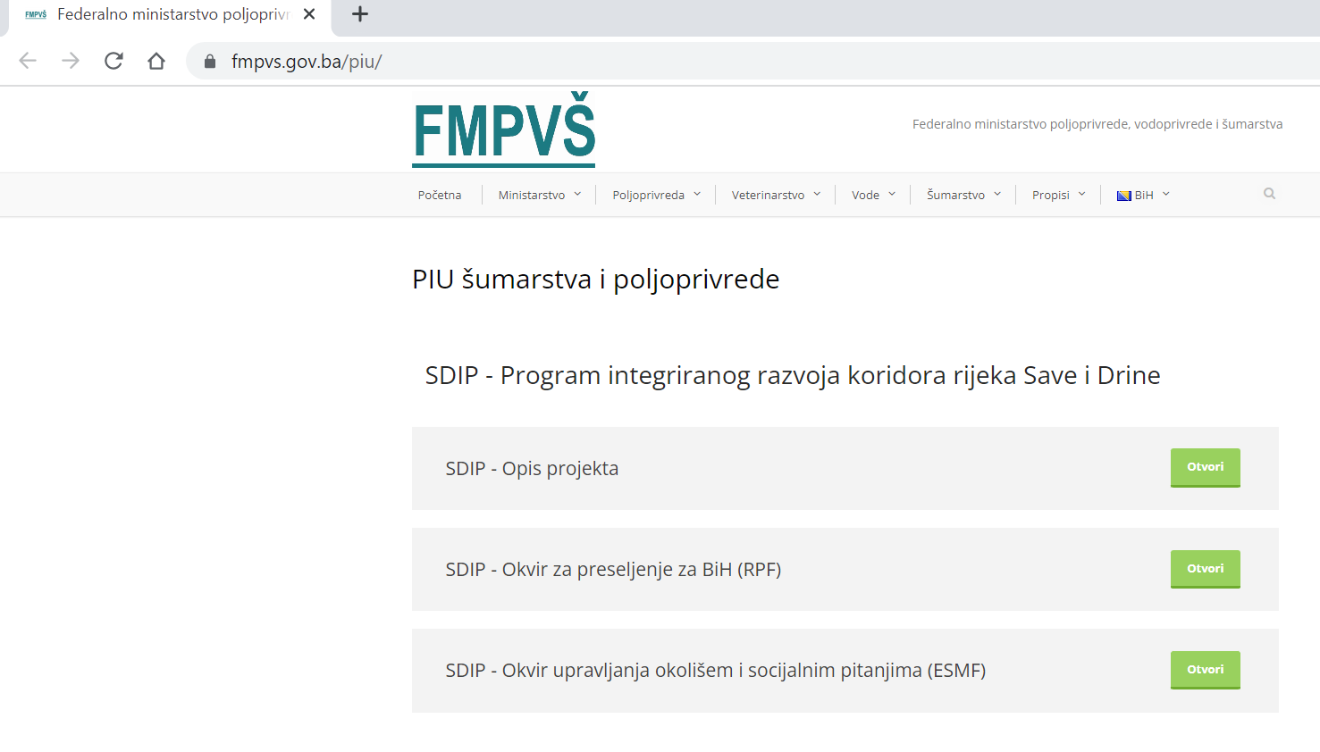

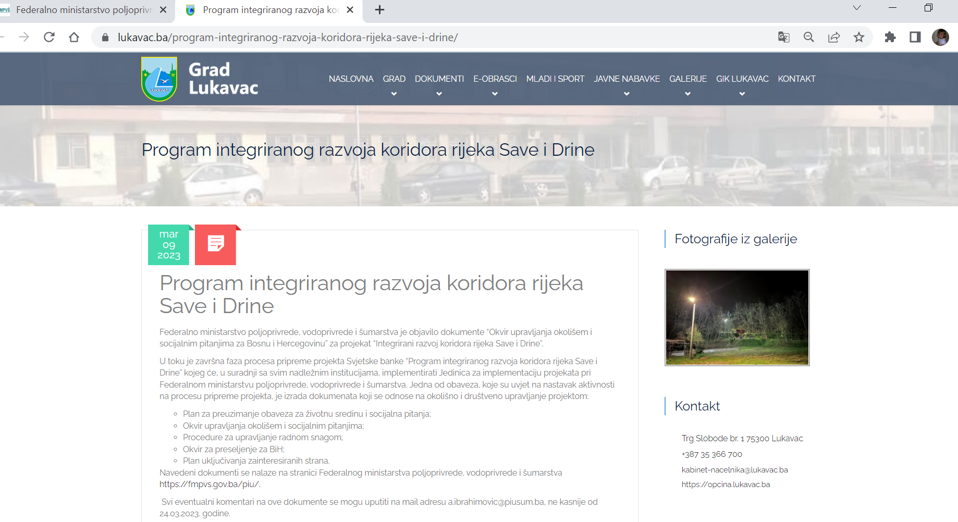

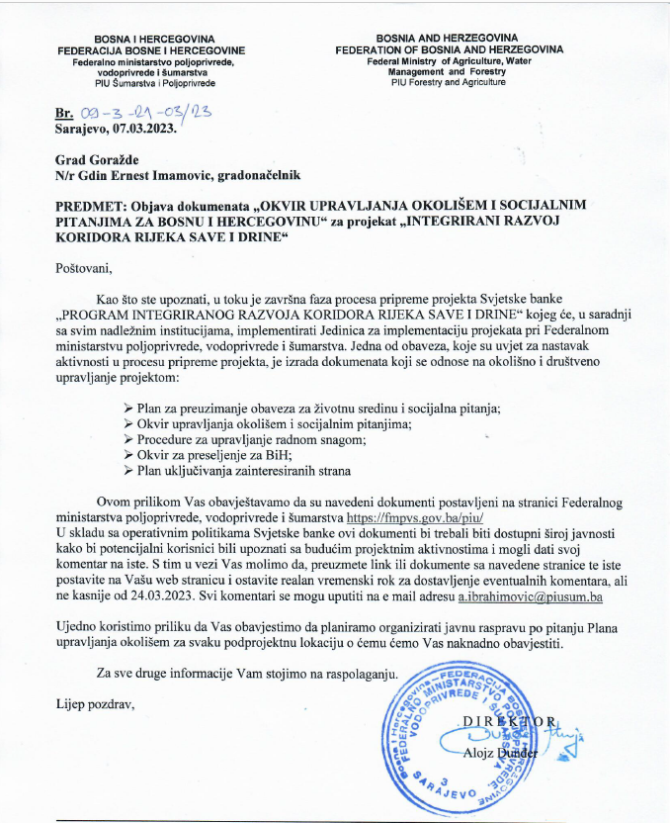

**Venue:** Hall of the Assembly of the Brčko District of BiH

**Date:** March 16, 2023

**Time:** 10:00 hr

**Organizer:** The unit for the implementation of projects financed from international funds of the Development and Guarantee Fund of the Brčko District of BiH

REPORT ON THE PUBLIC HEARING

The unit for the implementation of projects financed from international funds of the Development and Guarantee Fund of the Brčko District of BiH, for the needs of the "Project of Integrated Development of the Sava and Drina River Corridor", financed by the World Bank, is on March 16, 2023, from 10:00 a.m. to 12:00 p.m., in hall of the Assembly of the Brčko District of BiH, organized a public debate on the framework as follows:

1. Environmental and Social Management Framework – ESMF
2. Resettlement Framework – RPF
3. Stakeholder Engagement Plan – SEP
4. Environmental and social commitment plan ESCP
5. Labor Management Procedure – LMP

The aforementioned documents were available to citizens and interest groups on the website of the Government of Brčko District BiH and on the website of the Development and Guarantee Fund of Brčko District BiH www.rgfbd.com from 02.03.2023. years. until March 16, 2023, i.e. 14 days.

Eleven citizens and representatives of institutions (1 woman and 10 men) participated in the public debate, who had suggestions and comments on the documents presented as follows:

1. From BiH MAC, they suggested the accuracy of the data on demined areas of the Sava bank. Of the 9.9 million square meters of mine-contaminated areas of the Sava coast, that area of the BiH coast now amounts to 6,534,000 square meters. The number of unrealized demining projects was reduced from 144 to 94. The area along the Sava coast through the Brčko district includes 7 projects, which cover an area of 553,333 square meters, and whose implementation is scheduled for 2024.

2. From the Institute for Planning, Projecting and Development of the Brčko District, they pointed out the need to clearly state in the documents, in accordance with the Laws in the Brčko District, what is whose jurisdiction. And that the Department for Urbanism and Spatial Planning is the "Worker", while the Institute for Planning, Designing and Development of the District is the "Producer of Spatial Planning Documentation".

The minutes were drawn up by the representatives of the Project Implementation Unit of the Brčko District of Bosnia and Herzegovina.

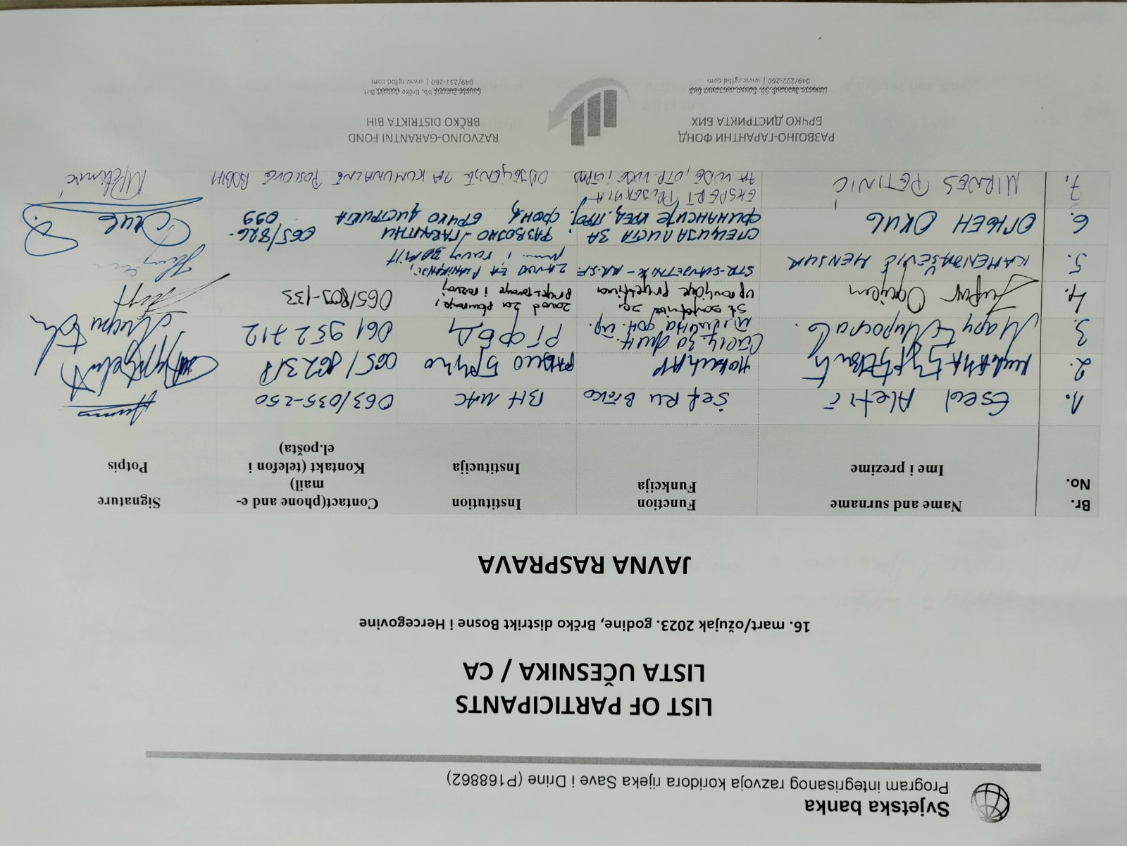

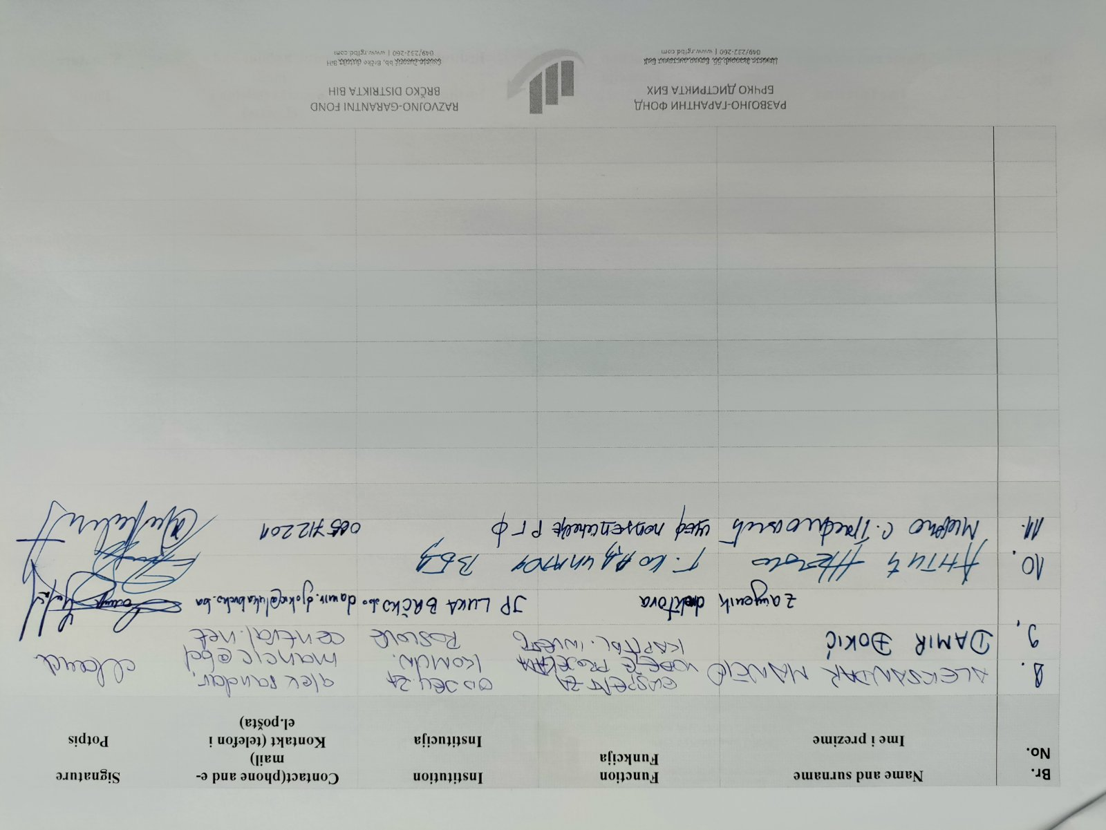

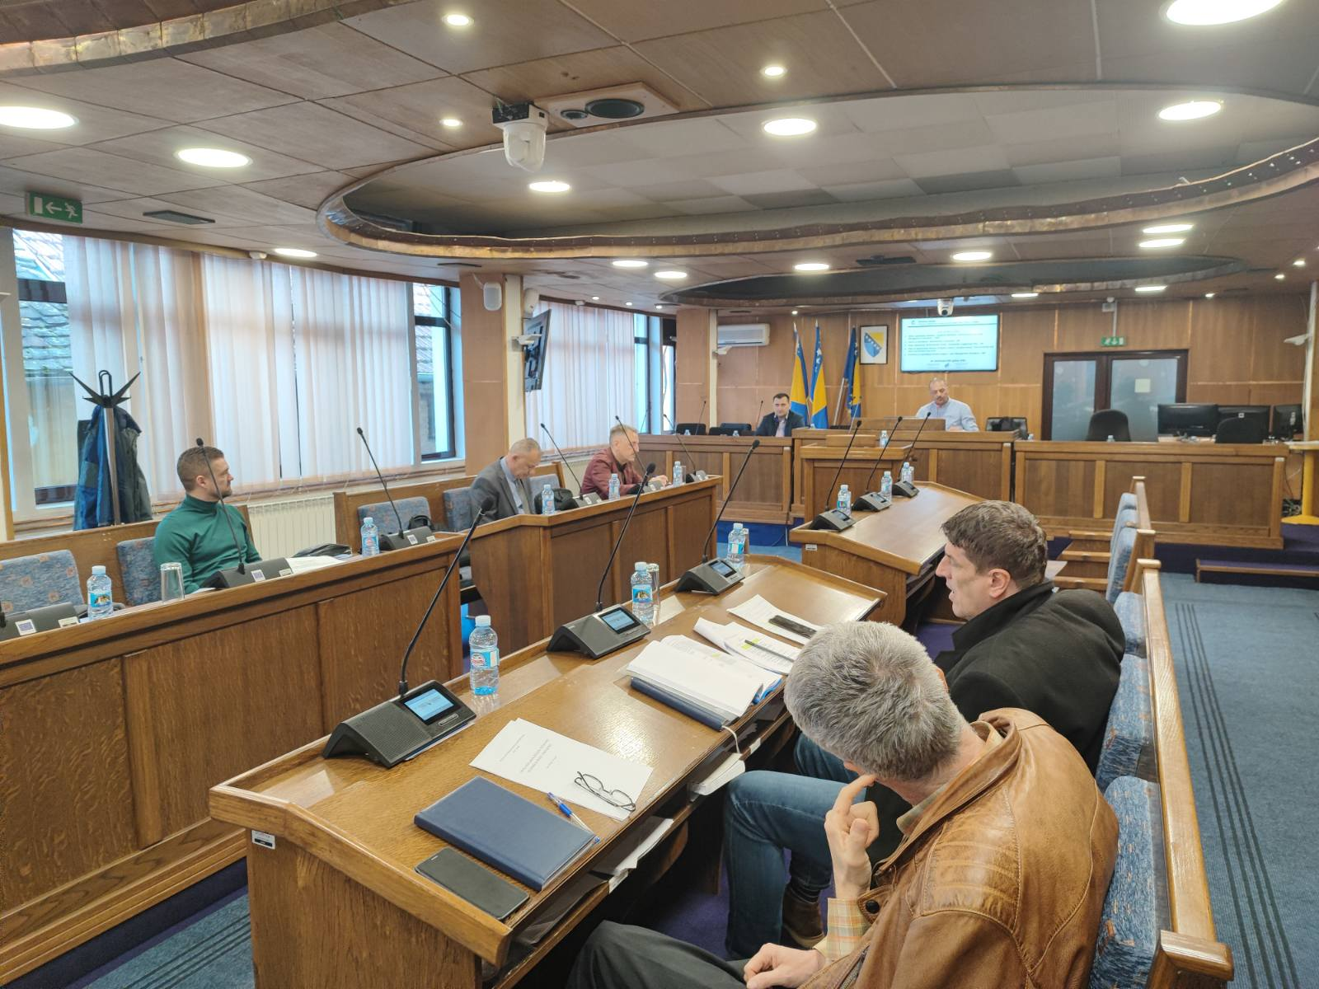

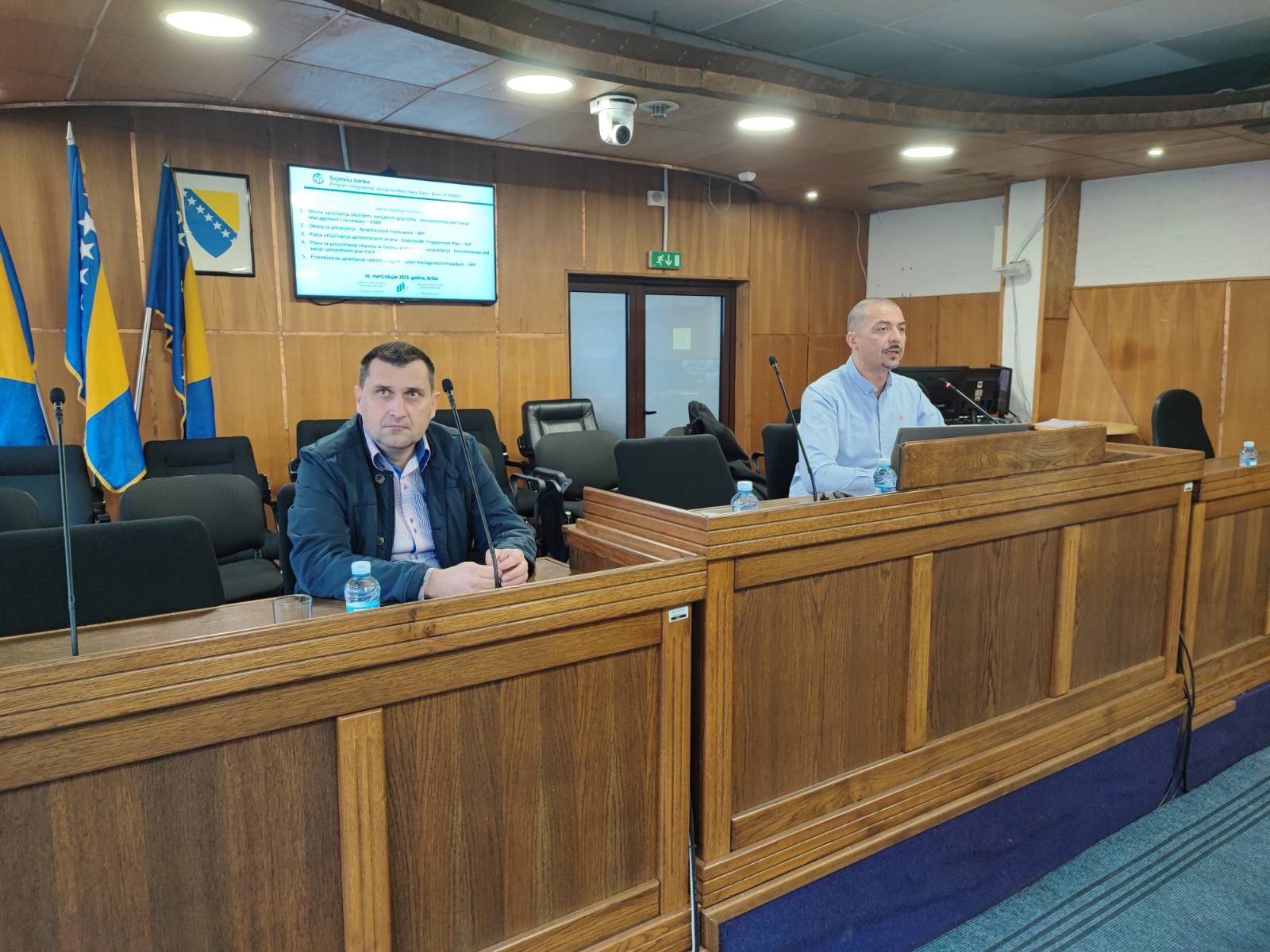

1. Official Gazette of FBiH, No. 32/01, 48/11
2. Official Gazette of FBiH, No. 33/03 and 38/09
3. Official Gazette of FBiH No. 63/04, 50/07 and 84/10
4. Official Gazette of FBiH, No. 2/06, 72/07, 32/08, 4/10, 13/10, 45/10
5. Official Gazette of RS, No. 20/01
6. Official Gazette of RS, No. 71/12 and 79/15
7. Official Gazette of RS, No. 40/13, 106/15, 3/16, 84/19
8. Official Gazette of BiH, No. 28/00, 45/06, 102/09, 62/11, 100/13
9. Official Gazette of BD BiH, No. 24/04, 01/05, 19/07, 09/09
10. Decision on the adoption of the Rulebook No. 01.1-02-028213/09 from 2 September 2009
11. Sub-groups at local and community level are not exclusive and may have multiple overlaps (e.g. young women agri-food producers who lives in a disadvantaged area would receive extra points in the selection criteria for all three characteristics (gender, age and location)).
12. BiH Country Partnership Framework for the period FY2016-20, World Bank, November 14, 2015
13. Updated in February 2025 to capture stakeholder engagement activities designed during the preparation of the Subproject for Demining the Right bank of the Sava River. The subproject specific ESMP and LMP are available at: <https://mkt.gov.ba/Content/Read/transport-infrastruktura-dokumenti>