SAVA AND DRINA RIVERS CORRIDORS INTEGRATED DEVELOPMENT PROJECT

RESETTLEMENT FRAMEWORK FOR BOSNIA AND HERZEGOVINA

February 2020/July 2022

Table of Contents

1 EXECUTIVE SUMMARY 6

2 INTRODUCTION 7

2.1 Brief Description the Project 7

2.1.1 Objectives 7

2.1.2 Components 7

2.1.3 Subprojects in Bosnia and Herzegovina 8

2.1.4 Implementation arrangements for the Entire Project 9

2.1.5 Timeline and Budget for the Entire Project 10

2.2 Scope and Purpose of the Resettlement Framework 10

2.3 Potential for Land Acquisition/Resettlement and the Screening Process 12

3 WORLD BANK REQUIREMENTS 13

4 LEGAL FRAMEWORK IN BOSNIA AND HERZEGOVINA 15

4.1 Constitution of BiH 15

4.2 Legal Framework in FBiH 15

4.3 Legal Framework in RS 19

4.4 Legal Framework in Brčko District 23

4.5 Gaps and Solutions 25

5 KEY LAND ACQUISITION / RESETTLEMENT PRINCIPLES AND COMMITMENTS 27

6 COMPENSATION AND ENTITLEMENTS 30

7 COMPENSATION FOR DIFFERENT CATEGORIES OF ASSETS 35

8 DISCLOSURE OF INFORMATION AND PUBLIC CONSULTATIONS 38

9 GRIEVANCE MECHANISM 40

10 Implementation of RPs 42

10.1 Implementation Responsibilities 42

10.2 Costs 43

10.3 Monitoring and Reporting 43

ANNEXES 44

A. Minimum Elements of a Resettlement Plan 45

B. Sample Grievance Form 49

C. Minutes from the public consultations 50

Abbreviations

|  |  |
| --- | --- |
| BiH | Bosnia and Herzegovina |
| FBiH | Federation of Bosnia and Herzegovina |
| RF | Resettlement Framework (this document) |
| RP | Resettlement Plan |
| RS | Republika Srpska |
| BD | Brcko District |
| PAP | Project Affected People |
| PIU | Project Implementation Unit |
| ESS | Environmental and Social Standards of World Bank |
| WB | World Bank |

List of Definitions of Terms Used in this Document

|  |  |
| --- | --- |
| Census Survey and Baseline Socio-Economic Study | The census identifies affected persons, and includes pertinent demographic (age, gender, family size, births, and deaths) and related social and economic information (ethnicity, health, education, occupation, income sources, livelihood patterns, productive capacity, and so forth). The census helps to determine eligibility of affected persons. It includes undertaking an inventory and valuation of assets and establishing, documenting, and making known the rights of those affected.  The information gathered in connection with the census is the baseline, which serves as a reference point against which income restoration and the results of other rehabilitation efforts can be measured. |
| Cut-Off Date | The date after which anyone who moves into the project area is no longer entitled to compensation and/or assistance. It is intended to help prevent encroachment by opportunistic settlers. |
| Economic Displacement | Loss of assets or access to assets which affects livelihoods or income generation as a result of the project. People or enterprises may be economically displaced with or without experiencing physical displacement. |
| Entitlement | Compensation and assistance which affected people have the right to receive during resettlement. Entitlements are defined for each individual project, and are listed in the form of an Entitlements Matrix, i.e. a table containing information on who is entitled to what type of compensation and/or assistance. |
| Land Acquisition | Refers to all methods of obtaining land for project purposes, which may include outright purchase, expropriation of property and acquisition of access rights, such as easements or rights of way. Land acquisition may also include: (a) acquisition of unoccupied or unutilized land whether or not the landholder relies upon such land for income or livelihood purposes; (b) repossession of public land that is used or occupied by individuals or households; and (c) project impacts that result in land being submerged or otherwise rendered unusable or inaccessible. “Land” includes anything growing on or permanently affixed to land, such as crops, buildings and other improvements, and appurtenant water bodies. |
| Livelihood | Refers to the full range of means that individuals, families and communities utilize to make a living, such as wage-based income, agriculture, fishing, foraging, other natural resource- based livelihoods, petty trade and bartering. |
| Market Value | Value calculated based on prices of property in the area in which the particular property is acquired, which can be achieved for a particular property on the market, depending on supply and demand at that moment of setting the price. |
| Moving Allowance | Cash compensation for costs directly associated to moving/relocation of a household or business. |
| Physical Displacement | Loss of house/apartment, dwelling or shelter as a result of project-related land acquisition which requires the affected person to move to another location. |
| Project Affected People (PAP) | Any person who, as a result of the land acquisition required by the project, loses the right to own, use, or otherwise benefit from a built structure, land, annual or perennial crops and trees, or any other fixed or moveable asset, either in full or in part, permanently or temporarily. |
| Replacement Cost | Defined as a method of valuation yielding compensation sufficient to replace assets, plus necessary transaction costs associated with asset replacement. Where functioning markets exist, replacement cost is the market value as established through independent and competent real estate valuation, plus transaction costs. Where functioning markets do not exist, replacement cost may be determined through alternative means, such as calculation of output value for land or productive assets, or the undepreciated value of replacement material and labor for construction of structures or other fixed assets, plus transaction costs. In all instances where physical displacement results in loss of shelter, replacement cost must at least be sufficient to enable purchase or construction of housing that meets acceptable minimum community standards of quality and safety.  The valuation method for determining replacement cost should be documented and included in relevant resettlement planning documents. Transaction costs include administrative charges, registration or title fees, reasonable moving expenses, and any similar costs imposed on affected persons. To ensure compensation at replacement cost, planned compensation rates may require updating in project areas where inflation is high or the period of time between calculation of compensation rates and delivery of compensation is extensive. |
| Restrictions on Land Use | Refers to limitations or prohibitions on the use of agricultural, residential, commercial or other land that are directly introduced and put into effect as part of the project. These may include restrictions on access to legally designated parks and protected areas, restrictions on access to other common property resources, restrictions on land use within utility easements or safety zones. |
| Resettlement Framework | A document developed when the exact nature or magnitude of the land acquisition or restrictions on land use related to a project with potential to cause physical and/or economic displacement is unknown due to the project development stage. The purpose of a framework is to clarify resettlement principles, organizational arrangements, and design criteria to be applied to subprojects to be prepared.  Once the subprojects and individual project components are defined and the necessary information becomes available, the framework is expanded into a specific plan proportionate to potential risks and impacts (see item Resettlement Plan below). |
| Resettlement Plan | The document in which a client specifies the procedures it will follow and the actions it will take to mitigate adverse effects, compensate losses and provide development benefits to persons and communities affected by an investment project.  Resettlement plans are prepared for any project that results in economic or physical displacement. The scope and level of detail of the plan varies with the magnitude of displacement and complexity of the measures required to mitigate adverse impacts. |
| Negotiated Settlements | Refers to situations where the Borrower needs to acquire specific land or restrict its use for project purposes, but rather than doing so through an expropriation proceeding, the Borrower first tries to arrive at a mutually agreeable negotiated settlement with the landowner/user. As explained in footnote 8, in many cases, both parties might find it advantageous to reach a negotiated settlement to avoid the delays and transaction costs associated with the full judicial or administrative process of expropriation or compulsory acquisition. In fact, many national laws require governments to first explore this more consensual approach. |
| Security of Tenure | Means that resettled individuals or communities are resettled to a site that they can legally occupy, where they are protected from the risk of eviction and where the tenure rights provided to them are socially and culturally appropriate. In no event will resettled persons be provided tenure rights that are in effect weaker than the rights they had to the land or assets from which they have been displaced. |
| Vulnerable People/ Groups | Vulnerable people are people who by virtue of gender, ethnicity, age, physical or mental disability, economic disadvantage, or social status, may be more adversely affected by resettlement than others and who may be limited in their ability to claim or take advantage of resettlement assistance and related development benefits.  Groups or persons who may be particularly vulnerable include, but are not limited to:   * poor people * people with disabilities * refugees and internally displaced people * children, women, the elderly or ill persons * households whose heads are children or female * households who have no or have very limited resources * ethnic minorities (such as Roma people or others) * people without land or use rights under local legislation |

# EXECUTIVE SUMMARY

The development objective of the Sava and Drina Rivers Corridors Integrated Development Program is to improve flood protection and enable transboundary water cooperation in the Sava and Drina Rivers Corridors. The Project consists of four components, will be implemented over a period of 10 years, organized in two phases. The sub-projects in Bosnia and Herzegovina will be managed by PIUs at entity/Brcko District level.

The proposed Project activities, due to the nature and extent of civil works, especially under Component 1 of the Project, may have displacement impacts. At this Project planning phase, the likely nature or magnitude of the impacts related to the Project is impossible to estimate; therefore, this Resettlement Framework (RF) is prepared to clarify resettlement principles, organizational arrangements, and design criteria to be applied to sub-projects, and to mitigate potential resettlement impacts. It has been prepared in accordance with the legal system, laws and procedures in force in Bosnia and Herzegovina, and in conformity with WB requirements and good international practices. This RF provides a framework for individual Resettlement Plans which will be prepared once the specific locations and impacts become known for any subproject that entails resettlement.

This RF covers the following elements:

* a brief description of the project, the scope of this RF and the potential for land acquisition/resettlement - Chapter 2;
* an overview of WB requirements regarding land acquisition/resettlement – Chapter 3;
* a detailed explanation of the legal framework in BiH, with an analysis of gaps between such framework and WB requirements – Chapter 4;
* principles and objectives governing resettlement preparation and implementation – Chapter 5;
* compensation and entitlements for Project Affected People – Chapters 6 and 7;
* requirements for disclosure of information and public consultations – Chapter 8;
* a description of grievance redress mechanisms - Chapter 9;
* arrangements for implementing Resettlement Plans to be developed – Chapter 10.

# INTRODUCTION

## Brief Description the Project

### Objectives

**The Higher-level Objective** of the Sava and Drina Rivers Corridors Integrated Development Program (SDIP) is to strengthen transboundary water cooperation and improve navigability and flood protection in the Sava and Drina Rivers Corridors.

**The Development Objective** of the SDIP (Phase 1 of the Program) is to improve flood protection and enable transboundary water cooperation in the Sava and Drina Rivers Corridors.

### Components

This project will implement subprojects with high implementation readiness and relevance to the program objectives, with detail designs and tender documents likely ready by Effectiveness in Montenegro, Bosnia and Herzegovina (BiH) and Serbia, while simultaneously preparing subprojects that will be implemented during the second phase of the Regional Program. The project consists of four components as described below:

Component 1: Integrated Management and Development of the Sava Rivers Corridors

Sub-component 1.1: **Flood protection, environmental management and climate change adaptation**. This sub-component will finance construction and rehabilitation of embankments at selected priority areas along the Sava River Corridor as well as nature-based solutions to re-vitalize selected protected areas of ecological significance to the Western Balkans. Upgraded flood protection capacity (at or above 1 in 100-year event) also enhance climate adaptation capacity of protected areas.

Sub-component 1.2: **Waterway improvements**. Under this sub-component, grant financing will be mobilized to finance demining activities along the Sava’s right bank within BiH, as a pre-requisite to the execution of civil works—planned for Phase II of the program—to increase the navigational capacity of the Sava river. The preparatory documentation for these Phase II works (engineering designs, environmental and social safeguards instruments, expected climate change impacts on navigability, bidding documents) will also be finalized during the project. The project-supported demining efforts are also an operational pre-requisite to the planned improvements to Sava river ports under Phase II. Demining activities are proposed as a no-regret investment that will help unlock the river’s economic potential for generations to come.

Component 2: Integrated Management and Development of the Drina River Corridor

Sub-component 2.1: **Flood protection and environmental management**. This sub-component will finance infrastructure works, studies, surveys, consultations and preparation of detailed design of interventions related to the management of environmental assets (the protection of local ecosystems that act as carbon sinks) along the Drina Corridor. The on-going GEF-SCCF-financed Drina River Basin Management project as well as the ESMAP technical assistance, are conducting studies that will identify the additional actions needed for flood protection, bank stabilization, drainage and river training works, and reservoir management in the Drina Corridor. Upgraded flood protection capacity (at or above 1 in 100-year event) also enhance climate adaptation capacity of protected areas.

Sub-component 2.2: **Integrated development of Drina watershed**. This sub-component will finance improved watershed management in the Lim and Grncar River basins of Montenegro, as well as works related to flood protection, drainage and irrigation measures within the Lim River Basin (a tributary of the Drina River) to mitigate flood risks and promote sustainable use of natural resources. These measures include: river bank stabilization; river training works; flood protection embankments and dykes. The detailed designs of these investments are under preparation through the ongoing GEF-SCCF project. This sub-component will further finance the preparation of selected priority investments in line with the project development objective.

Component 3: Project preparation and management

Sub-component 3.1: **Project preparation**. This sub-component will finance preparation of project documentation for phase II of the program, including environmental and social assessments.

Sub-component 3.2: **Institutional strengthening and project management**. This sub-component will finance activities to increase institutional capacity and inter-sectoral coordination in the participating countries to ensure more efficient decision making and program management at regional level. This sub-component will promote joint action and decision making in river basin management and flood risk management among riparian countries, thus enhance the climate adaptation capacity of the region.

Component 4: Regional activities

This component will support policy dialogue, consultations, preparation of plans and studies, and investments to strengthen the nexus between water services and connectivity with the regional development and economic cooperation objectives of the Sava and Drina Corridor. An advocacy and communication plan will be prepared and implemented to promote regional cooperation. Regional studies (i.e., hydrological, sediment, climate changes adaptation, etc.) in the Sava and Drina Rivers Corridors will improve the understanding of the Basin’s unique characteristics and opportunities to boost regional cooperation and integrated management.

### Subprojects in Bosnia and Herzegovina

The proposed SDIP components and sub-components that will be implemented in BiH are briefly described in the table below.

| Component | Sub-component | Sub-component description |
| --- | --- | --- |
| Component 1: Integrated Management and Development of the Sava River | Sub-component 1.1: Flood protection and environmental management | Construction and rehabilitation of embankment and dykes in Republika Srpska  Reforestation in Vrbanja, Vrbas and Sava River basin  Protection of ecological environment and biodiversity of Una River  Purchase of equipment in Republika Srpska  Brčko District landfill rehabilitation and its closure  Construction of Center for Solid Waste Management (location “Kladje”)  Regulation of part of the Waterstream / creek “Blizna” in Brčko District (part I and part II)  Regulation of the “Brka” river upper watercourse from bridge on “Kožara” toward railway bridge (Lički most)  Construction of the sidewalk and bicycle route along the right bank/side of the “Sava” river  Protection of Sava dykes in flood area in Central Posavina (FBiH) – 6 locations  Regulation of Bosna riverbed in Sarajevsko polje in the area of Municipality Novi Grad  Regulation of Bosna riverbed from bridge in Svrake, upstream  Regulation of river Zeljeznica from the bridge in Butmir to entity border in Vojkovici.  Regulation of river Zeljeznica from the bridge on the western entrance to the town in Otes to the estuary into river Bosna  Rehabilitation of Modrac lake dam – IV phase  Regulation of the portion of Jala riverbed downstream from regulated portion to the border with Municipality Lukavac |
| Sub-component 1.2: Waterway Improvements | Grant financing will be mobilized to finance demining activities along the Sava Right bank within BiH.  Construction of the quay on river Sava in Novi Grad (dock for small boats)  Construction of the small port on river Sava in Orasje (port for small boats)  Dredging and training work of river Sava in Novi Grad/Odžak on the stretch: Jaruge (RH) - Novi Grad/Odžak (FBIH) – preparation for phase II  Dredging under the bridge near Šamac – preparation for phase II |
| Component 2: Integrated Management and Development of the Drina River Corridor | Sub-component 2.1: Flood protection and environmental management | River training in Goražde city within the Federation of Bosnia and Herzegovina  Urgent rehabilitation works in Goražde  Regulation of Kosovska river |
| Component 3: Project preparation and management | Sub-component 3.1: Project preparation | Preparation of project documentation for phase II of the program, including E&S risk assessments. |
| Sub-component 3.2: Institutional strengthening and project management | PIU and project management, Phase I  Implementation and Operations Cost, Phase I |
| Component 4: Regional activities | Regional Dialogues and Studies | Policy dialogue, consultations, and the preparation of plans and studies for the Sava river basin.  Preparation of an advocacy and communication campaign |

### Implementation arrangements for the Entire Project

SDIP will be implemented through a sequential and simultaneous multiphase programmatic approach with five participating countries: Serbia, BiH, Montenegro, Croatia, and Slovenia. Slovenia will be the only non-borrowing program beneficiary; it will participate in the regional studies, regional dialogue, capacity building tools, and related activities under Component 3. Subprojects will be implemented at national level and will have cumulative regional benefits.

SDIP will be implemented by participating countries in a coordinated manner through two levels of coordination. At the regional level, a regional committee consisting of the existing ISRBC members and senior officials from key sectors such as water, transport, energy and tourism will facilitate dialogue and cooperation in the region. This committee will also provide strategic oversight and guidance for the implementation of regional activities in addition to national subprojects, ensuring stronger dialogue, integration and knowledge sharing. During implementation, other sectors will be coopted as and when the need arises.

At the national level, implementation will be undertaken by PIUs within line ministries of each country/entity and Brčko District. In each country/entity/District of Brčko, PIUs will be established comprising of the required technical and managerial expertise to support project implementation. In the Federation of BiH, the existing PIU within the FBiH Ministry of Agriculture, Water Management and Forestry will be responsible for implementation of the activities in FBiH. The Federal Ministry of Transport and Communications, Water Agency Sava and other institutions responsible for particular sectors (navigation, flood protection, tourism) will provide technical support. In Republika Srpska, the existing PIU within the RS Ministry of Agriculture, Forestry and Water Management will implement the project, and technical support will be provided from the Ministry of Transport and Communications, Ministry of Spatial Planning, Construction and Ecology, Water Agency and other relevant institutions. In the Brčko District, PIU established by the Government of Brčko District (BD IPIU) will work on preparation and implementation, while support will be provided by all relevant Departments from the Brčko District Government. At the BiH state level, for the purposes of implementing component 1.2, upon approval of grant funds for financing the activity, a PIU will be established, which will consist of members from MKT and BHMAC and will be responsible for the implementation of the activity.

### Timeline and Budget for the Entire Project

The program will be implemented over a period of 10 years, organized in two phases. Phase I will focus on flood protection and river basin management activities in the Sava and Drina Rivers Corridors. Phase II will build on Phase I and strengthen river port connectivity and environmental management. Countries will proceed to Phase II based on the readiness of jointly identified priority interventions prepared during Phase I. The estimated program cost for both phases is US$338 million.

## Scope and Purpose of the Resettlement Framework

The purpose of this Resettlement Framework (RF) is to clarify resettlement principles, organizational arrangements, and design criteria to be applied to subprojects to be prepared during Project implementation, taking into account:

* the legislation in force at the level of BiH, FBiH, RS and BD, and
* The World Bank Environmental and Social Framework, specifically its Environmental and Social Standard 5: “Land Acquisition, Restrictions on Land Use and Involuntary Resettlement” (ESS5)[1].

The RF has been prepared as the exact locations of subprojects, potential land impacts and the extent of resettlement have not yet been defined. Once the specific locations and impacts become known, the RF will guide the preparation of Resettlement Plans (RPs) where applicable. RPs will be prepared for all subprojects that entail resettlement, in order to satisfy the provisions of ESS5 and the requirements of local legislation regarding land acquisition. Project activities that will cause physical and/or economic displacement will not commence until such specific plans have been finalized and approved by the Bank.

The scope of requirements and level of detail of the RPs will vary with the magnitude and complexity of resettlement. RPs will be based on up-to-date and reliable information about:

1. the proposed project and its potential impacts on the displaced persons and other adversely affected groups,
2. appropriate and feasible mitigation measures, and
3. the legal and institutional arrangements required for effective implementation of resettlement measures.

The minimum elements of an RP according to ESS5 have been explained in Annex A to this document.

## Potential for Land Acquisition/Resettlement and the Screening Process

The proposed Project activities are very likely to have land acquisition impacts, including physical relocation due to civil works and restricted access to economic resources for riverine communities due to changes in access and resource use.

A preliminary list of subprojects has been identified, but are not yet mature for implementation.

Prior to the submission of subprojects for funding consideration, the PIU shall carefully screen the proposed subprojects to assess whether or not land acquisition may be required and to what extent. It is important to take into consideration during such screening that even though the planned project activities may not lead to impacts in terms of land acquisition, preparatory investment activities foreseen during the project preparation period (such as drilling activities, site clearance or construction of access roads) may involve temporary land acquisition or temporary occupation of land, in which case the PIU must ensure that such preparatory activities are also in compliance with the requirements of this RF. In addition, the proposed projects involving the development of studies and designs that would facilitate/recommend the construction of physical infrastructure need to be diligently screened to establish any potential impacts associated with specific subsequent investments (regardless whether such future activities will be funded by the WB or other sources).

Following the screening process and determination of potential impacts, the PIU shall report the findings of the screening process to the World Bank and prepare site-specific RPs, ensuring that all project activities adhere to the requirements of this RF. The RPs will be submitted to the World Bank for review and approval.

# WORLD BANK REQUIREMENTS

The World Bank’s ESS5 on Land Acquisition, Restrictions on Land and Involuntary Resettlement recognizes that project-related land acquisition and restrictions on land use can have adverse impacts on communities and persons. Project-related land acquisition or restrictions on land use may cause physical displacement (relocation, loss of residential land or loss of shelter), economic displacement (loss of land, assets or access to assets, leading to loss of income sources or other means of livelihood), or both. The objectives of ESS5 are:

According to ESS5, affected persons may be classified as follows:

|  | PAP categories | Rights |
| --- | --- | --- |
| a) | Those who have formal legal rights to land or assets (i.e., those who have formal documentation under national law to prove their rights, or are specifically recognized in national law as not requiring documentation) | Compensation for loss of land or assets  +  Resettlement and livelihood assistance |
| b) | Those who do not have formal legal rights to land or assets, but have claim to land or assets that are recognized or recognizable under national laws (e.g. those who have been using the land for generations without formal documentation under customary or traditional tenure arrangements that are accepted by the community and recognized by national law, or those who have never been provided formal title or their documents may be incomplete or lost) |
| c) | Those who have no recognizable legal right or claim to the land or assets they occupy or use (e.g. seasonal resource users, such as herders, grazers, fishers, hunters, or persons occupying land in violation of applicable laws) | Not eligible for compensation for land, but eligible for resettlement and livelihood assistance + compensation for assets owned |

The key requirements of ESS5may be summarized as follows:

* Involuntary resettlement should be avoided where possible. Where unavoidable, it will be minimized and appropriate measures to mitigate adverse impacts on displaced persons (and on host communities receiving displaced persons) will be carefully planned and implemented.
* All feasible alternative project designs should be considered to avoid or minimize land acquisition or restrictions on land use, while balancing environmental, social and financial costs and benefits, and paying particular attention to gender impacts and impacts on the poor and vulnerable;
* Negotiated settlements with affected persons are encouraged to help avoid administrative or judicial delays associated with formal expropriation, and to the extent possible to reduce the impacts on affected persons associated with formal expropriation;
* When land acquisition or restrictions on land use cannot be avoided, the Borrower will offer affected persons compensation at replacement cost, and other assistance as may be necessary to help them improve or at least restore their standards of living or livelihoods;
* The Borrower will not resort to forced evictions of affected persons. “Forced eviction” is defined as the permanent or temporary removal against the will of individuals, families, and/or communities from the homes and/or land which they occupy without the provision of, and access to, appropriate forms of legal and other protection. The exercise of eminent domain, compulsory acquisition or similar powers by a Borrower will not be considered to be forced eviction providing it complies with the requirements of national law and the provisions of ESS5, and is conducted in a manner consistent with basic principles of due process.
* Disclosure of relevant information and meaningful participation of affected communities and persons will take place during the consideration of alternative project designs, and thereafter throughout the planning, implementation, monitoring, and evaluation of the compensation process, livelihood restoration activities, and relocation process;
* The Borrower will ensure that a grievance mechanism for the project is in place as early as possible in project development to address specific concerns about compensation, relocation or livelihood restoration measures raised by displaced persons (or others) in a timely fashion.
* Where land acquisition or restrictions on land use are unavoidable, the Borrower will conduct a census to identify the persons who will be affected by the project, to establish an inventory of land and assets to be affected, to determine who will be eligible for compensation and assistance, and to discourage ineligible persons, such as opportunistic settlers, from claiming benefits.

# LEGAL FRAMEWORK IN BOSNIA AND HERZEGOVINA

## Constitution of BiH

The Constitution of BiH[2] stipulates that:

* BiH and its Entities shall ensure the highest level of internationally recognized human rights and fundamental freedoms,
* The rights and freedoms set forth in the European Convention for the Protection of Human Rights and Fundamental Freedoms and its Protocols shall directly apply in BiH and have priority over all other laws,
* The right to property is listed as one of thirteen fundamental human rights protected under the Constitution.

Expropriation, i.e. acquisition of real property in public interest, is regulated at entity (FBiH and RS) and BD level, as described in more detail below.

## Legal Framework in FBiH

Law on Expropriation of FBiH

The *Law on Expropriation of FBiH*[3] regulates the conditions (establishing public interest), the procedure for expropriation of property for construction of facilities in public interest, compensation eligibility and amounts, and handling of grievances and disputes handling.

The key provisions of the Law may be summarized as follows:

* *Public Interest and Purpose of Expropriation:* Property can only be expropriated upon the establishment of public interest for construction of facilities or carrying out other works on the property. Real property may be expropriated if this is required for construction of traffic infrastructure, business/industrial zones, economic, utility, health, educational and cultural facilities, defense facilities, administrative and other facilities in the public interest, when it is assessed that using the real property for which expropriation is proposed will produce a greater benefit than would be produced if the real property is continued to be used in the previous manner.

Expropriation may be carried out for the needs of FBiH, cantons, cities, municipalities, public enterprises and public institutions, unless otherwise provided by the Law.   
Exceptionally, expropriation may establish usufruct for the benefit of citizens for the purpose of installing water and sewage pipelines, electric and telephone cables, gas pipelines, and other cases provided for under the Law.

Public interest may be established by issuing a Decree or by a dedicated law. Public interest will be deemed as established by a physical plan or urban design adopted for a certain area.

The Decree on Establishing Public Interest, upon the proposal of the expropriation beneficiary submitted along with the Expropriation Study, is issued by: the Government of FBiH when construction or works are being carried out on the territory of two or more cantons (based upon the prior opinion of cantonal governments), the government of cantons when construction or works are to be carried out on the territory of two or more municipalities (upon the prior opinion of municipal councils), or the municipality when construction or works are being carried out on the territory of the municipality.

* *Expropriation Procedure:* The expropriation procedure comprises the following steps:

1. Preparation for expropriation: The expropriation beneficiary may request, for the purpose of preparing an investment study, or submitting a proposal for the establishment of public interest or submitting a proposal for expropriation, to be allowed to perform the necessary preparations on designated property, in accordance with the procedure set out in the Law. The proposal is submitted to the Municipal Administration for Ownership Affairs (“Municipal Administration”).
2. The relevant authority issues the Decree on Establishing Public Interest.
3. The expropriation beneficiary is required to publish a public announcement to invite the property owners and try to reach a prior amicable sale-purchase agreement with the affected owner.
4. The expropriation beneficiary submits a proposal for expropriation to the Municipal Administration, along with the required documentation set out in Article 24 of the Law. If deemed necessary, the proposal may contain a request for temporary occupation of other land needed for the construction of the facility or carrying out works in public interest. This request may also be submitted as a separate proposal.
5. The Municipal Administration is obliged to notify the owner of the property, without delay, of the submitted proposal for expropriation. The expropriation beneficiary and the owner of property may also conclude an amicable sale-purchase agreement *after* the submission of the proposal for expropriation, i.e. up to the validity of the Decision on Expropriation issued by the Municipal Administration.
6. The expropriation notice is entered into the land register and other registers upon the request of the expropriation beneficiary.
7. The Municipal Administration is obliged to hear the owner of the property in regard to the expropriation facts.
8. The Municipal Administration issues a Decision on Expropriation, after completing the proceedings on an urgent basis. Appeal against this Decision may be submitted to the Federal Administration for Geodesy and Legal Property Affairs (mentioned as the “Federal Administration” in the Law). In the event that the land registry entry does not correspond to the actual ownership situation (often the case), the municipal department should sort out the title issues prior to proceeding with further steps.
9. When the Decision on Expropriation becomes enforceable, the Municipal Administration is obliged to convene and hold a hearing to determine the compensation for the expropriated real property through an agreement and without delay.
10. If no agreement on compensation is reached within 2 months of the validity of the Decision on Expropriation (or less if the Municipal Administration decides as such), the Municipal Administration submits the valid Decision together with other relevant documents to the competent Court, at the territory of which the expropriated real property is located, for the purpose of determining the compensation. The competent court ex officio decides in non-contentious proceedings on the amount of compensation for the expropriated real property.
11. For reasons of urgency and in order to avoid major damage, the expropriation beneficiary may take possession of the expropriated land even before the decision on expropriation becomes final and before the compensation is paid, but exclusively on the basis of a decision by the Government of BiH in case of construction or reconstruction of public infrastructure (road, energy, utility, etc.), and provided that the special requirements prescribed by law have been met. Prior to submitting a request to gain access to the property, the expropriation beneficiary shall present to the owner the reasons for the urgency and an offer for a negotiated settlement that allows an early access to the property. The request for an early access to property is submitted to the Administrative Commission of the Government of FBiH, while the Federation Administration for Geodetic and Real Property Affairs prepares the proposed decision. If the case involves expropriation of a residential or commercial structure, the expropriation beneficiary may not file a request for an early access unless a replacement property is secured.
12. Formal transfer of legal title in the land register is carried out on the basis of a valid Decision and proof of payment of compensation or proof that the previous owner has acquired ownership over other corresponding real property.

* *Full (“Complete”) and Partial (“Incomplete”) Expropriation:* Full expropriation allows the expropriation beneficiary to obtain legal title over the expropriated property, while the rights of the previous owner over the real property as well as other rights cease to exist. Partial expropriation provides the beneficiary with usufruct rights on the land and structures, as well as the lease of land for a definite period of time - at the end of the lease, usufruct rights over land are returned to the previous owner. Partial expropriation is subject to the possibility that the land can be fully restored and the lease not being more than five years.

However, owners that are affected by a partial loss of their properties are entitled to request complete expropriation and the corresponding compensation, in case partial expropriation would deteriorate the economic situation of the real property owner or make the remaining part of the real property useless or difficult to use. Such landowners must be informed about this entitlement by the official managing the expropriation process.

* *Compensation:* The Law provides that compensation arrangements must be settled prior to formal transfer of ownership of the expropriated property. Compensation to affected people is provided by the expropriation beneficiary. A general principle of the Law is that compensation should be provided at market value. The market value is calculated based on the price in the territory in which the real property is to be expropriated, which may be achieved for a specific real property on the market, and which depends on the ratio of offer and demand at the time of its determination.

Compensation for land is based on the type of land (agricultural land, forests, orchards, etc.) and the related benefits that the owner would obtain if there were no expropriation.

Owners of informally built structures (i.e. structures built without the necessary construction permits) are not entitled to receive the compensation; however, the owners of informal structures may demolish the structure and take away the materials within the time set by the responsible administrative department; otherwise, the structure shall be removed at the expense of the owners of informally built structures. The exception from this rule is when an informally built residential building is the only residential building the owner and their closest family members (right to home) or their legal heirs possess, in which case they are entitled to the compensation at market value. Conditions for recognition of the right to compensation to an owner of an informally built structure, in addition to the above, include:

that the responsible authority had not passed a final decision to remove the building;

that the informally built structure is registered in the official Arial survey of the territory of FBiH;

that the informal building is the only home of the owner of the informally built structure and members of their closest family, or their heirs.

The personal and family circumstances of the owners whose real property is pending expropriation, as well as circumstances which may have adverse economic effects, should be taken into account when determining the compensation extent[4] (Article 47). This Article addresses livelihood restoration beyond the sheer compensation of the lost asset by providing flexibility based on a case-by-case assessment of personal circumstances. Businesses and their specific livelihood restoration requirements are explicitly addressed by Article 47.

Other Related Legislation of FBiH

* The *Law on Proprietary Rights[5]* regulates the general issues of acquiring, using, disposing of, protecting and terminating ownership rights and other proprietary rights and possession rights, including the issues of restricting such rights, the right of servitude, co-ownership and joint ownership rights, the procedure for acquiring property rights over land and/or structures erected on someone else’s land. The Law states that ownership rights and other proprietary rights may only be limited or taken away in public interest and under the conditions defined by the Law in accordance with the principles of international law.

A significant provision of the Law is that occupants of property acquire ownership rights upon 10 years of conscientious and legal occupancy, or upon 20 years of conscientious occupancy.

In addition, the Law provides that the conscientious builder of a structure on land owned by another person is entitled to acquire such land, if the land owner did not oppose to the construction. The land owner is in this case entitled to request to be compensated for the market value of the land.

* The *Law on Agricultural Land of FBiH[6]* contains the basic definitions and principles regarding the management, protection, use, planning, and records related to agricultural land. The Law provides that a right of way may be established on agricultural land, as decided by the city or municipal council. The owners of such land are entitled to compensation in accordance with the Law on Expropriation.
* The *Law on Construction Land of FBiH[7]* allows for the legalization of informally constructed structures on construction land in state ownership on which a structure has been built.This Law enables the subsequent issuing of a permit for construction, by the Municipal Council, in accordance with the Law on Spatial Planning. Legalization of informally constructed buildings is further regulated by decrees taken at cantonal level, and implemented at municipality level.
* The *Law on Administrative Proceedings of FBiH[8]* is applied in the procedure of expropriation as a subsidiary law to the *Law on Expropriation.* It regulates the procedures the administrative authorities apply when deciding on rights and obligations of the citizens. Parties have the right to appeal the decisions issued in the first instance. The law offers the opportunity of appointing the temporary representative if, for example, the residence of the owner of property being expropriated is unknown. The temporary representative shall be appointed by the body conducting the procedure if so required by the urgency of the case. If the temporary representative were appointed to act on behalf of a person whose residence is unknown, the authority conducting the procedure shall publish their conclusion on the bulletin board or in another usual way (in newspapers or other media outlets).
* The *Law on Land Registry of FBiH[9]* regulates keeping, maintaining and establishing land register, as well as entry of property and rights on properties in such land register. The right of ownership and other proprietary rights are acquired by registration in the land register. In the procedure of expropriation, the final decision on expropriation accompanied with the evidence of payment shall be considered the grounds for registration of the expropriation beneficiary as the owner.
* The *Law on Non-Contentious Proceedings of FBiH[10]* **stipulates** the rules the courts apply in proceedings and decision-making process on individual, family, property and other rights or legal interest, which are under the law resolved in non-contentious proceedings. The courts establish the amount of compensation for the expropriated property in non-contentious procedure. The parties may conclude an agreement on the form and scope of compensation, i.e. the amount of the compensation, and the court passes the decision that is based on their agreement, if it finds the agreement compliant with the regulations defining ownership relations.
* The *Law on Bases of Social Welfare, Protection of Civilian Victims of War, and Protection of Families with Children[11]* regulates social protection and aims at ensuring social protection to its citizens and their families that are in social need. Individuals and families in need are entitled to temporary, one-time and other types of monetary assistance, as well as other types of assistance. Right to such assistance may be asserted before the responsible body of the municipality where the person and family reside.

## Legal Framework in RS

Law on Expropriation of RS

The Law on Expropriation of RS[12] regulates the conditions (establishing public interest), the procedure for expropriation of real property for construction of facilities and carrying out works in public interest and the compensation for expropriated property.

The key provisions of the Law may be summarized as follows:

* *Public Interest:* Property may only be expropriated upon the establishment of public interest for construction of facilities or carrying out other works on the property, in the sectors of health, education, social protection, energy, sports, water, culture, telecommunication and utility infrastructure, industrial facilities, administrative facilities, providing protection of living environment or protection from natural disasters, as well as research and exploitation of mineral and other natural resources.

Public interest is established by a Decree, but may also be established by a dedicated law or physical planning documents. Following the submission of a proposal by the expropriation beneficiary, the Government of RS issues a Decree on Establishing Public Interest upon the prior opinion of the assembly of local governments on whose territory it is intended to construct or carry out works. The assembly is obliged to issue its opinion within 30 days upon receiving the request. The Government of RS is then obliged to decide upon the matter within 30 days upon receiving the opinion of the assembly.

* *Expropriation Procedure:* The expropriation procedure comprises the following steps:

1. Preparation for expropriation: The expropriation beneficiary may request to be allowed to perform the necessary preparations on designated property, in accordance with the procedure set out in the Law. The proposal is submitted to the Administration for Ownership Affairs[13] (“Administration”).
2. The relevant authority issues the Decree on Establishing Public Interest, as described above.
3. The expropriation beneficiary is required to try to reach an amicable sale-purchase agreement with the affected owner.
4. The expropriation beneficiary submits a proposal for expropriation to the Administration, along with the required documentation set out in Article 25 of the Law. If deemed necessary, the proposal may contain a request for temporary occupation of other land needed for the construction of the facility or carrying out works in public interest.
5. The Administration is obliged to notify the owner of the property, without delay, of the submitted proposal for expropriation.
6. The expropriation beneficiary and the property owner may conclude an amicable sale-purchase agreement *after* the submission of the proposal for expropriation, i.e. until the Decision on Expropriation is issued, in which case the expropriation procedure is terminated.
7. The Administration is obliged to hear the owner of the property in regard to the expropriation facts.
8. The Administration issues a Decision on Expropriation, after completing the proceedings on an urgent basis. An appeal against this Decision may be submitted to the RS Administration for Geodesy and Legal Property Affairs.
9. When the Decision on Expropriation becomes enforceable, the Administration is obliged to convene and hold a hearing to determine the compensation for the expropriated real property through an agreement and without delay.
10. If no agreement on compensation is reached within 2 months of the validity of the Decision on Expropriation (or less if Administration decides as such), the Administration submits, without delay, the valid Decision to the competent Court on whose territory the expropriated real property is located, for the purpose of determining the compensation. In case an agreement cannot be concluded, the competent court ex officio decides in non-contentious proceedings on the extent of compensation for the expropriated real property.
11. Taking possession over the affected property is possible only upon a formal Decision on Expropriation and after the possession of substitute property or compensation payment. When RS is the expropriation beneficiary, it acquires the right to take possession over the affected property on the date of finality of the Decision on Expropriation. When local governments are the expropriation beneficiary, they acquire the right to take possession over the affected property on the date of validity of the Decision. The exceptions are infrastructure projects, in which case the Government may issue a Decree to allow the beneficiary to take possession of the property prior to the finality of the Decision if necessary due to urgency or avoiding considerable damage. If the expropriation proposal is later rejected in the further procedure, the expropriation beneficiary is required to compensate for damage caused to the owner by gaining the possession of the real property. In case of expropriation in areas affected by natural disasters, the Government may allow the beneficiary to take possession of the property prior to the finality of the Decision.
12. Formal transfer of legal title in the land register is carried out on the basis of a valid Decision and proof of payment of compensation or proof that the previous owner has acquired ownership over other corresponding real property.

* *Full and Partial Expropriation:* Full expropriation allows the expropriation beneficiary to obtain legal title over the expropriated property, while the rights of the previous owner over the real property as well as other rights over that real property cease to exist. Partial expropriation provides the beneficiary with usufruct rights on the land and structures, as well as the lease of the land for a definite period of time - at the end of the lease, usufruct rights over land are returned to the previous owner. Partial expropriation is subject to the possibility that the land can be fully restored and the lease not being more than five years. However, owners that are affected by a partial loss of their properties are entitled to request complete expropriation, in case partial expropriation makes the remaining part of the real property useless or difficult to use.
* *Compensation:* As in FBiH, compensation for expropriated property is in principle provided through a corresponding alternative real property in the amount of the market value of the expropriated real property in the same municipality or city, thus enabling the owner of expropriated real property approximately the same conditions of use as he/she had over that real property.

If the owner of expropriated real property does not accept an equivalent property as compensation or if the expropriation beneficiary cannot ensure such property, fair compensation is to be determined in cash not less than the market price of the expropriated property at the time of issuing the first-instance Decision on Expropriation or the time of concluding the sale-purchase agreement.

For illegally constructed facilities, the constructor is entitled to compensation in the amount of his/her investments, if, at the time of the investment, conditions for the legalization of the facility had been met. This is not applicable to facilities illegally constructed after the submission of the proposal for expropriation.

In case of usufruct, compensation is determined in the amount for which the market value of the real property has been reduced, as well as for the damage occurred. In case of lease, compensation is determined in the amount of lease on the market, either as a one-time payment covering the full duration of the lease, or in several regular installments.

Compensation for temporary use of land is determined in the manner applicable for compensation for lease.

Personal and other family conditions of the previous owner of the expropriated real property are taken into consideration as a corrective for an increase in the amount of determined compensation. The Law contains a separate chapter regarding penalty provisions in terms of determining financial compensation for persons giving incorrect information in the proposal for expropriation, and for persons who obstruct the preparation for expropriation or the execution of the Decision on Expropriation.

It should be noted that fair compensation mentioned in the RS law provides the possibility of determining full compensation (the possibility of increasing market value in relation to the sentimental value the property holds for the owner in justified cases, in addition to the cash compensation for the market value).

Other Related Legislation of RS

* The *Law on Real Property Rights of RS[14]* regulates the acquisition, use, disposal, protection and termination of ownership rights, and other real property rights. Article 58 states that the occupant acquires right of ownership over real property which is in the ownership of another person, upon 10 years of conscientious and legal occupancy, or upon 20 years of conscientious occupancy. Article 59 states that a conscientious person who builds a structure on land over which another person has formal rights, is entitled to acquire the land on which the structure has been built, if the land owner did not oppose to the construction. The land owner is in this case entitled to request only the compensation of the market value of the land.
* The *Law on Spatial Development and Construction of RS[15]* defines the detailed procedure of legalization of structures built without the necessary permits.
* The *Law on Agricultural Land of RS[16]* prohibits the use of agricultural land for non-agricultural purposes, but exceptionally allows the expropriation of such land if public interest has been established for the construction of facilities in defined areas (including communal infrastructure).
* The *Law on Legalization of Illegal Buildings of RS[17]* regulates the conditions and procedure for legalizing illegally built buildings.
* The *Law on Extra-Judicial Proceedings of RS*[18] prescribes the rules by which courts decide upon personal, family, property-related and other rights and legal interests resolved in extra-judicial proceedings. The courts determine the amount of compensation for expropriated property in extra-judicial proceedings. The petitioners may conclude an agreement about the compensation form and range.
* The *Law on General Administrative Procedure of RS*[19] regulates the procedures applied by administration bodies in deciding upon citizens’ rights and obligations within the framework of administrative procedures. Parties are entitled to appeal against decisions adopted in the first instance. Only the Law may prescribe that appeals are not permitted in certain administrative issues, if the protection of rights and legality is ensured in some other way. Gives the possibility to appoint a temporary representative if a party does not have a legal representative or if an action is to be taken against a person whose place of residence is unknown, and who does not have a proxy.
* The *Law on Land Registration of RS*[20] regulates keeping, maintenance and setting up of land registries, as well as the registration of real estate and proprietary rights in land registries in RS.
* The *Law on Land Survey & Cadastre of Property in RS*[21] regulates survey of land, buildings and other structures, establishment and maintenance of registry of land, buildings and other structures, records and registration of property. Records of property possessors are kept in the land registry.
* The *Law on Social Protection of RS*[22] regulates social welfare, which in terms of this law is considered an organized activity in RS, aimed at ensuring the social security of its citizens and their families in need. The persons or families in need due to forced migration (among others) are entitled to a temporary, one-off and other financial assistance or natural assistance if they meet two conditions (i.e. they do not have enough income to support themselves; and ii. They do not have family members who are legally obligated to support them, or if they have, that these persons are not able to support them).

## Legal Framework in Brčko District

Law on Expropriation of BD

The *Law on Expropriation of Real Estate in Brcko District*[23] regulates the conditions, manner and procedure for expropriation of property for needs of performing works or constructing facilities in public interest.

The key provisions of the Law may be summarized as follows:

* *Public Interest and Purpose of Expropriation:* Property can only be expropriated upon the establishment of public interest for projects that bring greater benefit for the public. The Decision on Public Interest is issued by the District Assembly upon the proposal of the expropriation beneficiary. The proposal for expropriation has to include an expropriation plan (a detailed list of properties to be expropriated, their location, information about individuals who have formal legal rights on these properties and valuation reports), accompanied by extracts from the Cadastre or other public documents (land registries).
* *Expropriation Procedure:* The expropriation procedure comprises the following steps:

1. Preparation for expropriation: The expropriation beneficiary may request, for the purpose of preparing an investment study, or submitting a proposal for the establishment of public interest or submitting a proposal for expropriation, to be allowed to perform the necessary preparations on designated property. The proposal is submitted to the BD Government Department for Spatial Planning and Property Affairs (“the Department”).
2. The BD Assembly issues a Decree on Establishing Public Interest.
3. The expropriation beneficiary submits a proposal for expropriation to the Department, along with the required documentation set out in Article 18 of the Law. A condition to submit the proposal is the existence of funds necessary for compensating affected people.
4. Prior to making a decision based on the received proposal for expropriation, the Department is obliged to meet with the property owners or hold a public hearing.
5. The expropriation beneficiary and the property owner may sign a negotiated settlement about the amount of compensation before the Department issues a Decision on Expropriation.
6. The Department issues a Decision on Expropriation, after completing the proceedings on an urgent basis. An appeal against this Decision may be lodged. The expropriation beneficiary acquires the right to take possession of the property as of the date the Decision on Expropriation becomes valid, unless otherwise agreed with the property owner. In case of expropriation of residential structures, compensation must be paid to the affected owner prior to the demolition of the structure.
7. After the Decision on Expropriation becomes valid, the Department is required to hold a hearing with the affected owners to attempt a negotiated settlement. A settlement can be reached within 2 months after the Decision became valid.
8. Formal transfer of legal title in the land register is carried out on the basis of a valid Decision and proof of payment of compensation or proof that the previous owner has acquired ownership over other corresponding real property.

* *Full (“Complete”) and Partial (“Incomplete”) Expropriation:* Full expropriation allows the expropriation beneficiary to obtain legal title over the expropriated property, while the rights of the previous owner over the real property as well as other rights cease to exist. Partial expropriation provides the beneficiary with usufruct rights on the land and structures, as well as the lease of land for a definite period of time.

However, owners that are affected by a partial loss of their properties are entitled to request complete expropriation and the corresponding compensation, in case partial expropriation would deteriorate the economic situation of the real property owner or make the remaining part of the real property useless or difficult to use. Such landowners must be informed about this entitlement by the official managing the expropriation process.

* *Compensation:* The Law foresees compensation in cash at market value or in-kind compensation at a value not higher than the market value. The market value is determined by the Finance Directorate[24].

Compensation is provided to those who have formal legal rights on property, with the exception of owners of illegally built residential structures who are compensated regardless of the formal title. No compensation is provided after the cut-off date (the date the affected owner has been informed in writing by the Department that a proposal for expropriation has been submitted), except compensation for expenses necessary for regular use of the property. The affected people are entitled to harvest their crops or, if not possible, to be compensated for their crops. Compensation is also provided for instigation of an easement, a lease and for temporary occupation of land.

Other Related Legislation of BD

* The *Law on Ownership and Other Property Rights of BD[25]* regulates the acquisition, content, protection and termination of property rights, possession and rights of foreign persons on the territory of BD.
* The *Law on Property Survey and Cadaster of BD[26]* regulates all issues related to land survey, cadaster and registry, managed by the BD Government Department for Public Registry.
* The *Law on the Office for Providing Free Legal Assistance of BD[27]* regulates the general authorities and jurisdiction of the Office for Providing Free Legal Assistance. The Office provides services to low-income citizens (e.g. persons receiving social benefits, unemployed persons, etc.).
* The *Law on Spatial Planning and Construction of BD[28]* stipulates the basic principles of spatial planning and construction, organization of spatial planning, spatial planning documents, building location permits, technical features essential to the structures, technical approvals, project documentation, participants in construction, approvals for construction, etc.
* The *Law on Social Welfare of BD*[29] regulates the principles for the protection of vulnerable citizens, the minimum rights for certain forms of social welfare and conditions for their realization, foundations of the organization in the field of social care and its financing, as well as other issues significant for the achievement of social welfare for the citizens of the District.
* The *Law on Legalization of Illegally Built Structures of BD*[30] regulates the conditions and procedure for legalization of illegally built structures in BD. The procedure is managed by the BD Government Department for Spatial Planning and Property Affairs.

## Gaps and Solutions

In general, the above described legislation of FBiH, RS and BD provides an adequate framework to carry out resettlement and compensation activities in line with WB requirements. The main gaps between local legislation and WB requirements and the solutions addressed through this RF are presented in Table 1 below. Given the explained differences between ESS5 and the local legislation, it will be possible to reconcile these differences in the phase of negotiations (for both formal and informal owners/users) which are encouraged by the legislation in order to avoid formal expropriation.

*Table 1: Analysis of gaps and measures to bridge gaps*

| Issue | Gap | Measures to bridge the gap |
| --- | --- | --- |
| Avoiding involuntary resettlement | The legislation on expropriation does not specifically mention avoidance of involuntary resettlement and thus does not encourage public authorities to seek such avoidance. However, the authorities as the beneficiaries of expropriation have the legal obligation to seek to achieve negotiated settlements under all three expropriation laws (FBiH, RS and BD).  Furthermore, project designing processes in the past have consistently sought to avoid or minimize resettlement and expropriation in practice within efforts to reduce costs. | Maximum efforts will be made to sign negotiated settlements with project affected persons in order to avoid expropriation, and such efforts shall be documented, as defined under the “Key Principles and Commitments” chapter of this RF. |
| Resettlement planning and implementation | None of the three expropriation laws have explicit requirements related to socio-economic surveys or development of resettlement plans. However, with a view of facilitating expropriation in an early phase, the laws require the development of an expropriation study which include a geodetic/cadastral plan of the area identified for expropriation, list of affected owners and properties, evaluation of the property value, and other related information. The scope of the expropriation study is not identical to the baseline assessment as required by ESS5. | As defined under the “Key Principles and Commitments” chapter of this RF, RPs will be prepared for all subprojects that entail resettlement.  The development of the RPs will also include a socio-economic survey and census which will identify both formal and informal land/property users as well as vulnerable persons/ households. |
| Cut-off date | There are no differences with respect to determining the cut-off date (the date or after which persons who take residence in the project area are not eligible to a compensation and/assistance) between ESS5 and the national legislation.  However, national legislation has no requirement to communicate the cut-off date throughout the project area. | As defined under the “Key Principles and Commitments” chapter of this RF, the cut-off date will be communicated (i) in the local media, (ii) at consultation meetings. |
| Compensation for displaced persons | There are no differences between ESS5 and the three expropriation laws with respect to the principle of determining the *type* of compensation, given that the laws favor allocation of a replacement property of equal value, and if the beneficiary of expropriation does not have appropriate property, it will offer cash compensation at market value of the property.  However, there are two major differences between ESS5 and the expropriation laws.  The first difference is the category of persons who are entitled to compensation. The expropriation laws refer mainly to formal owners of property with some exceptions for informally built residential structures.  The second difference lies in the fact that ESS5 requires compensation at replacement cost, whereas the three expropriation laws require compensation at market value of property, and the laws do not explicitly refer to compensation for any registration costs etc. | Compensation will be provided in line with ESS5 requirements, as defined under the “Key Principles and Commitments” chapter. Specific entitlements are listed in the Entitlements Matrix. |
| Economic displacement | The national laws do recognize the right of (formal) owners to *compensation of lost profit* which they would have made through former use of properties during the period from their transfer until the point when they gained access to replacement properties. Thus, e.g., the formal owner of a business structure is entitled to compensation for any loss of income until he/she is able to fully restore business activities.  However, the national legislation does not foresee compensation for economic displacement to the same extent as ESS5 (e.g. compensation for informal owners/users who will be economically displaced, ensuring a system of assistance, etc.). | Same as above |
| Vulnerable groups | There are no specific provisions in the three expropriation laws which require consultations with and providing assistance to vulnerable groups in the expropriation process.  In practice, impacts on socially disadvantaged persons are to a certain extent mitigated through social welfare measures implemented at local government level and social welfare centers, as well as by applying specific legal remedies regulated by the *Law on Expropriation* in form of an increased compensation for expropriated properties to formal owners, and in each specific case taking into account the social status, financial situation, unemployment, income level, etc. | Appropriate measures will be applied in line with this RF. |
| Grievance mechanism | While three expropriation laws do envisage the right of affected population to file complaints in various phases of the expropriation procedure, there is no requirement for establishment of an independent grievance mechanism to process complaints related to specific projects. | A grievance mechanism in line with ESS5 will be established as described under the “Grievance Mechanism” chapter of this RF. |
| Participation/ consultations | Several articles of the expropriation laws stipulate notifying of/consultation with property owners and stakeholders. However, there is no requirement to ensure involvement of all affected population from the earliest phase. | Disclosure of information and consultations will be carried in out in line with the requirements of this RF. |

# KEY LAND ACQUISITION / RESETTLEMENT PRINCIPLES AND COMMITMENTS

The following principles of resettlement and land acquisition will be adhered to in relation with Project implementation:

1. Compliance with local legislation and WB requirements

Any involuntary acquisition of property, restriction of access to assets or resettlement that may arise in conjunction with the implementation of subprojects will be conducted in compliance with the applicable legislation in BiH, the requirements of ESS5, this RF and good international practice.

1. Avoiding or minimizing resettlement

Involuntary resettlement will be avoided where feasible, or minimized, exploring all viable alternative project designs.

To the extent possible, amicable negotiations and agreements with Project Affected Persons will be sought to avoid or minimize the extent of involuntary resettlement.

1. Resettlement Plans (RPs)

Where it is not feasible to avoid resettlement, the procedures and requirements outlined in this RF will be followed in the preparation and implementation of site-specific RPs for each of the locations/sites where resettlement is expected.

During the preparation of RPs, a census and baseline survey will be conducted in order to determine the number of people affected, their average income and standard of living, employment rate and general health condition etc., and establish who shall be eligible for compensation and assistance.

1. Resettlemet Audit

Where land acquisition or land use restrictions occurred prior to the project, but which were undertaken or initiated in anticipation of, or in preparation for, the project, a Resettlement Audit will be prepared to: (a) document and assess the adequacy of prior mitigation measures to address the environmental and social impacts of the past resettlement; (b) assess compliance with national legislation; (c) identify gaps in meeting the requirements of ESS5; (d) identify any complaints, grievances, or other outstanding issues; and (e) determine measures to close identified gaps and address complaints.

The resettlement Audit will be prepared prior to the start of the tendering procedure. If activities resulting in displacement are ongoing at the time of identification, they will need to stop until the due diligence review (resettlement Audit) has been undertaken, and/or the requirements of ESS5 are being followed.

1. Cut-off date

The cut-off date for the establishment of eligibility for formal land owners will be the date of submission of proposals for expropriation by the expropriation beneficiary to relevant authorities (as stipulated by the local legislation on expropriation), and the cut-off date for informal owners not recognized by the local legislation will be date of the baseline survey.

The cut-off date will be publicly disclosed in the local media and consultation meetings, with an accompanying explanation.

Persons who have settled in the Project area after the cut-off date will not be eligible for any compensation, but will be given sufficient advance notice, requested to vacate premises and dismantle affected structures prior to project implementation. The materials of their dismantled structures will not be confiscated and they will not pay any fine or suffer any sanction.

1. Improving livelihoods and standards of living

Livelihoods and standards of living of affected persons shall be improved or at least restored to pre-displacement levels or to levels prior to the beginning of Project implementation, whichever is higher, in as short a period as possible.

1. Compensation

All owners, occupants and users of affected properties at the time of the cut-off date, whether with or without fully recognized ownership rights, will be eligible for certain type of compensation or assistance as outlined in the Entitlements Matrix (Table 2 of this document). Both loss of shelter (physical displacement) and loss of livelihoods (i.e. “economic displacement”) shall be taken into account and mitigated.

Compensation eligibility will be limited by a cut-off date to be set for each subproject on the date of submission of proposals for expropriation for formal owners, and on the day of the beginning of the baseline survey (project-affected-persons (PAPs) census) for any informal users.

Compensation will always be effected prior to land entry or taking of possession over property by the expropriation beneficiary. The land cannot be taken physically (i.e. any civil works or construction cannot start) before compensation has been paid to the affected persons. In the case of absentee owners (e.g. people with legal rights to the land but who are living elsewhere), they will still be eligible for compensation and the implementing agency should make, and document, good faith efforts to find them and inform them about the process. These efforts may include efforts to reach them through their neighbors, publication of an ad in newspapers informing about the process, etc. If they cannot be found, and in accordance with local requirements, the compensation amount must be allocated in an escrow account and be readily available should the absentee owner reappear.

In case there any legal issues related to the ownership of a property, the compensation amount must be allocated in an escrow account and be readily available once the legal issues related to the ownership had been resolved.

In accordance with the WB requirements and principles of the FBiH, BD and RS laws on expropriation, for any displaced persons whose livelihoods are land-based, preference will be given to land-based resettlement strategies to the extent possible. Whenever replacement land is offered, affected persons should be provided with land for which the combination of productive potential, location-specific advantages and other features is at least equivalent to those of the land to be taken for Project needs. However, payment of cash compensation for lost assets may be appropriate where livelihoods are land-based but the land to be acquired for the Project represents a small fraction of the affected plot and the residual part is still economically viable; where active markets for land or housing exist and there is sufficient offer of land and housing; or in case of livelihoods that are not land-based. Cash compensation will be provided at replacement cost. The replacement cost includes the amount sufficient to replace lost assets and cover transaction costs (e.g. administrative, registration, transaction fees, transfer taxes, legalization fees, etc.). In determining the replacement cost, depreciation of the asset will not be taken into account.

In case a business is affected, livelihood restoration assistance will be based on the income lost during the period required to re-establish the business elsewhere, to be assessed on a case-by-case basis.

1. Information disclosure and consultations

All affected persons and any new host communities will be informed, meaningfully consulted and encouraged to participate in the planning, RP development, resettlement implementation and evaluation. Affected people will be informed about their options and rights pertaining to resettlement, and consulted on, offered choices among, and provided with technically and economically feasible resettlement alternatives.

All directly affected persons (owners, occupants and users) will be visited and explained the land acquisition process and the specific impacts on their land.

Access to information and assistance for vulnerable persons/households will be facilitated by the PIU according to the specific needs of such persons, on the basis of case-by-case screening to be carried out with support from the relevant municipal social departments.

In addition, the PIU will disclose this RF and any future RPs to municipalities on whose territory land acquisition may take place, and assist the municipalities in understanding the requirements set out in these documents. The PIU, in cooperation with local authorities, will ensure that procedures for submitting grievances are communicated and available to PAPs at municipal level.

1. Temporary occupation of land

Short-term impacts related to temporary occupation of land for construction purposes will be compensated in accordance with the local legislation on expropriation, as well as in accordance with the requirements of ESS5 for any informal owners/users affected by such temporary land occupation, as stipulated in the Entitlements Matrix (Table 2 of this document).

1. Assistance to vulnerable persons

Particular attention and consideration must be paid to the needs of vulnerable groups. Vulnerable people will be identified and appropriate measures for providing support to such people will be incorporated in the RPs, based on the personal situation of such vulnerable people. An indicative list of such measures includes but is not limited to: individual meetings to explain eligibility criteria and entitlements, assistance during the payment process (ensuring that compensation documents and payment process are well understood), supplemental social assistance, support for removal and transportation of materials, etc.

1. Relocation assistance

Relocation assistance should cover the cost of moving furniture and other personal belongings in case of physical resettlement of households, and the costs of transfer and reinstallation of equipment, machinery or other assets for affected businesses. Where applicable, the moving assistance should also include support to cover the cost of identifying and securing a new dwelling, as well as other relocation costs such as the cost of transferring utilities to the new address.

1. Grievance mechanism

An effective grievance mechanism will be in place for receiving and addressing in a timely fashion specific concerns about compensation and relocation raised by displaced persons, in the manner described in more detail in Chapter 9 of this RF.

1. Monitoring and evaluation

The PIU will monitor and evaluate the implementation of the RPs, both through internal, official institutional arrangements, as well as through an independent, external monitor, in the manner described in more detail in Chapter 10.3 of this RF.

# COMPENSATION AND ENTITLEMENTS

In cases where land acquisition and resettlement cannot be avoided, all Project Affected Persons (PAPs) shall be entitled to compensation, according to the compensation principles of the local laws on expropriation and ESS5 requirements. The whole process must be transparent, publicly disclosed, and defined in detail within the RPs. The primary criterion for PAP eligibility is that the person or the asset must have been located within a project area before the cut-off date.

According to ESS5, there are 3 categories of persons in terms of compensation eligibility:

* Those who have formal legal rights to land or assets;
* Those who do not have formal legal rights to land or assets, but have claim to land or assets that are recognized or recognizable under national laws; and
* Those who have no recognizable legal right or claim to the land or assets they occupy or use.

This indicates that the persons who have or claim formal rights to land or assets are considered eligible for compensation of the land or assets they lose, as well as other assistance such as moving allowance and support after resettlement, whereas persons who do not have any recognizable legal rights or claims to the land they have been occupying before the acquisition procedure are eligible for resettlement and livelihood assistance.

In case an amicable sale-purchase agreement between the expropriation beneficiary and the affected owner is reached, the PIU must make sure that the agreement is in accordance with ESS5 requirements. No land acquisition (i.e. start of construction) shall take place prior to the provision of all types of required compensation to affected owners.

Compensation entitlements for different categories of eligible persons and assets covered either by the current applicable legislation of FBiH, BD and RS, or by this RF to bridge the gaps and meet the specific WB requirements are described below in Table 2.

*Table 2: Entitlements Matrix*

| TYPE OF PROJECT AFFECTED RIGHT OR PROPERTY | ENTITLEMENT |
| --- | --- |
| **HOUSEHOLDS** | |
| Loss of land plot  (owner) | Replacement property with similar or same characteristics  or  Cash compensation for land plot at replacement cost for land plot |
| Loss of residential structure erected with construction permit on one’s own land | Replacement property with similar or same characteristics  or  Cash compensation at replacement cost  +  Cash compensation in the amount of construction value for informally built auxiliary structures (sheds, garages, drier, summer kitchens, etc.)  +  Moving allowance |
| Loss of residential structure erected with construction permit on one’s own land (and informal annexes and upgrades) | Replacement property with similar or same characteristics  or  Cash compensation at replacement cost for the formal part of the structure and land plot  +  Cash compensation at construction value for the informal part of the structure and informally built auxiliary structures  +  Moving allowance |
| Loss of residential structure erected without construction permit on one’s own or someone else’s land | Compensation for the land to the owner at replacement cost  +  Cash compensation at construction value for informally built structures and auxiliary structures (sheds, garages, drier, summer kitchens, etc.)  +  If the total paid compensation to structure owner is insufficient to build/purchase a new accommodation , the owner of informally built structure is entitled to be provided with an adequate accommodation with security of tenure, if he/she and the members of their family do not own another residential structure or apartment, along with additional assistance as needed, to be assessed on a case by case basis  +  Moving allowance |
| Loss of an apartment as a special part of a building (owner) | Replacement property with similar or same characteristics  or  Cash compensation at replacement cost  +  Moving allowance |
| Loss of residential structure/apartment (informal occupant) | Provision of use of alternative accommodation H, with security of tenure, if the occupant has no or no stable sources of income and his/her family does not own other property, along with additional assistance as needed, to be assessed on a case by case basis  +  Moving allowance |
| Temporary land occupation and losses (owner or tenant) | Compensation in the amount of rental obtainable on the market  +  Cash compensation for loss of assets (such as structures, crops, plantation)  +  Obligation to restore the land to pre-project condition  +  Compensation at market value for loss of net income from subsequent crops that cannot be planted for the duration of temporary possession (e.g. compensation for harvest lost at average yield/hectare) |
| Loss of right of way (owner or tenant) | Compensation for reduced market value of the property[31]  +  Compensation for any damages to the property |
| Loss of residential structure/apartment (lessee) | Timely notification of the lessee in order to honour the notice period (as regulated in the lease agreement)  +  Payment of resettlement costs and compensation for other costs caused by relocation and cash compensation on a one-time basis (transitional allowance)  +  Provision of replacement structure/apartment for lease or assistance to identify an alternative location  +  Transitional assistance suited to the needs of each group of displaced persons |
| Loss of land (informal land possessors) | Cash compensation for loss of assets (crops, irrigation infrastructure and other upgrades on the land) at replacement cost |
| Loss of annual crops (formal or informal owner of land) | Right to harvest crops  or (if harvesting is not possible)  cash compensation for crops at replacement cost |
| Loss of perennial crops / orchards  (formal or informal owner of land) | Right to pick fruits, vegetables, etc.  +  Cash compensation for perennial plants and trees at replacement cost |
| **BUSINESSES** | |
| Loss of place of business and loss of business (owner of formal business structure) | Replacement property with similar or same characteristics  or  Cash compensation at replacement cost  +  Cash compensation at construction value for any informally erected commercial structures (if they exist on the business location)  +  Cash compensation for costs of the transfer and reinstallation of the plant, machinery or other equipment  +  Cash compensation for loss of profit as a result of the project (until the restoration of business activities elsewhere), calculated based on average values of business transactions over the past three years recorded in the responsible tax authority |
| Loss of place of business and loss of business (owner of informal business structure or business structure of temporary character) | Cash compensation at construction value of commercial structure (as existing on the day of the cut-off date)  +  Ensuring an adequate replacement location for lease to enable continued business transactions, unless the owner has the same or similar business activity elsewhere  +  Cash compensation for costs of the transfer and reinstallation of the plant, machinery or other equipment  +  Cash compensation for loss of profit as a result of the project (until the restoration of business activities elsewhere (up to 6 months)), calculated based on average values of business transactions over the past three years recorded in the responsible tax authority |
| Loss of business in a leased structure (lessee) | Timely notification of the lessee in order to honour the notice period  +  Compensation for all improvements on premises (such as reconstruction, refurbishment etc.) at replacement cost  +  Compensation for costs of equipment and inventory relocation and re-installation  +  Cash compensation on a one-time basis (transitional allowance) to be determined on a case to case basis during social survey by obtaining relevant data on income and livelihood. Transitional allowance shall then be determined commensurate with the loss  +  Provision of replacement premises for lease or assistance to identify an alternative location |
| Temporary land occupation during construction works (formal or informal business structures) | Affected land and infrastructure shall be restored to the pre-project condition  +  Cash compensation for temporary occupation of the land in the amount of a lease at market value  +  Compensation for any lost asset (such as structure, trees, etc.) |
| Loss of salaries (employees in formal or informal business structures) | In case of temporary interruption of business operations and consequently temporary interruption of work of employees:  compensation for loss of salaries to employees, in the amount of the average salary for the last six months (to be paid directly to the employer who shall submit proof of paid salaries in the transition period)  In case of termination of business activities as a result of the project:  compensation for severance pay to employees in the amount of salaries paid in the last six months (to be paid directly to the employees) |
| Temporary losses of business income/rent during the construction works (businesses which are not relocating) | Cash compensation for loss of income until the completion of construction works which directly impact the business operations of the business entity, in line with assessment of court experts |
| Reduced value of business property due to acquisition of part of land on which business assets are located (e.g. parking lot of business) | Cash compensation for reduced value for business property, in line with assessment of court experts |
| **OTHER** | |
| Impacts on vulnerable groups | On top of all rights defined in this matrix, vulnerable PAP will be provided additional assistance including legal assistance and help. Any additional support required for any affected vulnerable households will be determined on case-to-case basis during socio-economic survey.  These PAP are to be given priority of employment on the project if possible. |
| Loss of public infrastructure | Public infrastructure will be replaced before destruction by infrastructure of the same or better specifications. |
| Undefined impact (permanent or temporary loss) | Any undefined impact shall be mitigated in accordance with the principles and objectives of this RF. In case of discrepancies between national legislation and WB policy in a particular case, the provision more favourable for the affected owner/user shall prevail. |

# COMPENSATION FOR DIFFERENT CATEGORIES OF ASSETS

Compensation for structures and compensation for construction land

The preferred option for structures and construction land which are identified for expropriation should be a replacement structure/land in accordance with the FBiH, RS and BD laws on expropriation. In case of replacement assets, the following criteria should be applied to the greatest possible extent:

* Plots with structures should be of approximately same size and involve same possibilities of use,
* Structures should be of similar size and standards, including access to utilities, and
* Structures should be at a reasonable distance and have similar potential from the livelihood aspect (e.g. access to employment and agriculture).

If PAP are offered a replacement structure of smaller size or less favorable characteristics, the owners must be paid the difference in value.

If an affected owner decides to take cash compensation in lieu of replacement property or if it is not possible to find appropriate replacement property in the given area, the structures shall be compensated in cash at full replacement cost. This will be the market value of the materials required to build a replacement structure with an area and quality similar to or better than those of the affected structure, or to repair a partially affected structure, plus the cost of transporting building materials to the construction site, plus the cost of any labor and contractors' fees, plus the cost of any registration and transfer taxes. In determining the replacement cost, depreciation of the asset and the value of salvage materials are not to be taken into account, nor is the value of benefits to be derived from the project deducted from the valuation of an affected asset. It also includes costs for levelling or other preparation for new construction or use. The costs shall be calculated at the time when the property is replaced, if this is not the case, the calculation shall take into account inflation.

Compensation will also be provided for any damages caused by construction activities.

Compensation for agricultural land

As regulated by the FBiH, RS and BD laws on expropriation, compensation for land shall be determined whenever possible in form of another appropriate property which enables the previous owner approximately equal terms of use. Equal terms of use are satisfied if the following criteria are met:

* being acceptable to the affected owner/farmer,
* being approximately the same size,
* having a similar or better agricultural potential, i.e. fertility, slope, parcel shape, exposition to sunshine, and
* Being located at reasonable distance.

In case when the affected owner cannot be offered an equivalent property because no equivalent agricultural land can be found at reasonable distance or the land which is available is not acceptable for the owner, the body in charge of expropriation shall provide a written prove on failed attempts to find similar land, and pay compensation for such land at full replacement cost.

For agricultural land, the replacement cost of the land of equally productive potential or use which is in the vicinity of the affected land during the period before the project or in the pre-displacement phase, whereby the higher value should be taken into account, with the cost of land preparation required to bring it to the level similar to the affected land, including costs of registration in land registry and transfer fees.

The national legislation does not explicitly define the situation when it is possible to offer a plot of smaller size or a plot with lower agricultural potential in lieu, and whether it would be acceptable to pay the difference in cash including compensation in kind in order to settle the difference in size or potential*.* In situations when it is not possible to identify and offer a plot of the same size and with the same potential, while it is possible to offer smaller plots with less potential, the owner will be offered a possibility to receive a part of compensation in kind (replacement property – plot) and a part in cash. In such case it is necessary to valuate both plots, affected and replacement plot, in order to calculate the difference.

Compensation for unviable land

Unviable land refers to agricultural land remaining after partial expropriation of land, which is too small in size to make cultivation economically profitable. In case where the land owner assesses the plot remainder as unsuitable for further agricultural use or in case where the land plot would lose its access road, the owner can apply for expropriation of the whole plot. Such situations are to be assessed on an individual basis, based on the following criteria:

* Size, dimensions and shape of the unviable part of the plot;
* Agricultural potential of the remaining part of the plot compared to that of the expropriated part;
* Access restrictions;
* Size and nature of mechanical equipment typically used for cultivation on this plot and whether such equipment reasonably can be used given the size, shape and dimensions of the unviable part of the plot;
* Potential restrictions to irrigation or drainage during the construction period.

Compensation for unviable land, once recognized such, will be based on the same entitlements as the main affected piece of land.

Compensation for crops and trees

All trees perennial and annual crops (that cannot be harvested prior to land entry) shall be compensated at full market value. Any potential damages as a result of construction works on trees and crops shall also be compensated at full replacement cost.

To the extent possible, expropriation and land entry will generally be phased in such a manner that any standing annual crops, regardless of their development stage, can be harvested before the land is taken from the land owner or land user. Annual crops that are harvested before land occupation by the beneficiary agency shall not be compensated. For those annual crops that cannot be harvested prior to land entry or that are damaged by construction works, they shall be compensated at full market value. Recent records of agricultural produce prices at cantonal or municipal level shall be used. Where such records are not available, the most recent official data published by the Agency for Statistics of BiH shall be used by agricultural experts.

The calculation of the full replacement cost requires consideration not only of the product of the crop over one year, but also of the cost of re-establishing the plantation (seedlings, soil preparation, fertilizers, others), as well as of the lost income during the period needed to re-establish the crop. In addition, appraisers will assess whether current productivity reflects the true productivity of the land or if it is a function of lack of inputs to the land. In the event that more than one year´s compensation is due to the affected persons, the crops after the first year will be compensated at gross market value.

For trees and forests the calculation should be made in accordance with the principle of full replacement cost, whereby the rate of compensation C for a tree shall be determined by application of the following formula:

**C = V x D + CP + CL**

V – Average market value of production of one tree for one year

D – Average period of time required to grow a new tree to an adult production level, in years

CP – Cost of planting (seedling, soil preparation, initial fertilization)

CL – Costs of the labor required to maintain the crop during the period of time needed to grow a new tree to the previous production level

The unit rate C per tree shall then be applied to the whole plot under the assumption of an average density or on the basis of precise counting of all trees.

Compensation rates will be generated for the following four stages of tree development

* Seedling,
* Young, not productive,
* Young productive, and
* Mature.

Unlike perennial plantation of fruit trees, where crops can be harvested over a prolonged period of time, the majority of commercial types of trees produce yield only once. The replacement cost should therefore be the market value of an average timber. If affected commercial forests cannot be logged before the expropriation beneficiary gains access to the plot, the principle of compensation will be similar to the one applied to annual crops, taking into account the value of lost timber.

Compensation for business-related losses

Businesses that need to be relocated will be compensated for:

* monetary compensation at full replacement cost for commercial structures and land (in line with the same principles as defined above for residential assets),
* relocation costs (e.g. costs of the transfer and reinstallation of the plant, machinery or other equipment),
* loss of net income incurred as a result of Project activities until the full restoration of business activities.

Businesses losing only part of their land will be provided with:

* monetary compensation at full replacement cost for land,
* loss of net income incurred as a result of Project activities until the full restoration of business activities,
* any damages caused by construction activities.

Owners of businesses who would prefer to be provided with an alternative (replacement) business location instead of cash compensation will be offered support from the PIU and the municipal authorities in locating an appropriate replacement property with similar conditions of use in the manner defined above.

# DISCLOSURE OF INFORMATION AND PUBLIC CONSULTATIONS

Requirements

The requirements for disclosure of Project relevant information and public consultations have been set out in the Stakeholder Engagement Plan (SEP) prepared within the framework of the Project for the purpose of enhancing stakeholder engagement throughout the life cycle of the Project, and carrying out stakeholder engagement in line with local legislation and WB requirements.

The PIU, together with the representatives of public authorities in charge of expropriation, is responsible for communicating with affected communities and Project Affected People (PAPs).

**All stakeholders will be timely informed about the Project’s scope and contacts for further information inquiries, the available grievance mechanism and the availability of the publicly available documents**, through:

* the website of the Ministry of Foreign Trade and Economic Relations of BiH (www.mvteo.gov.ba)
* the website of the Ministry of Agriculture, Water Management and Forestry of FBiH (www.fmpvs.gov.ba)
* the website of the Ministry of Agriculture, Forestry and Water Management of RS (www.vladars.net/sr-SP-Cyrl/Vlada/Ministarstva/mps)
* the website of the BD Government (http://www.vlada.bdcentral.net/)
* the website of the involved municipality.

**Affected households and businesses will be individually visited and informed by the public departments in charge of expropriation about the impacts of the Project on their property**, particularly the precise impacts on their property. PAPs will be consulted during the preparation of the RP and informed on the results of the census and baseline survey, and their opinions on compensation or other resettlement assistance will be given due consideration. The processes and mechanisms ensuring the active involvement of PAPs and other stakeholders will be detailed in the RPs which will also include an appendix with the date, list of participants, and minutes of consultation meetings.

**Access to information for vulnerable groups will be facilitated by the PIU**, as appropriate for each person/household according to their specific needs and/or situation, in cooperation with municipal departments for social affairs.

The **PIU will disclose this RF and any future RPs to municipalities on whose territory land acquisition may take place** (in both English and local languages), and assist the municipalities in understanding the requirements set out in these documents. The PIU, in cooperation with local authorities, will ensure that procedures for submitting grievances are communicated and available to PAPs at municipality level.

Public consultation on this RF

The set of documents that will guide the further E&S due diligence during sub-project implementation based on the 2018 WB E&S Framework including:

* this Resettlement Framework (RPF)
* the Environmental and Social Management Framework (ESMF)
* the Environmental and Social Commitment Plan (ESCP)
* the Stakeholder Engagement Plan (SEP) and
* the Labor Management Plan (LMP)

was disclosed to the public on December 31, 2019 through the website of the Ministry of Agriculture and Rural Development (link: <http://www.vladars.net/sr-SP-Cyrl/Vlada/Ministarstva/mps/Pages/default.aspx#collapsible1> under the link „Јединица за координацију пољопривредних пројеката -набавке“).

On January 22, 2020, the PIU announced that the public hearing took place on January 29, 2020 in the City of Banja Luka. The invitations were sent to 20 local self-governments in the Sava and Drina River Basins (Banja Luka, Prijedor, Kostajnica, Milići, Doboj, Laktaši, Bijeljina, Šamac, Zvornik, Višegrad, Foča, Šamac, Modriča, Kozarska Dubica, Derventa, Gradiška, Čelinac, Brod, Kotor Varoš, Novi Grad). 10 local self-governments officially confirmed the receipt of the invitation and their participation. They also published documents on their webpages.

The revised RPF, as of July 2022, has been disclosed on the websites of Brcko District, Federation BiH and the BIH MCT websites in early March 2023 following a similar procedure on public consultations to those that were carried out in January 2020. The RPF has been updated to reflect the conclusions of the consultations, written comments received, and to include the updated version of the Minutes of Meeting and list of participants. A public hearing has been organized in Brcko on March 16, 2023, while targeted invitations and notifications have been sent to the key counterparts. It is important to note that the FBIH PIU has had long standing consultations and stakeholder engagement on previous projects in the anticipated project areas and on specific project sites, so for those municipalities a kind request was sent in writing for providing comments, if any on the Framework set of documents.

This RPF has been updated to include the outcomes of the public consultation process, which focused on the project components and providing more clarity on the scope, with no actual comments or questions on the environmental and social risk management.

The minutes from the public hearing with an accompanying list of participants and photographs is included in Annex C.

# GRIEVANCE MECHANISM

The PIU will establish a register of grievances, and ensure that Project Affected Persons are fully informed of the grievance mechanism by communicating the availability of this registry, its function, the contact persons and the procedures to submit a complaint in the affected areas.

A sample grievance form is provided in Annex B of RF.

The PIU will ensure that the involved municipality dedicates at least one officer to the task of administering grievances. This officer will ensure that grievances are acknowledged receipt of within 3 calendar days, that grievances are allocated to the right person for review and proposal of resolution, and that resolution / closure letters are timely sent to the complainant and acknowledged receipt of. The officer in charge at municipality level will have to provide updates to the PIU on the received grievances on a regular basis and upon any extraordinary or urgent developments.

Any comments or concerns can be brought to the attention of the PIU or the Local municipal officer verbally or in writing (by post or e-mail) or by filling in a grievance form, without any costs incurred to the complainant. Grievances can also be submitted anonymously.

All grievances will be recorded in the register and assigned a number, and acknowledged within 7 calendar days. Each grievance will be recorded in the registry with the following information:

* description of grievance,
* date of receipt acknowledgement returned to the complainant,
* description of actions taken (investigation, corrective measures), and
* date of resolution and closure / provision of feedback to the complainant.

The PIU or the Local municipal officer will make all reasonable efforts to address the complaint upon the acknowledgement of grievance. If the PIU Local municipal officer is not able to address the issues raised by immediate corrective action, a long-term corrective action will be identified. The complainant will be informed about the proposed corrective action and follow-up of corrective action within 25 calendar days upon the acknowledgement of grievance.

If the particular issue raised through the grievance mechanism cannot be addressed or if action is not required, a detailed explanation/ justification will be provided to the complainant on why the issue was not addressed. The response will also contain an explanation on how the person/ organization that raised the complaint can proceed with the grievance in case the outcome is not satisfactory.

If the complainant is not satisfied with the implemented corrective action and/or a justification on why the corrective action is not required, the complaint will be directed to the Grievance Committee. The Grievance Committee will include at least:

* one member of the PIU,
* one member of the relevant Municipality/City,
* two representatives of PAP.

The Committee will re-evaluate previously carried corrective action and/or the justification on why an action is not required, and reconsider alternatives to address the complaint on the satisfactory manner. The complainant will be informed about the proposed alternative corrective action and follow-up of alternative corrective action within 3 months upon the acknowledgement of grievance.

At all times, complainants may seek other legal remedies in accordance with the legal framework of FBiH, BD and RS.

**Contact details for enquiries and grievances:**

**Attention**: Stefan Mitrović, Head of PIU, Republika Srpska Ministry of Agriculture, Forestry and Water Management

**Address**: Trg Republike Srpske 1, Banja Luka

Phone: +387 (0)51 338 736

Fax: + 387 (0)51 338 857

[www.rsapcu.org](http://www.rsapcu.org)

Contact details for enquiries and grievances in FBiH:

**Attention**: Amela Ibrahimovic, Environmental and Social Specialist, PIU Forestry and Agriculture, Federal Ministry of Agriculture, Water Management and Forestry

**Address**: Trampina 4/1, Sarajevo

Phone: +387 33 552452

Fax: + 387 33 552450

Email: info@piusum.ba

Contact details for enquiries and grievances in BD:

Attention: Na pažnju: Zlatan Musić, head of BD IPIU

Adress: Cvijete Zuzorić bb, 76100 Brčko

Phone: +387 49 232 260

Fax: + 387 49 232 260

Email: Zlatan.music@rgfbd.com

# Implementation of RPs

## Implementation Responsibilities

Ensuring that the entire process of RP preparation and implementation in Bosnia and Herzegovina is carried out adequately in line with the requirements of this RF will be the responsibility of the PIU.

The PIU will appoint an officer for liaison with municipalities and other involved agencies, who will be responsible for communication with and disclosure of information to all involved parties.

RPs will be in place prior to the initiation of any land acquisition activities.

The specific tasks regarding the preparation and implementations of RPs will be shared between the PIU, municipal administrations and other involved agencies, according to Table 2 below:

*Table 3: Organizational Responsibilities and Arrangements*

|  |  |
| --- | --- |
| **Task** | **Responsible party** |
| Preparation of RPs | |
| Ensuring the preparation of RPs including the census and socioeconomic surveys | PIU |
| Developing municipalities’ awareness of the requirements of RF and RPs | PIU |
| Approval of RP | WB |
| Information disclosure and consultations | |
| Disclosure of information and documents to all Project Affected People and communities, and organization of public meetings | PIU in cooperation with the involved municipalities |
| Keeping records of consultation activities | PIU |
| Land acquisition process | |
| Direct communication with and visits to owners and occupants | PIU and the involved municipalities as the expropriation authorities |
| Negotiations and expropriation activities, prior to construction commencement | PIU and the involved municipalities |
| Provision of assistance to vulnerable persons / households | PIU in cooperation with the municipal departments responsible for social care, displaced persons and refugees |
| Payment / provision of compensation packages | PIU |
| Monitoring and reporting | |
| Monitoring and reporting to WB with respect to land acquisition | PIU |
| Monitoring and reporting in respect of temporary land occupation carried out after construction commencement | Contractor |
| Preparation of a Completion Audit at the end of the land acquisition process | Independent third party contracted by PIU |
| Receiving and managing grievances | |
| Grievance processing and management | PIU / Local municipality officer |
| Receiving grievances and acknowledging receipt of grievances | PIU / Local municipality officer |
| Keeping an integrated registry of grievances | PIU |

## Costs

The costs of the land acquisition / resettlement process will be the responsibility of the entity level line ministries (i.e., the RS Ministry of Agriculture, Forestry and Water Management, and the FBiH Ministry of Agriculture, Water Management and Forestry) and the BD Government. Social assistance costs will be the responsibility of the mentioned ministries and the involved municipalities. Detailed cost estimates will be provided in the RPs.

## Monitoring and Reporting

Monitoring of the land acquisition and resettlement process will be conducted by the PIU to:

* ascertain whether activities are in progress as per schedule and the timelines are being met;
* ensure that the standards of living of PAPs are restored or improved;
* assess whether the compensation / rehabilitation measures are sufficient;
* identify any potential issues; and
* identify methods to mitigate any identified issues.

The PIU will maintain a land acquisition database on the families/businesses whose properties have been affected (including the non-owners). The data/information will be updated periodically in order to keep track of the families’ and businesses’ progress.

The indicators to be used for monitoring will include, in particular, the following:

* Overall spending on land acquisition and compensation,
* Number of projects affected people by categories
* Number of structures (residential, commercial and auxiliary) identified for expropriation,
* Number of private land plots identified by the contractor as necessary to be temporarily occupied during construction works (type of land plot, amount of compensation paid, duration of land occupation),
* Number of public meetings and consultations with affected persons,
* Number and percentage of negotiated settlements signed,
* Number of persons requesting special assistance and types of assistance provided to vulnerable individuals/households in a timely manner,
* Number of people having received compensation in the period disaggregated by type of compensation and by classes of amounts,
* Number and type of grievances in relation to land acquisition (number of grievances, number and percentage of grievances resolved within set deadlines, number and percentage of persons satisfied with the outcome, e.g. response to their grievance/comment, disaggregated by gender) and number of court cases related to land acquisition,
* Number of successful relocations of households (new location, level of income),
* Number of successful relocations of businesses (new location, level of income, number of employees),
* Number of successfully re-established agricultural activities after land acquisition or restriction of access as a result of the Project (level of income).

The PIU will prepare and submit to WB annual Project Progress Reports including the progress achieved in the implementation of RPs.

In addition, the PIU will facilitate the development of a Completion Audit at the end of the land acquisition process by an independent expert.

# ANNEXES

|  |  |
| --- | --- |
| A | Minimum Elements of a Resettlement Plan |
| B | Sample Grievance Form |

## Minimum Elements of a Resettlement Plan

The tables below have been prepared based on the requirements set out in the WB Framework, specifically *ESS5—Annex 1. Involuntary resettlement instruments.*

General requirements for a resettlement plan

| ELEMENT | EXPLANATION |
| --- | --- |
| Description of the project | General description of the project and identification of the project area |
| Potential impacts | Identification of:   1. project components or activities that give rise to displacement, explaining why the selected land must be acquired for use within the timeframe of the project; 2. zone of impact of such components or activities; 3. scope and scale of land acquisition and impacts on structures and other fixed assets; 4. any project-imposed restrictions on use of, or access to, land or natural resources; 5. alternatives considered to avoid or minimize displacement and why those were rejected; and 6. mechanisms established to minimize displacement, to the extent possible, during project implementation. |
| Objectives | The main objectives of the resettlement program. |
| Census survey and baseline socioeconomic studies | The findings of a household-level census identifying and enumerating affected persons, and, with the involvement of affected persons, surveying land, structures and other fixed assets to be affected.  The census survey also serves other essential functions:   1. identifying characteristics of displaced households, including a description of production systems, labor, and household organization; and baseline information on livelihoods (including, as relevant, production levels and income derived from both formal and informal economic activities) and standards of living (including health status) of the displaced population; 2. information on vulnerable groups or persons for whom special provisions may have to be made; 3. identifying public or community infrastructure, property or services that may be affected; 4. providing a basis for the design of, and budgeting for, the resettlement program; 5. in conjunction with establishment of a cutoff date, providing a basis for excluding ineligible people from compensation and resettlement assistance; 6. establishing baseline conditions for monitoring and evaluation purposes.   If deemed relevant, additional studies on the following subjects may be required:   1. land tenure and transfer systems, including an inventory of common property natural resources from which people derive their livelihoods and sustenance, non-title-based usufruct systems (including fishing, grazing, or use of forest areas) governed by local recognized land allocation mechanisms, and any issues raised by different tenure systems in the project area; 2. the patterns of social interaction in the affected communities, including social networks and social support systems, and how they will be affected by the project; 3. social and cultural characteristics of displaced communities, including a description of formal and informal institutions (e.g., community organizations, ritual groups, nongovernmental organizations (NGOs)) that may be relevant to the consultation strategy and to designing and implementing the resettlement activities. |
| Legal framework | The findings of an analysis of the legal framework, covering:   1. scope of the power of compulsory acquisition and imposition of land use restriction and the nature of compensation associated with it, in terms of both the valuation methodology and the timing of payment; 2. applicable legal and administrative procedures, including a description of the remedies available to displaced persons in the judicial process and the normal timeframe for such procedures, and any available grievance redress mechanisms that may be relevant to the project; 3. laws and regulations relating to the agencies responsible for implementing resettlement activities; 4. gaps, if any, between local laws and practices covering compulsory acquisition, imposition of land use restrictions and provision of resettlement measures and ESS5, and the mechanisms to bridge such gaps. |
| Institutional framework | The findings of an analysis of the institutional framework covering:   1. identification of agencies responsible for resettlement activities and NGOs/CSOs that may have a role in project implementation, including providing support for displaced persons; 2. assessment of the institutional capacity of such agencies and NGOs/CSOs; 3. any steps that are proposed to enhance the institutional capacity of agencies and NGOs/CSOs responsible for resettlement implementation. |
| Eligibility | Definition of displaced persons and criteria for determining their eligibility for compensation and other resettlement assistance, including relevant cutoff dates. |
| Valuation of and compensation for losses | The methodology to be used in valuing losses to determine their replacement cost; and a description of the proposed types and levels of compensation for land, natural resources and other assets under local law and such supplementary measures as are necessary to achieve replacement cost for them. |
| Community participation | Involvement of displaced persons (including host communities, where relevant):   1. description of the strategy for consultation with, and participation of, displaced persons in the design and implementation of the resettlement activities; 2. summary of the views expressed and how these views were taken into account in preparing the resettlement plan; 3. review of the resettlement alternatives presented and the choices made by displaced persons regarding options available to them; 4. institutionalized arrangements by which displaced people can communicate their concerns to project authorities throughout planning and implementation, and measures to ensure that such vulnerable groups as indigenous people, ethnic minorities, the landless, and women are adequately represented. |
| Implementation schedule | An implementation schedule providing anticipated dates for displacement, and estimated initiation and completion dates for all resettlement plan activities. The schedule should indicate how the resettlement activities are linked to the implementation of the overall project. |
| Costs and budget | Tables showing categorized cost estimates for all resettlement activities, including allowances for inflation, population growth, and other contingencies; timetables for expenditures; sources of funds; and arrangements for timely flow of funds, and funding for resettlement, if any, in areas outside the jurisdiction of the implementing agencies. |
| Grievance redress mechanism | The plan describes affordable and accessible procedures for third-party settlement of disputes arising from displacement or resettlement; such grievance mechanisms should take into account the availability of judicial recourse and community and traditional dispute settlement mechanisms. |
| Monitoring and evaluation | Arrangements for monitoring of displacement and resettlement activities by the implementing agency, supplemented by third-party monitors as considered appropriate by the Bank, to ensure complete and objective information; performance monitoring indicators to measure inputs, outputs, and outcomes for resettlement activities; involvement of the displaced persons in the monitoring process; evaluation of results for a reasonable period after all resettlement activities have been completed; using the results of resettlement monitoring to guide subsequent implementation. |
| Arrangements for adaptive management | The plan should include provisions for adapting resettlement implementation in response to unanticipated changes in project conditions, or unanticipated obstacles to achieving satisfactory resettlement outcomes. |

Additional planning requirements where resettlement involves physical displacement

When project circumstances require the physical relocation of residents (or businesses), resettlement plans require additional information and planning elements, as follows:

| ELEMENT | EXPLANATION |
| --- | --- |
| Transitional assistance | The plan describes assistance to be provided for relocation of household members and their possessions (or business equipment and inventory). The plan describes any additional assistance to be provided for households choosing cash compensation and securing their own replacement housing, including construction of new housing. If planned relocation sites (for residences or businesses) are not ready for occupancy at the time of physical displacement, the plan establishes a transitional allowance sufficient to meet temporary rental expenses and other costs until occupancy is available. |
| Site selection, site preparation, and relocation | When planned relocation sites are to be prepared, the resettlement plan describes the alternative relocation sites considered and explains sites selected, covering:   1. institutional and technical arrangements for identifying and preparing relocation sites, whether rural or urban, for which a combination of productive potential, locational advantages, and other factors is better or at least comparable to the advantages of the old sites, with an estimate of the time needed to acquire and transfer land and ancillary resources; 2. identification and consideration of opportunities to improve local living standards by supplemental investment (or through establishment of project benefit-sharing arrangements) in infrastructure, facilities or services; 3. any measures necessary to prevent land speculation or influx of ineligible persons at the selected sites; 4. procedures for physical relocation under the project, including timetables for site preparation and transfer; and 5. legal arrangements for regularizing tenure and transferring titles to those resettled, including provision of security of tenure for those previously lacking full legal rights to land or structures. |
| Housing, infrastructure, and social services | Plans to provide (or to finance local community provision of) housing, infrastructure (e.g., water supply, feeder roads), and social services (e.g., schools, health services); plans to maintain or provide a comparable level of services to host populations; any necessary site development, engineering, and architectural designs for these facilities. |
| Environmental protection and management | A description of the boundaries of the planned relocation sites; and an assessment of the environmental impacts of the proposed resettlement and measures to mitigate and manage these impacts (coordinated as appropriate with the environmental assessment of the main investment requiring the resettlement). |
| Consultation on relocation arrangements | The plan describes methods of consultation with physically displaced persons on their preferences regarding relocation alternatives available to them, including, as relevant, choices related to forms of compensation and transitional assistance, to relocating as individual households families or with preexisting communities or kinship groups, to sustaining existing patterns of group organization, and for relocation of, or retaining access to, cultural property (e.g., places of worship, pilgrimage centers, cemeteries). |
| Integration with host populations | Measures to mitigate the impact of planned relocation sites on any host communities, including:  (a) consultations with host communities and local governments;  (b) arrangements for prompt tendering of any payment due the hosts for land or other assets provided in support of planned relocation sites;  (c) arrangements for identifying and addressing any conflict that may arise between those resettled and host communities; and  (d) any measures necessary to augment services (e.g., education, water, health, and production services) in host communities to meet increased demands upon them, or to make them at least comparable to services available within planned relocation sites. |

Additional planning requirements where resettlement involves economic displacement

If land acquisition or restrictions on use of, or access to, land or natural resources may cause significant economic displacement, arrangements to provide displaced persons with sufficient opportunity to improve, or at least restore, their livelihoods are also incorporated into the resettlement plan, or into a separate livelihood improvement plan. These include:

| ELEMENT | EXPLANATION |
| --- | --- |
| Direct land replacement | For those with agricultural livelihoods, the resettlement plan provides for an option to receive replacement land of equivalent productive value, or demonstrates that sufficient land of equivalent value is unavailable. Where replacement land is available, the plan describes methods and timing for its allocation to displaced persons. |
| Loss of access to land or resources | For those whose livelihood is affected by loss of land or resource use or access, including common property resources, the resettlement plan describes means to obtain substitutes or alternative resources, or otherwise provides support for alternative livelihoods. |
| Support for alternative livelihoods | For all other categories of economically displaced persons, the resettlement plan describes feasible arrangements for obtaining employment or for establishing a business, including provision of relevant supplemental assistance including skills training, credit, licenses or permits, or specialized equipment. As warranted, livelihood planning provides special assistance to women, minorities or vulnerable groups who may be disadvantaged in securing alternative livelihoods. |
| Consideration of economic development opportunities | The resettlement plan identifies and assesses any feasible opportunities to promote improved livelihoods as a result of resettlement processes. This may include, for example, preferential project employment arrangements, support for development of specialized products or markets, preferential commercial zoning and trading arrangements, or other measures. Where relevant, the plan should also assess the feasibility of prospects for financial distributions to communities, or directly to displaced persons, through establishment of project-based benefit-sharing arrangements. |
| Transitional support | The resettlement plan provides transitional support to those whose livelihoods will be disrupted. This may include payment for lost crops and lost natural resources, payment of lost profits for businesses, or payment of lost wages for employees affected by business relocation. The plan provides that the transitional support continues for the duration of the transition period. |

## Sample Grievance Form

|  |  |  |  |
| --- | --- | --- | --- |
| **Reference number:** |  | | |
| **Full name (*optional*)** |  | | |
| **Contact information (optional)**  **Please mark how you wish to be contacted (mail, telephone, e-mail).** | * **By post: Please provide mailing address:**   **___________________________________________________________________________________________________________________________________________________________________________**   * **By telephone: ___________________________________________________** * **By e-mail: ___________________________________________________** | | |
| **Preferred language of communication** | * **Bosnian / Serbian / Croatian** * **English (if possible)** | | |
|  |  | | |
| **Description of incident for grievance** | | What happened? Where did it happen? Who did it happen to? What is the result of the problem? | |
|  | | | |
| **Date of incident / grievance** |  | | |
|  | * **One-time incident/grievance (date ________________)** * **Happened more than once (how many times? ______)** * **On-going (currently experiencing problem)** | | |
|  |  | | |
| **What would you like to see happen?** | | |  |
|  | | | |

Signature: ________________________

Date: _______________________________

**Please return this form to:**

|  |
| --- |
| **Attention**: Stefan Mitrović, Head of PIU, Republika Srpska Ministry of Agriculture, Forestry and Water Management  **Address**: Trg Republike Srpske 1, Banja Luka  Phone: +387 (0)51 338 736  Fax: + 387 (0)51 338 857  www.rsapcu.org |

## Minutes from the Public Consultations

**Venue:** Meeting hall in the building of the Government of Republika Srpska

**Date:** 29 January 2020

**Time:** 12:00 hr

**Organizer:** Ministry of Agriculture, Forestry and Water Management of Republika Srpska, Project Implementation Unit for Agriculture Projects (PIU)

The public consultation meeting for the set of documents that will guide the further E&S due diligence during sub-project implementation based on the 2018 World Bank E&S Framework was organized by the PIU established under the Ministry of Agriculture, Forestry and Water Management of Republika Srpska. The set of documents in both English and local language was published on the website of the Ministry. The invitation to the public consultation meeting was sent officially to the addresses of 20 local self-governments from the Sava and Drina River Basins, providing relevant information about the location of the document, as well as the time and venue of the public meeting. Representatives of 6 key local self-governments were present at the meeting.

The introductory note and welcome speech at the public meeting were given by the Director of the Implementation Unit for Agriculture Projects in the Ministry of Agriculture, Forestry and Water Management – Mr. Stefan Mitrović. Mr. Gavrić greeted the Municipality representatives, participants, representatives of the World Bank and the expert working on the mentioned documents. He provided basic information about the World Bank support and guidance in the preparation of the SDIP project, its aims and envisioned results. In addition, the components of the SDIP project and the preparatory work conducted by the expert team in the past period were presented, which resulted in the selection of sub-projects that will be implemented and development of all the key documents essential for the start of the SDIP project implementation. This information served as an introduction for the detailed presentation of the documents.

Ms Irem Silajdžić, the E&S specialist engaged by the Ministry of Agriculture, Forestry and Water Management of Republika Srpska to work on the documents presented the main scope and results of her work. Ms Silajdžić provided relevant background information on the SDIP project and the selected sub-projects that will be implemented in Montenegro and relevant background information on the World Bank requirements. Following the introductory review, Ms Silajdzic presented each of the documents listed below:

* the Environmental and Social Management Framework (ESMF)
* the Environmental and Social Commitment Plan (ESCP)
* the Stakeholder Engagement Plan (SEP)
* the Resettlement Policy Framework (RPF)
* the Labor Management Plan (LMP)

The focus of her presentation was on the results of the E&S assessment of the known sub-projects and the framework procedures that will guide further implementation of each of them in the domains of E&S risk assessment, stakeholder engagement, resettlement and labor management. The special focus of her presentation was related to the obligations of the PIU and the role of local self-government in this process.

Following the presentation, the discussion was initiated by Ms Dragana Milošević from the City of Zvornik. She noted that the SDIP project will extend to two phases and she expressed interest on behalf of her local self- government to take part in the second phase. Some of the potential projects are related to clean-up of the old solid waste dumpsite, (nautical) tourism development and flood protection.

Mr. Milan Gavrić, the deputy minister for water management in the Ministry of Agriculture, Forestry and Water Management, welcomed the interest of the City of Zvornik. He informed Ms Milošević about the steps each local self-government needs to undertake to nominate projects for future phases of the SDIP. The sub-projects are selected in consultation with relevant Ministries and the main criteria was their readiness. For example, for projects such as nautical tourism, the relevant ministry is the Ministry of Transport and Communication of Republika Srpska, while for tourism development it is the Ministry of Trade and Tourism of Republika Srpska. Each project needs to fulfil formal and legal procedures before becoming a candidate for implementation under the SDIP.

Mr. Branislav Marović, an architect from the City of Zvornik, added that sub-projects on reforestation are of great importance and he praised the fact that those are included in the SDIP. He mentioned the importance of wastewater treatment and necessity to build plants in order to protect the Drina River from municipal and industrial pollution.

Mr. Milan Gavrić said that the Ministry has recognized the need of reforestation and nominated three relevant projects. Related to the wastewater treatment plants, he said that the number of international wastewater treatment projects including the WATSAN project are implemented in BiH. It is up to the local self-government to prepare the necessary project documentation and nominate the projects to be financed by the Government of Republika Srpska or other donors. Local self-governments are those that need to articulate their needs and take the first step.

Mr. Igor Palandžić from the World Bank mentioned that the overall objective of the SDIP is to strengthen local development. The project will last for 10 years. Phase I of the SDIP includes projects that are ready for implementation. Part of the funds from Phase I is reserved for the development of design documents for projects that will be financed in Phase II of the SDIP. The RS Government needs to define projects that will be implemented in Phase II. The tourism project in Zvornik can be an interesting project for financing. He also mentioned that the GEF SCC project is currently implemented on the Drina River, so he invited representatives from Zvornik to contact the PIU and discuss this issue further. He said that the Ministry of Transport and Communication of RS is also participating in this project, so any project coming from this Ministry will be considered.

Since there were no further questions, Ms Irem Silajdžić once more underlined the importance of the framework procedures that were presented today and invited the representatives of 6 municipalities present to carefully study the procedures that also reflect on their role in the process, especially concerning resettlement and land acquisition.

The meeting ended at 14:00.

**Photographs**

**List of participants**

**Venue:** Online soliciting of comments

**Date:** March 6, 2023 until March 20, 2023 (3 weeks)

**Organizer:** Project Implementation Unit of the FBIH Ministry of Agriculture, Water Management and Forestry

The package of ESF documentation was disclosed on March 6th, 2023 on FMAWF website within special tab referring the World Bank projects and PIU activities in line with pre-defined procedures. Invitation for submission of comments to the published documents was advertised in local daily magazines with clearly quoted e-mail address, and deadline for the comments submission. Very next day letters were sent to 9 stakeholder Municipalities/ Towns (Vogošća, Novi Grad Sarajevo, Ilidža, Tuzla, Lukavac, Odžak, Orašje, Goražde, Foča in FBIH) stating brief information on the Project itself, its status, as the commitments that Borrowers have to respect at this point including the publishing/advertising the set of “environment-social” documentation on municipalities/towns websites. Deadline for comments submission was 3 weeks and no comments have been received during this time-period.

Taking into consideration the fact that proposed applications for Drina river catchment were planned within the now closed Drina river Flood Protection Project and that Public Consultations were conducted for Environment Management Plan and social issues on January 16th, 2014, our stakeholder municipalities and cities are already aware of the consultations process and the framework documents. All site specific due diligence will be disclosed with planned and detailed public consultations including meetings in the specific project areas.

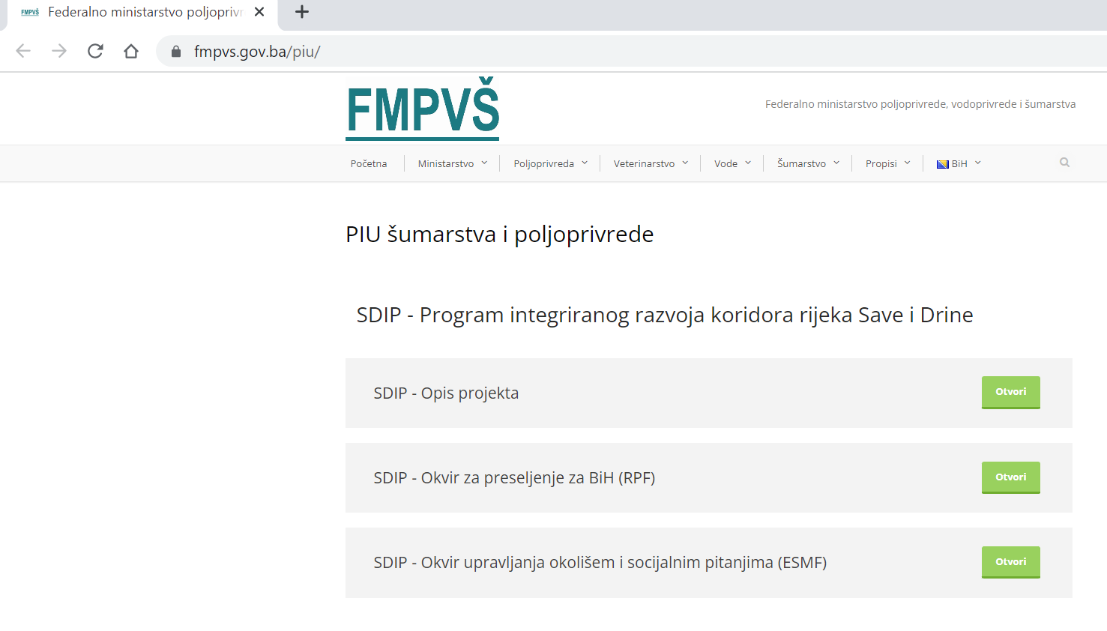

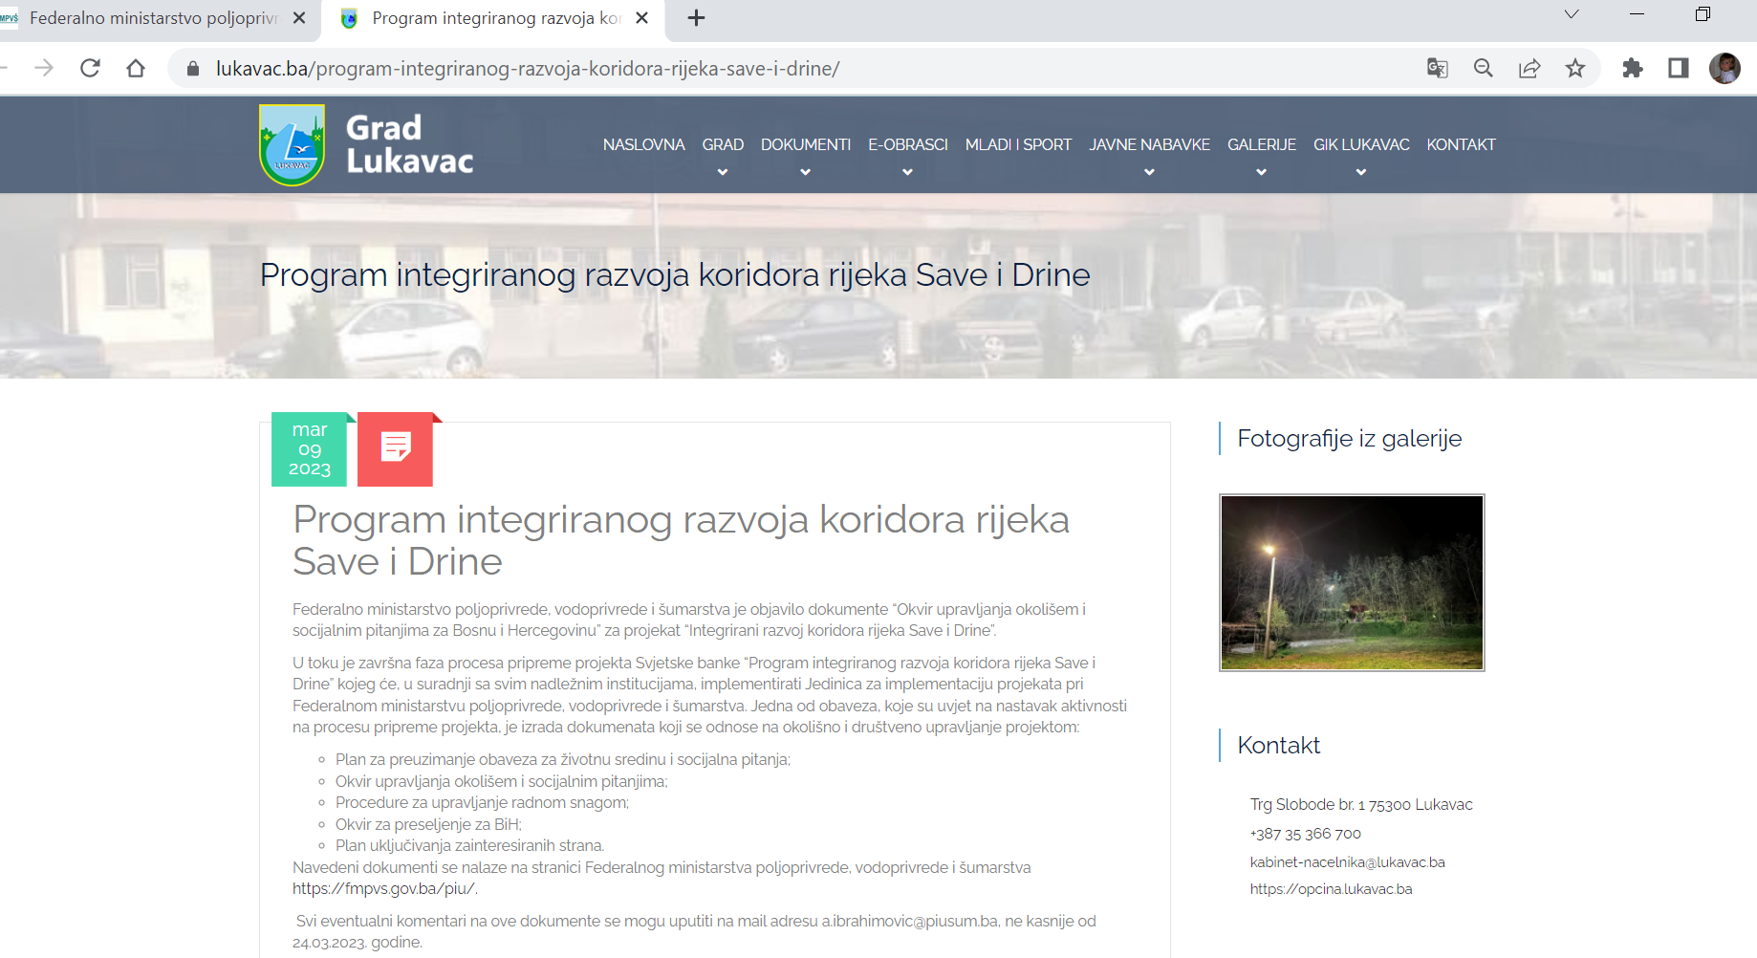

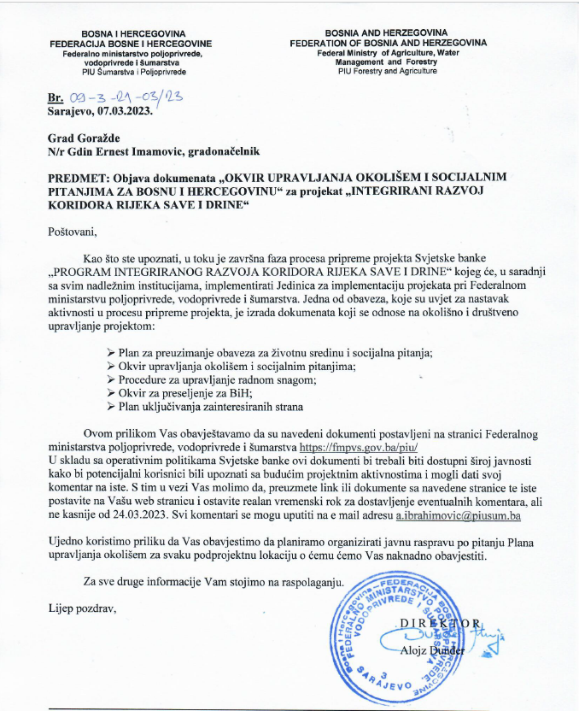

**Venue:** Hall of the Assembly of the Brčko District of BiH

**Date:** March 16, 2023

**Time:** 10:00 hr

**Organizer:** The unit for the implementation of projects financed from international funds of the Development and Guarantee Fund of the Brčko District of BiH

REPORT ON THE PUBLIC HEARING

The unit for the implementation of projects financed from international funds of the Development and Guarantee Fund of the Brčko District of BiH, for the needs of the "Project of Integrated Development of the Sava and Drina River Corridor", financed by the World Bank, is on March 16, 2023, from 10:00 a.m. to 12:00 p.m., in hall of the Assembly of the Brčko District of BiH, organized a public debate on the framework as follows:

1. Environmental and Social Management Framework – ESMF
2. Resettlement Framework – RPF
3. Stakeholder Engagement Plan – SEP
4. Environmental and social commitment plan ESCP
5. Labor Management Procedure – LMP

The aforementioned documents were available to citizens and interest groups on the website of the Government of Brčko District BiH and on the website of the Development and Guarantee Fund of Brčko District BiH www.rgfbd.com from 02.03.2023. years. until March 16, 2023, i.e. 14 days.

Eleven citizens and representatives of institutions (1 woman and 10 men) participated in the public debate, who had suggestions and comments on the documents presented as follows:

1. From BiH MAC, they suggested the accuracy of the data on demined areas of the Sava bank. Of the 9.9 million square meters of mine-contaminated areas of the Sava coast, that area of the BiH coast now amounts to 6,534,000 square meters. The number of unrealized demining projects was reduced from 144 to 94. The area along the Sava coast through the Brčko district includes 7 projects, which cover an area of 553,333 square meters, and whose implementation is scheduled for 2024.

2. From the Institute for Planning, Projecting and Development of the Brčko District, they pointed out the need to clearly state in the documents, in accordance with the Laws in the Brčko District, what is whose jurisdiction. And that the Department for Urbanism and Spatial Planning is the "Worker", while the Institute for Planning, Designing and Development of the District is the "Producer of Spatial Planning Documentation".

The minutes were drawn up by the representatives of the Project Implementation Unit of the Brčko District of Bosnia and Herzegovina.

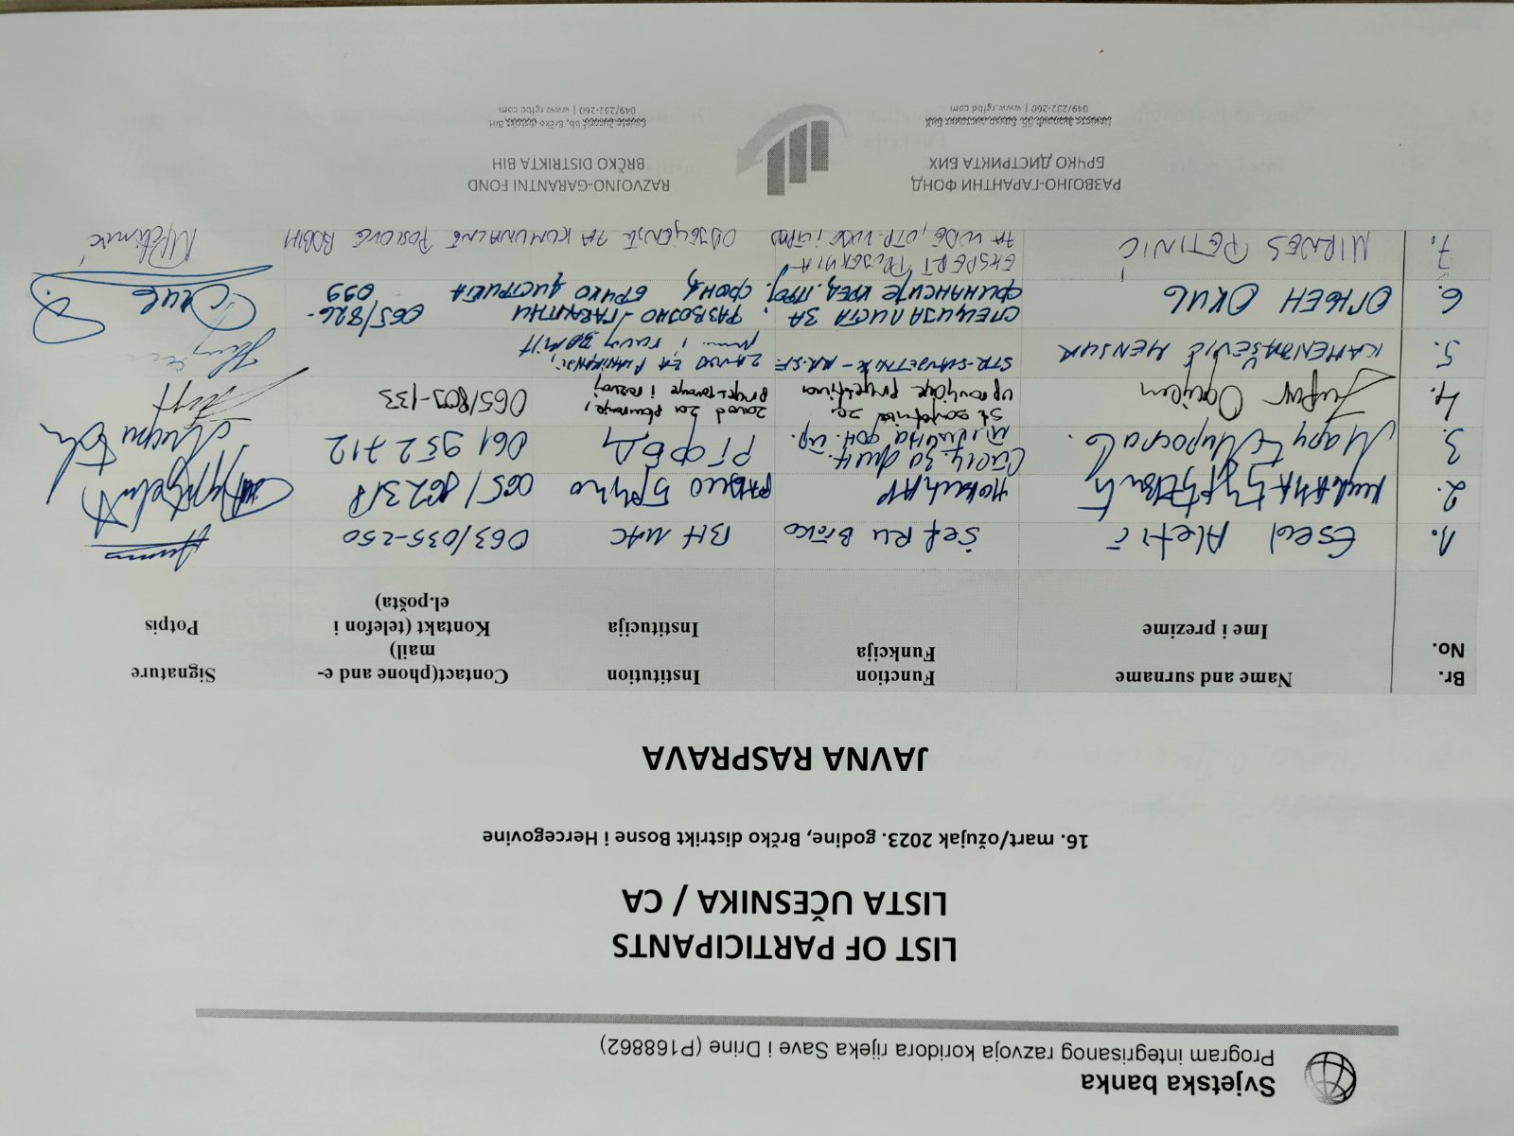

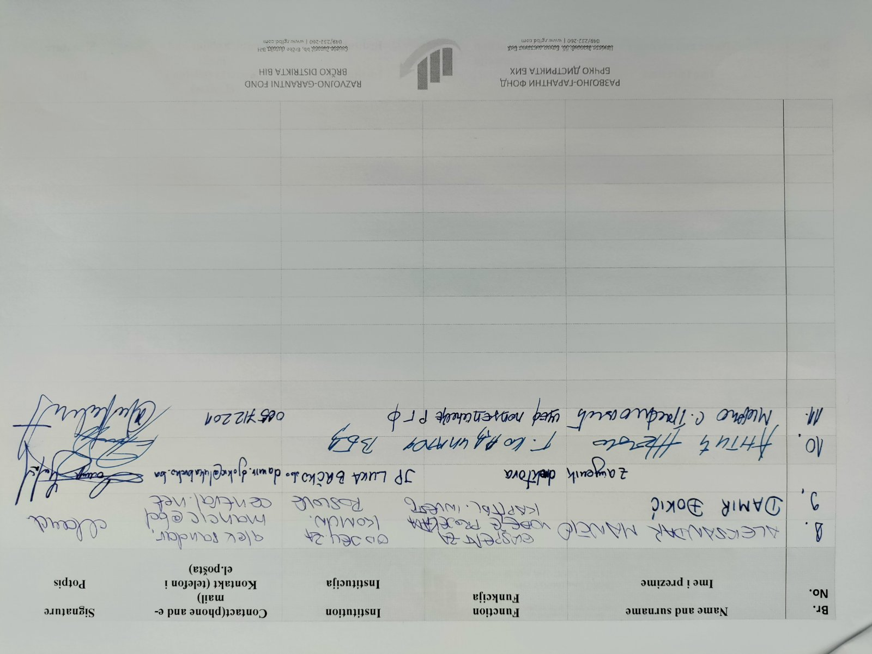

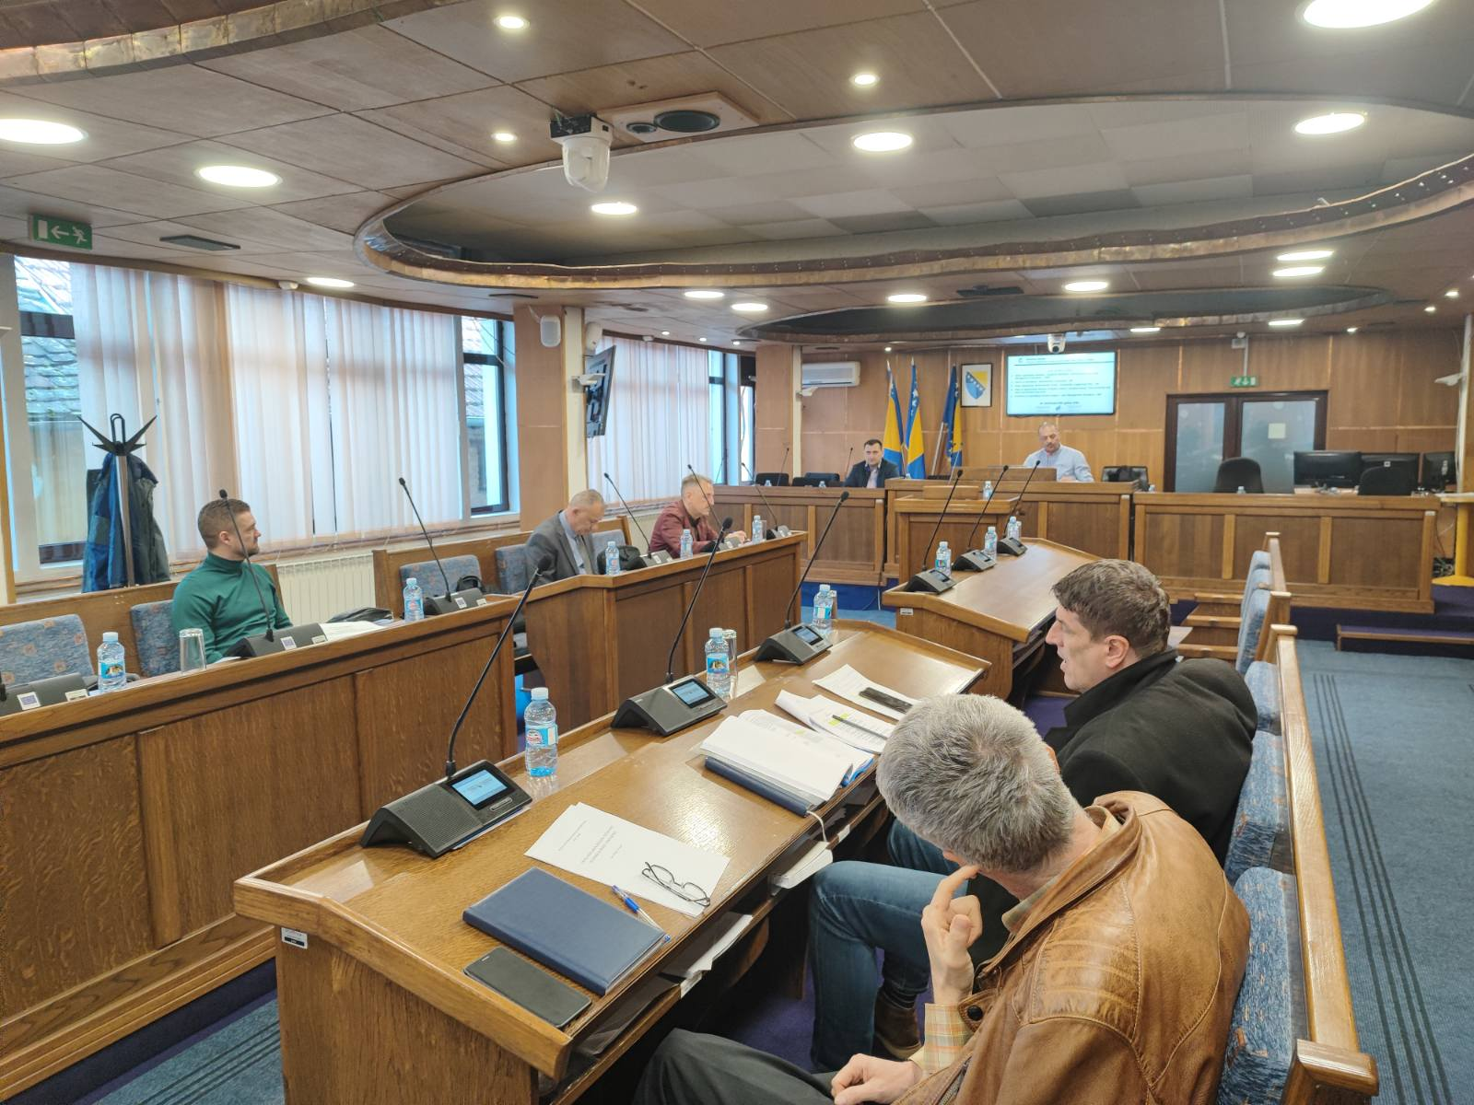

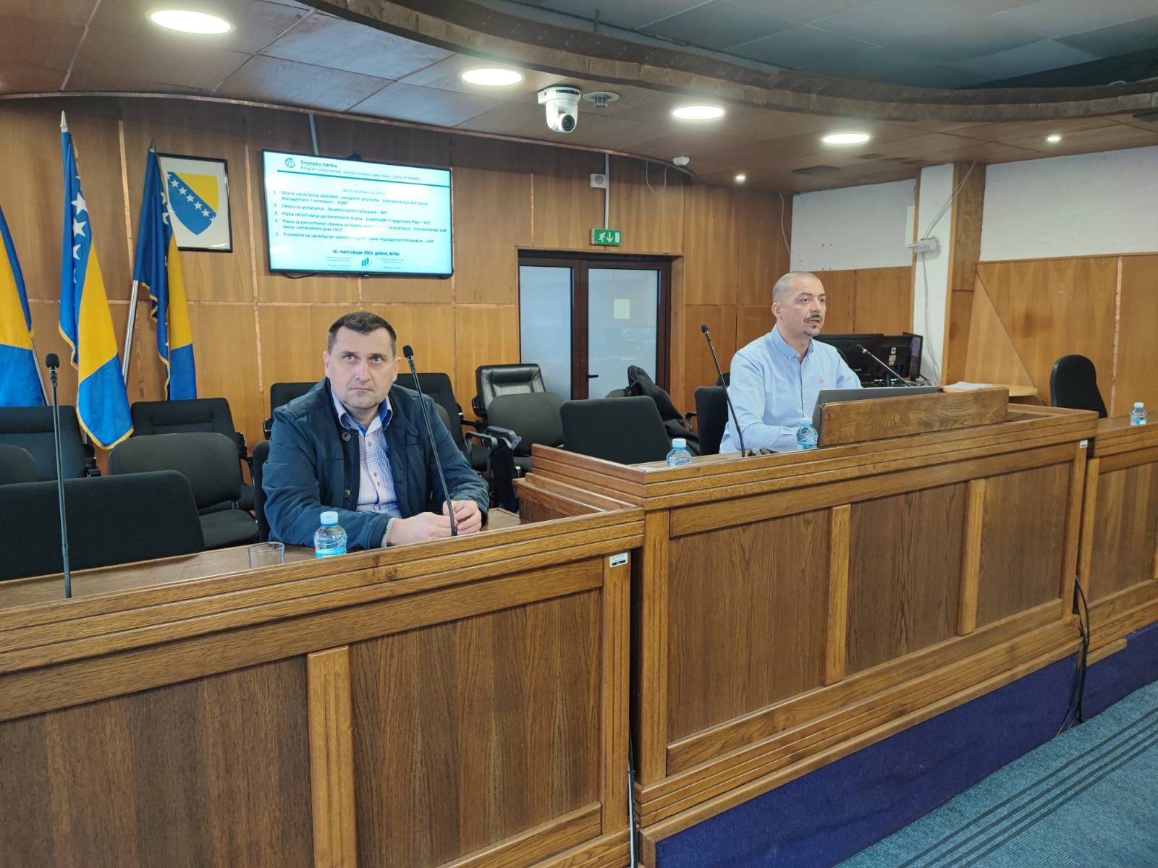

1. Available in English at: <http://pubdocs.worldbank.org/en/837721522762050108/Environmental-and-Social-Framework.pdf>
2. Agreed in 1995 between the parties to the General Framework Agreement for Peace in BiH, i.e. the Dayton Peace Agreement
3. Official Gazette of FBiH, No. 70/07, 36/10, 25/12, 34/16
4. Article 47: “Personal and other family conditions of the previous owner of the expropriated real property shall be taken into consideration as a corrective for an increase in the amount of determined compensation if those conditions are of great importance for the subsistence of the previous owner, and in particular if his/her subsistence has been endangered due to the expropriation of a larger part or the entire land or business premises in which the previous owner legally performed a business activity, as well as in the case where due to the expropriation members of an agricultural household have to move from the territory where they had lived.”
5. Official Gazette of FBiH, No. 66/13, 100/13
6. Official Gazette of FBiH, No. 52/09
7. Official Gazette of FBiH, No. 67/05
8. Official Gazette of FBiH, No. 2/98, 48/99
9. Official Gazette of FBiH, No. 19/03, 54/04
10. Official Gazette of FBiH, No. 39/04, 73/05
11. Official Gazette of FBiH, No. 36/99, 54/04, 39/06, 14/09, 45/16 and 40/18
12. Official Gazette of RS, No. 112/06, 37/07, 110/08, 79/15
13. Administrations for Ownership Affairs are the Regional Units of the RS Administration for Geodesy and Legal Ownership Affairs in charge of expropriation.
14. Official Gazette of RS, No. 124/ 08, 58/09, 95/11 and 60/15
15. Official Gazette of RS, No. 40/13, 106/15 and 3/16
16. Official Gazette of RS, No. 93/06, 86/07, 14/10, 05/12 and 58/19
17. Official Gazette of RS, No. 62/18
18. Official Gazette of RS, No. 36/09, 91/16
19. Official Gazette of RS, No. 13/02, 50/10, 66/18
20. Official Gazette of RS, No. 67/03, 46/04, 109/05, 119/08
21. Official Gazette of RS, No. 6/12, 110/16, 62/18
22. Official Gazette of RS, No. 37/12, 90/16
23. Official Gazette of BD, no. 26/04, 19/07, 02/08, 19/10, 15/11 and 18/18
24. The Directorate of Finance of BD is the only institution responsible for assessing the market value of the property, updating the market value of all properties, and estimating the new value of the property when the intended use of the property has changed, the property has undergone significant changes in market value or when the property has suffered damage, in accordance with the *Guidelines on Prescribing Uniform Standards for Estimating the Market Value of Real Estate in Brcko District (2010).*

    Compensation is further regulated in more detail by the *Rulebook on the Manner of Determining the Amount of Compensation during Expropriation* (2012), which states that the market value of property is determined in the amount of the market price of the same property in the same or similar area. The market price consists of the average sales price achieved in the supply and demand conditions at the time the price is determined. A committee for determining the amount of compensation in the expropriation process is appointed by the Mayor at the proposal of the Directorate of Finance.
25. Official Gazette of BD, No. 11/01, 08/03, 40/04 and 19/07
26. Official Gazette of BD, No. 02/12, 31/13 and 48/18
27. Official Gazette of BD, No. 19/07 and 23/19
28. Official Gazette of BD, No. 29/08 and 18/17
29. Official Gazette of BD, No. 1/03, 4/04, 19/07, 2/08
30. Official Gazette of BD, No. 21/03, 3/04, 29/04, 19/07 and 54/18
31. Reduced market value represents a decrease in value of real estate due to establishment of right of way by the expropriation beneficiary, and is determined on a case-by-case basis. It is paid in the form of cash compensation defined by an official court expert.