SAVA AND DRINA RIVERS CORRIDORS INTEGRATED DEVELOPMENT PROJECT

LABOR MANAGEMENT PROCEDURE

FOR BOSNIA AND HERZEGOVINA

February 2020/July 2022

Table of Contents

1 OBJECTIVES AND PURPOSE OF THE LABOR MANAGEMENT PROCEDURE 4

1.1 Introduction 4

1.2 Public consultations on the LMP 5

2 OVERVIEW OF LABOR USE ON THE PROJECT 7

2.1 Categories of Workers according to World Bank Categorization 7

2.2 Project Workers 8

2.3 Timing of Labor Requirements 9

3 ASSESSMENT OF KEY POTENTIAL LABOR RISKS 10

4 BRIEF OVERVIEW OF LABOR LEGISLATION IN FBIH, RS AND BD AND ASSESSMENT OF THE NATIONAL FRAMEWORK 12

4.1 Conventions of the International Labor Organization 12

4.2 Labor Legislation in FBiH, RS and BD 14

4.3 Legislation on Protection and Safety at Work in FBiH, RS and BD 20

5 RESPONSIBLE STAFF 25

6 POLICIES AND PROCEDURES 26

7 AGE OF EMPLOYMENT 27

8 TERMS AND CONDITIONS 28

9 GRIEVANCE MECHANISM 29

10 CONTRACTOR MANAGEMENT 31

11 PRIMARY SUPPLIERS 33

ANNEX 1 34

ANNEX 2 37

ANNEX 3 38

ANNEX 4 39

Abbreviations

|  |  |
| --- | --- |
| BD | Brcko District |
| BHMAC | Bosnia and Herzegovina Mine Action Center |
| BiH | Bosnia and Herzegovina |
| ESSs | Environmental and Social Standards of the World Bank |
| FBiH | Federation of Bosnia and Herzegovina |
| GBV | Gender-based violence |
| ILO | International Labor Organization |
| LMP | Labor Management Procedure |
| PIUs | Project Implementation Units |
| RS | Republika Srpska |
| SOP | Standard Operating Procedure |

# OBJECTIVES AND PURPOSE OF THE LABOR MANAGEMENT PROCEDURE

## Introduction

The World Bank (WB) as a trusted partner aims to provide financing through a multiphase program approach to the Government of Bosnia and Herzegovina (BiH)[1] for the implementation of the BIH part of the first phase of the Sava and Drina rivers corridors integrated development program (hereinafter referred to as: The Project). The Development Objective of the Sava and Drina Rivers Corridors Integrated Development Project (Phase 1 of the Program) is to improve flood protection, and enable transboundary water cooperation in the Sava and Drina river corridors.

The project is designed as an Investment Project Financing (IPF) and as such needs to comply with the World Bank’s Environmental and Social Framework (2016) (ESF) comprising, inter alia, the Environmental and Social Standards (ESS)[2].

The Framework specifies the mandatory requirements in the form of 10 standards that borrowers must apply.

One of those 10 standards is the Environmental and Social Standard 2 (“ESS2“) which addresses labor and working conditions. This standard recognizes the importance of employment creation and income generation in the pursuit of reducing poverty and inclusive economic growth. By treating workers fairly and providing safe and healthy working conditions, borrowers can promote sound worker management relations and enhance the development benefits of a project.

Objectives of ESS 2 are the following:

* to promote safety and health at work.
* to promote the fair treatment, non-discrimination and equal opportunity of project workers.
* to protect project workers, including vulnerable workers such as women, persons with disabilities, children (of working age, in accordance with this ESS) and migrant workers, contracted workers, community workers and primary supply workers, as appropriate.
* to prevent the use of all forms of forced labor and child labor.
* to support the principles of freedom of association and collective bargaining of project workers in a manner consistent with national law.
* to provide project workers with accessible means to raise workplace concerns.

Under ESS2, borrowers are required to develop and implement written labor management procedures (“LMP”) applicable to the project. The purpose of the LMP is to facilitate planning for the project and help identify the resources necessary to address the labor issues associated with the project. The LMP help to (a) identify the different types of project workers that are likely to be involved in the project, and (b) set out the ways of meeting the requirements of ESS2 that apply to the different types of workers.

In response to the commitment of the Government to comply with the ESF, the Government has developed these Labor Management Procedure (LMP), laying out the Project’s approach to meeting the objectives of World Bank ESS 2: Labor and Working Conditions (ESS2). It sets out the terms and conditions for employment or engagement of workers on the project, specifies the requirements and standards to be met and the policies and procedures to be followed, assesses risks and proposes the implementation of compliance measures and promotes fair treatment, nondiscrimination and equal opportunity of project workers. The LMP is developed to help avoid, mitigate and manage risks and impacts in relation to project workers and set out the way in which project workers will be managed, in accordance with the requirements of national law and the ESS2. The procedures address the way in which both standards will apply to different categories of project workers including direct workers, and the way in which third parties will manage their workers compliant to this document.

This procedure was developed on the basis of the Bank’s requirements, as well as the current domestic legislation in FBiH, RS and BD. The non-binding template provided by the World Bank was used for developing the procedure. The procedure will be updated as necessary in the course of Project preparation, development and implementation. Supplementing and updating of the procedure shall also be performed in case the domestic legislation changes in any aspect of importance for this Procedure.

## Public consultations on the LMP

The set of documents that will guide the further E&S due diligence during sub-project implementation based on the 2018 WB E&S Framework including:

* this Labor Management Plan (LMP)
* the Resettlement Framework (RPF)
* the Environmental and Social Management Framework (ESMF)
* the Environmental and Social Commitment Plan (ESCP)
* the Stakeholder Engagement Plan (SEP) and

was disclosed to the public on December 31, 2019 through the website of the Ministry of Agriculture and Rural Development (link: <http://www.vladars.net/sr-SP-Cyrl/Vlada/Ministarstva/mps/Pages/default.aspx#collapsible1> under the link „Јединица за координацију пољопривредних пројеката -набавке“).

On January 22, 2020, the PIU announced that the public hearing took place on January 29, 2020 in the City of Banja Luka. The invitations were sent to 20 local self-governments in the Sava and Drina River Basins (Banja Luka, Prijedor, Kostajnica, Milići, Doboj, Laktaši, Bijeljina, Šamac, Zvornik, Višegrad, Foča, Šamac, Modriča, Kozarska Dubica, Derventa, Gradiška, Čelinac, Brod, Kotor Varoš, Novi Grad). 10 local self-governments officially confirmed the receipt of the invitation and their participation. They also published documents on their webpages.

The revised LMP, as of July 2022, has been disclosed on the websites of Brcko District, Federation BiH and the BIH MCT websites in early March 2023 following a similar procedure on public consultations to those that were carried out in January 2020. The LMP has been updated to reflect the conclusions of the consultations, written comments received, and to include the updated version of the Minutes of Meeting and list of participants. A public hearing has been organized in Brcko on March 16, 2023, while targeted invitations and notifications have been sent to the key counterparts. It is important to note that the FBIH PIU has had long standing consultations and stakeholder engagement on previous projects in the anticipated project areas and on specific project sites, so for those municipalities a kind request was sent in writing for providing comments, if any on the Framework set of documents.

This LMP has been updated to include the outcomes of the public consultation process, which focused on the project components and providing more clarity on the scope, with no actual comments or questions on the environmental and social risk management.

The minutes from the public hearing with an accompanying list of participants and photographs is included in Annex 4.

# OVERVIEW OF LABOR USE ON THE PROJECT

## Categories of Workers according to World Bank Categorization

ESS2 identifies the following categories of workers on a project:

Direct workers

People employed or engaged directly by the Borrower (including the project proponent and the project implementing agencies) to work specifically in relation to the project. Therefore, a “direct worker” is a worker with whom the Borrower has a directly contracted employment relationship and specific control over the work, working conditions, and treatment of the project worker. The worker is employed or engaged by the Borrower, paid directly by the Borrower, and subject to the Borrower’s day-to-day instruction and control. Examples of direct workers may include persons employed or engaged by the Borrower’s project implementation unit to carry out design and supervision, monitoring and evaluation, or community engagement in relation to the project.

Contracted workers

People employed or engaged through third parties to perform work related to core functions of the project, regardless of location, are referred to as contracted workers. Therefore, a “contracted worker” is a worker employed or engaged by a third party to perform work or provide services related to the core functions of the project, where the third-party exercises control over the work, working conditions, and treatment of the project worker. In such circumstances, the employment relationship is between the third party and the project worker, even if the project worker is working on an ongoing basis on project activities.

Primary supply workers

People employed or engaged by the Borrower’s primary suppliers are referred to as primary supply workers. Therefore, a “primary supply worker” is a worker employed or engaged by a primary supplier, providing goods and materials to the project, over whom a primary supplier exercises control for the work, working conditions, and treatment of the person.

Community workers

People employed or engaged in providing community labor are referred to as community workers. The type of projects in which community workers are involved can vary considerably in terms of complexity, duration, and type of work; number of workers involved; types of project benefits, and the way in which ESS2 applies to the participation of community workers. Examples range from projects where the objective is to construct small-scale community infrastructure to regional or national projects designed to provide a social safety net to address unemployment or underemployment. The application of ESS2 to such projects is designed to address the relevant risks and impacts in a proportionate manner, tailored to the specific context, objectives, and design of the project.

## Project Workers

Within the framework of this Project, in the category of **direct workers**, there are:

* staff from the involved BiH, FBiH, RS and BD level ministries that are involved in the project (civil servants) and
* any external consultants that would be engaged for the Project.

For civil servants involved in Project operations, regardless of whether they work full time or part time, terms and conditions of their existing contracts or appointments in the public sector shall apply. When engaging external consultants, provisions of national legislation on work engagement shall apply, in parallel with compliance with requirements of this Labor Management Procedure.

The category of **contracted workers** includes the workers of contractors and service providers to be engaged in civil works for needs of subprojects. It is possible that the contractor will engage multiple subcontractors and in such cases the subcontractors’ workers will be also considered as contracted workers.

The table below provides data on the basis of preliminary assessment at the time of preparing this LMP. Data in the table below shall be updated by the PIUs subsequently, after more precise data on engaged direct workers and contracted workers become known.

| Type of workers | Number of project workers[3] | Type of tasks | Necessary skills | Location |
| --- | --- | --- | --- | --- |
| Direct workers | 18 | Office and administrative tasks | Essential managerial skills | Sarajevo and Mostar (FBiH ministries), Banja Luka (RS ministries) and Brcko (BD ministries) |
| External consultants for PIUs | 7 | Office consulting tasks | Knowledge in the area of environmental and social issues relevant for the Project  Knowledge in the area of demining activities on land and under water  Communication skills | Sarajevo, Banja Luka and Brcko, but also from entire BiH |
| Contracted workers | approx. 110 (BD)  approx.25 (FBiH)  approx.200 (RS) | Office and field tasks | Advanced technical skills including demining skills  Communication skills for project managers | From entire BiH |

Given the nature of the Project and construction needs (supply of various materials such as crushed stone, geotextile, sand, gravel, etc.) it might happen that **primary suppliers are engaged**. Although these impacts are not subject to ESS2 it will be looked through ESS1 and ESS2, and relevant management plans (i.e. the Project level ESMF, sub-project ESMPs and any Contractors management plan as required by the ESMF). The extent in which primary supply workers will contribute in the projects pool of workers, including the assessment whether supply of goods and/or materials will be on an ongoing basis to the project essential to the core function of the project to qualify as primary suppliers is at this point at a best estimate considering the type of supply needs for construction/rehabilitation works. The labor management procedures set out the procedures how potential risks of child labor, forced labor and serious safety issues which may arise in relation to primary suppliers will be identified including roles and responsibilities for monitoring primary suppliers.

According to World Bank definitions, there are **no other categories of workers** on this Project. Taking into consideration the nature of the sub-projects it is expected that the number of female workers will be in the region of 5-10 percent of the workers. Women workers will most likely be engaged as technical staff (engineers) and administration staff.

## Timing of Labor Requirements

It is expected that the first Contract for construction works will be awarded by February 2020. Each sub-project will be subject to a separate tendering procedure, separate contracts and formation of teams. Each contract will be managed separately in terms of labor and working conditions. The majority of skilled and unskilled workers are likely to come from local and wider communities, while managerial and technical staff might come from entire BiH and the contractor’s home country. Tasks such as land clearing, foundation excavation and installation, land restoration, tree cutting, etc. will be done by unskilled and semiskilled workers, while skilled workers will be engaged as managers, engineers, equipment and driver operators, electrical workers.

# ASSESSMENT OF KEY POTENTIAL LABOR RISKS

**Project activities**

It is expected that the greater number of sub-projects will be implemented on the Sava and Drina Rivers. The implementation of these sub-projects mainly includes construction and rehabilitation of embankments for flood protection, reforestation, demining activities along the Sava’s right bank to increase the navigational capacity of Sava river. Typical activities of such sub-projects include the following:

* clearance of right of way;
* construction of access roads (wherever required);
* land-clearing and construction of foundation;
* major equipment installation;
* soil stabilization;
* laying of crushed stone over geotextile layer;
* embankment stabilization;
* dredging;
* cutting trees and high vegetation;
* demolition of buildings;
* working in/near and over water;
* reinstatement and revegetation of impacted areas;
* mechanical excavation (removing of soil and overgrown vegetation from suspected areas for inspection of mines).

**Key Labor Risks**

It is assessed that key labor risks would be associated with health and safety risks related to the construction activities of sub-projects such as exposure to physical hazards during construction activities: works on river banks with high speed currants, use of heavy equipment, trip and fall hazards, exposure to hazardous materials and electrical hazards from the use of tools and machinery. Since the construction and demining activities will involve hazardous work, persons under the age of 18 will not be employed by the Project.

It is expected that **direct workers** (PIUs and external consultants) within the framework of the Project would perform office operations primarily, in addition to occasional visits to subproject locations on the part of the consultants, so that the risks upon the health and safety of those workers are minimal or negligible. The risks in relation to work in civil service and consultant business are, in general, very small in BiH (for example, irregular payment of compensation for work, informal labor or labor of minors are not practiced).

It is anticipated that the workers (**contracted workers**) will be exposed to occupational health and safety hazards, primarily including but not limited to:

* stringing works;
* working at height;
* working in/near water;
* excavations hazards;
* lifting of heavy structures;
* chain saws and treefall during timber cutting;
* exposure to dust and odor;
* working on steep and treacherous terrain;
* working near or on roads with live traffic;
* electrical works;
* steel erection hazards;
* during demining: wearing heavy equipment, loss of concentration, exposure to excessive heat and humidity, working in a semi-squatting position.

No other labor risks are considered to be significant. The Project is assessed as low on gender-based violence (GBV) risk. If other labor risks arise during sub-projects implementation, this procedure will be appropriately amended to prevent further impacts.

# BRIEF OVERVIEW OF LABOR LEGISLATION IN FBIH, RS AND BD AND ASSESSMENT OF THE NATIONAL FRAMEWORK

## Conventions of the International Labor Organization

Bosnia and Herzegovina has been a member of the International Labor Organization (ILO) since June 1993. In BiH there are in effect eight fundamental conventions and four priority conventions. The eight fundamental conventions include the following:[4]

* Convention on Forced Labor, dating from 1930.
* Convention on Trade Union Freedoms and Protection of Trade Union Rights, dating from 1948.
* Convention on Application of Principle of Right to Organize and Collectively Negotiate, dating from 1949.
* Convention on Equal Awards to Male and Female Labor Force for Work of Equal Value, dating from 1951.
* Convention on Prohibition of Forced Labor, dating from 1957.
* Convention on Discrimination in Regard to Employment and Occupation, dating from 1958.
* Convention on Minimum Age for Entering into Labor Relations, dating from 1973.
* Convention on Worst Forms of Abuse of Child Labor, dating from 1999.

The priority conventions that BiH has also ratified are the following:

* Convention on Labor Inspection, dating from 1947.
* Convention on Employment Policy, dating from 1964.
* Convention on Labor Inspection (Agriculture), dating from 1969.
* Convention on Tripartite Consultations (International Labor Standards), dating from 1976.

The other ratified conventions are the following:

* Convention on Unemployment, dating from 1919.
* Convention on Right to Association (Agriculture), dating from 1921.
* Convention on Worker Indemnity (Agriculture), dating from 1921.
* Convention on Use of Poisonous Bleach (in Coloring), dating from 1921.
* Convention on Worker Indemnity (in Case of Accidents), dating from 1925.
* Convention on Workers’ Compensation for Occupational Diseases, dating from 1925.
* Convention on Equal Treatment (Indemnity in Case of Accident), dating from 1925.
* Convention on Insurance in Case of Illness (Agriculture), dating from 1927.
* Convention on Employment Services, dating from 1948.
* Convention on Nighttime Work of Women, dating from 1948.
* Convention on Nighttime Work of Youth / Children (Industry), dating from 1948.
* Convention on Social Insurance (Minimum Standards), dating from 1952.
* Convention on Weekend Rest (Trade and Administration), dating from 1957.
* Convention on Determination of Minimum Salaries, dating from 1970.
* Convention on Paid Annual Holidays, dating from 1970.
* Convention on Workers’ Representatives, dating from 1971.
* Convention on Occupational Cancerous Diseases, dating from 1974.
* Convention on Paid Leave for Expert Education Purposes, dating from 1974.
* Convention on Human Resource Development, dating from 1975.
* Convention on Work Environment (Air Pollution, Noise and Vibrations), dating from 1977.
* Convention on Promotion of Collective Bargaining, dating from 1981.
* Convention on Safety and Protection of Health at Work, dating from 1981.
* Convention on Termination of Labor Relations, dating from 1982.
* Convention on Professional Rehabilitation and Employment of Persons with Disabilities, dating from 1983.
* Convention on Labor Medicine Services, dating from 1985.
* Convention on Prevention of Larger Industrial Accidents, dating from 1993.
* Convention on Part-time Work, dating from 1994.
* Convention on Safety and Health in Mines, dating from 1995.
* Convention on Protection of Motherhood, dating from 2000.
* Convention on Safety and Protection of Health in Agriculture, dating from 2001.
* Convention on Promotional Framework for Occupational Safety and Protection of Health at Work, dating from 2006.
* Convention on Maritime Labor, dating from 2006.

Additionally, Bosnia and Herzegovina ratified the Convention on Anti-Personnel Mine Ban Convention 1998, and the Convention entered into force 1999.[5]

## Labor Legislation in FBiH, RS and BD

The legislation from the area of labor relations in BiH is in exclusive competence of the two entities and BD. The text below provides a review of labor laws of FBiH[6], RS[7] and BD[8], wherein key aspects of the domestic legislation on the treatment of different categories of workers are presented separately.

| Key aspects of the Law | Federation of BiH | Republika Srpska | Brcko District |
| --- | --- | --- | --- |
| Entering into a labor relation | A labor relation shall be initiated by concluding a contract on labor. The contract shall be concluded in writing and shall contain a list of data prescribed under the Labor Code. | A labor relation shall be initiated by concluding a labor contract, a decision on recruitment, a decision on selection and appointment or other legal grounds regulated under a special law.  A labor contract shall be concluded in writing and shall contain a list of data prescribed under the Labor Code. | A labor relation is based on the conclusion of a labor contract.  An employment contract must be concluded in writing. |
| Rights of workers | A worker shall have the right to:   * + a fair salary,   + conditions of work that ensure safety and protection of life and health at work,   + special protection in case of illness, reduction or loss of capacity to work and old age;   + full compensation of salary for the period of annual holidays, official holidays, temporary inability to work due to injury at work or occupational disease, as well as during interruption in work caused by oversight on the part of the employer   + compensation of salary for period of absence from work,   + severance payment if he has a permanent labor contract. | A worker shall have the right to:   * + safety and protection of life and health at work;   + health protection;   + protection of personal integrity;   + special protection in case of illness, reduction or loss of capacity to work and old age;   + full compensation of salary for the period of annual holidays, official holidays, temporary inability to work due to injury at work or occupational disease, as well as during interruption in work caused by oversight on the part of the employer.   + severance payment if he has a permanent labor contract. | A worker shall have the right to:   * an increased salary for overtime or nightwork, and for work on Sundays or public holidays or any other day legally defined as non-working day; * use annual holidays; * in case of termination of an employment contract, an employer may pay an employee compensation for the days of unused annual holiday; * to conclude several part-time contracts in order to achieve full-time employment. |
| Obligations of workers | Obligations of workers shall be the following:   * + to perform the tasks taken over, comply with organization of work and business operations of the employer,   + when concluding a labor contract or in the course of the duration of the labor relation, inform the employer of any disease or other circumstances that are distracting him in execution of obligations under the labor contract,   + educate oneself and develop oneself for work in compliance with one’s capacities and requirements of work. | Obligations of workers shall be to:   * + conscientiously and responsibly perform tasks,   + comply with organization of work and business operations of the employer,   + inform the employer of important circumstances that affect or could affect performance of tasks stipulated under the labor contract,   + inform the employer of potential hazards to life and health and onset of tangible damages,   + subject himself to health examinations and assessment of labor capacity upon request of the employer. | Obligations of employees shall be the following:   * to inform an employer of any invention or technical improvement to whom the employee came during his/hers work; |
| Obligations of employer | Obligations of the employer shall be the following:   * + to register workers for pension and disability insurance, health insurance and insurance in case of unemployment,   + after registration for mandatory insurance, to serve the worker with a photocopy of the registration as well as any other change in insurance that concerns the worker. | Obligations of the employer shall be to:   * + register the worker to the Single system and serve a copy of the registration to him;   + serve the identification document of the worker to the worker when initiating work;   + pay salary to the worker for the work performed;   + ensure conditions of work and organize work for the purpose of safety and protection of life and health at work;   + inform the worker of obligations resulting from regulations on labor and regulations on safety and protection of life and health at work;   + ensure that the worker can perform the tasks stipulated under the labor contract;   + collectively insure all workers in case of accident at work. | Obligations of the employer shall be to:   * to pay salaries in cash; * provide a worker with a written employment contract which states all the conditions at the latest on the day the worker starts to work; * to register a worker for pension and health insurance; * provide an employee with a written salary calculation; * in writing explain the dismissal to an employee; * an employer cannot terminate an employment contract of an employee who suffered an injury at work or occupational disease while temporarily unable to work; |
| Prohibition of discrimination | Discrimination of workers and job seekers is prohibited, in regards to sex, sexual orientation, marital status, family obligations, age, disability, pregnancy, language, religion, political and other opinions, ethnic origin, social origin, financial status, birth, race, skin color, membership or lack of in political parties and trade unions, health status, or any other personal characteristic. | A worker, as well as a job seeker, cannot be placed in an unequal position when realizing rights on the basis of labor and right to employment because of his race, ethnic or national origin, skin color, sex, language, religion, political or other opinion and affiliation, social origin, financial status, membership or lack of in a trade union or a political organization, physical and mental health and other characteristics that are not in a direct relation with the nature of the labor relation. | Discrimination of a job seeker and worker is prohibited, in regard to race, skin color, sex, language, religion, political opinion, ethnic and social origin, financial status, sexual orientation, membership and non-membership in a political party and trade union, physical and mental health issues. |
| Employment of women | Provisions of this Law for women prescribe the following:   * + that they cannot be employed on tasks underground (in mines) except if it concerns a managerial position that does not require physical labor or in services of health and social protection;   + that pregnancy and use of maternity leave cannot be a reason for employment of women;   + that a labor contract of a woman cannot be cancelled after the expiry of the maternity leave, woman with child at least up to age 1;   + that a woman whose labor contract with limited duration expires during maternity leave or a pregnant woman whose labor contract expires shall not be deemed to have had her labor contract cancelled. | Employers are prohibited:   * + to condition employment of a woman worker with a pregnancy test, except if the enactment on risk assessment determines that it concerns tasks in which there is a risk upon health of the woman and the child;   + to allow nighttime work of a woman, starting from the 6th month of pregnancy and of mothers with children up to 2 years of age;   + to not employ a woman because of pregnancy;   + to cancel a labor contract because of pregnancy or maternity leave. | Provisions of this Law for women prescribe the following:   * that they cannot be employed on tasks underground (in mines) except if it concerns a managerial position that does not require physical labor or in services of health and social protection; * pregnancy and use of maternity leave cannot be a reason for termination of employment of women; * a woman must be assigned to other jobs during pregnancy or breastfeeding if it is in the interest of her medical condition; |
| Employment of persons of age 15 to 18 | A labor contract can be concluded in exceptional cases with a person who is 15 to 18 years of age, pending consent of the legal representative and a health certificate that proves that the person is health-wise capable of work.  This category of workers cannot work for longer than 35 hours per week, work overtime, in nighttime and on especially hard manual tasks, work underground or under water etc. | A labor contract can be concluded in exceptional cases with persons who are 15 to 18 years of age, pending written consent of the legal representative, if such work does not jeopardize his health, ethic and education and on the basis of findings of a competent health institution which determines health capacity of workers for work and if those tasks are not harmful to his health.  This category of workers cannot work in nighttime, on jobs for which it is determined that they carry increased risk or that they involve especially hard manual tasks, in workplaces that are underground or under water, on other tasks that could carry increased risk upon his life, health and psychological and physical development. | An employment contract can be concluded with a person who is 15 years of age, pending consent of the legal representative and a health certificate that proves that the person Is health-wise capable of work.  This category of employees can work at night article 55 of the Law, the night work for minor is considered between 19.00 h and 07.00 of the following day.  A minor employee shall be entitled to annual leave of at least 24 working days. |
| Working hours | Full working hours amount to 40 hours per week and they can be allocated to max. six working days. | Full working hours amount to 40 hours per week and cannot be shorter than 36 hours per week. The working week lasts 5 working days, while the working day lasts 8 hours. | Full working hours amount to 40 hours per week. |
| Overtime work | Overtime work (up to 8 hours per week) is allowed in case of a sudden increase in the scope of work and in cases of force majeure.  Overtime work shall not be allowed to workers who are minors, pregnant women, mothers, i.e. adoptive parents of a child up to three years of age, as well as a single parents, single adoptive parents and persons to whom, on the basis of a decision of a competent authority, a child had been entrusted to keep and raise, up to six years of age of the child.  Workers shall be entitled to increased salary for overtime work. | Overtime work can neither last for more than 10 hours per week, nor more than 4 hours per day. A worker cannot work for more than 180 hours of overtime in the course of a calendar year.  Overtime work is not allowed to workers who are minors, pregnant women and mothers with children up to three years of age and single parents of children younger than six.  Workers are entitled to increase of salary during overtime work. | In case of force majeure or a sudden increase in workload the employer may require an employee to work up to 10 additional hours per week, so the total number of working hours per week is 50 hours (Article 50).  At the request of the employer, an employee with the written consent may work overtime for a maximum of 10 hours per week and maximum 300 hours of overtime in the course of a calendar year.  A pregnant woman, mother, adoptive parent of a child up to 1 year of age and single parent of a child of 2 years of age may work overtime, if s/he gives a written statement of voluntary consent to such work. |
| Nighttime work | Working during the hours between 22 in the evening and 6 in the morning of the next day shall be deemed nighttime work.  Nighttime work shall be prohibited to pregnant women starting from the sixth month of pregnancy, mothers and adoptive parents, as well as persons to whom, on the basis of a decision of a competent authority, a child had been entrusted to keep and raise, up to two years of age of the child. Nighttime work of workers who are minors shall also be prohibited.  Workers shall be entitled to increase of salary for nighttime work. | Working during the hours between 22 in the evening and 6 in the morning of the next day shall be deemed nighttime work.  Nighttime work shall be prohibited to workers who are minors, pregnant women, starting from the sixth month of pregnancy, and mothers with children up to two years of age.  Workers shall be entitled to increase of salary during nighttime work. | Working between 22 in the evening and 6 in the morning of the next day shall be deemed nighttime work. |
| Rest during working hours | For working longer than 6 hours a day, a worker shall be entitled to rest in the duration of at least 30 minutes. | A worker who is working full working hours or at least 6 hours a day shall be entitled to rest during working hours in the duration of 30 minutes. For overtime work, the worker shall, in addition to the rest of 30 minutes, be entitled to additional 15 minutes. | An employee who is working full working hours is entitled to rest during working hours in the duration of at least 30 minutes.  An employee may request 1-hour rest but only for one day during the work week. |
| Daily rest | A worker shall be entitled to rest between two consecutive working days (daily rest) in the duration of at least 12 hours, uninterrupted. | A worker shall be entitled to daily rest between two consecutive working days in the duration of at least 12 hours without interruptions, and for workers employed in agriculture and on seasonal tasks at least ten hours without interruptions. | All employees are entitled to rest between two consecutive working days in the duration of at least 12 hours, uninterrupted. |
| Weekly rest | A worker shall be entitled to weekly rest in the duration of at least 24 hours without interruptions. | A worker shall be entitled to weekly rest in the duration of at least 24 hours without interruptions. | An employee is entitled to weekly rest in the duration of at least 24 hours without interruptions. |
| Annual holidays | For each calendar year, a worker shall be entitled to paid annual holidays in the duration of 20 working days at least, and 30 working days at most. The right to annual holidays shall be acquired after 6 months of uninterrupted working. Annual holidays shall be used in two parts, wherein the first part shall last at least 12 days, and the second part needs to be used by June 30th of next year. | A worker shall have the right to annual holidays in the duration of at least 4 working weeks, i.e. at least 20 working days. Annual holidays can be used without interruptions, in two or more parts. The first part shall last 2 weeks, and the second part should be used by June 30th of next year. | For each calendar year, an employee is entitled to paid annual holidays of at least 18 working days.  In determining the duration of annual holidays, a work week is counted as 5 working days.  Annual holidays can be used in one or more parts.  An employer is obliged to allow an employee to use unused part of annual holiday from the previous year up to the end of June of next year.  If an employee experience adverse effects in the workplace, s/he shall be entitled to annual holidays of at least 30 working days. |
| Workers’ grievance mechanism | A worker who is of the opinion that his employer has violated any of the rights from his labor relation shall be under obligation to request from the employer to realize that right within the deadline of 30 days from the date of delivery of the decision under which his right had been violated, i.e. from the date of gaining the knowledge of the violation of the right.  Before submitting a lawsuit, the worker and the employer can agree on peaceful resolution of the dispute. If the procedure is not concluded within a reasonable deadline (not longer than 60 days) or the reconciliation process ends without success, the worker shall be entitled to initiate a lawsuit before the competent court. | A worker who is of the opinion that his employer has violated his right from labor relation can submit a written request to the employer to ensure realization of that right, within the deadline 30 days from the date of gaining the knowledge of the violation of the right, and within three months at the latest from the date on which the violation was committed.  The employer shall be under obligation to decide on the worker’s request within the deadline of 30 days from the date of submitting the request, and if it fails to decide within that deadline, it shall be deemed that the request was granted.  A worker who is of the opinion that his employer had violated a right from his labor relation can submit a proposal for peaceful resolution of the labor dispute to the competent authority or a lawsuit to the competent court for protection of that right. The lawsuit can be submitted if the subject of the dispute had not been resolved prior to that in the procedure of peaceful dispute resolution with the competent authority. | An employee who believes that his employer has violated his right from labor relation can require realization of that right from the employer.  An employee may file a lawsuit within 1 year from the date of occurrence of the violation, and within 3 years at the latest from the date on which the violation was committed.  A rulebook on internal organization may provide a procedure on peaceful resolution of the labor dispute. Solving the labor dispute parties may entrust to arbitration. |
| Freedom of association | Workers may freely form, become members in or leave a trade union based on their own free choice without any prior approval, and cannot be discriminated against on the basis of their membership or lack of in such an organization. Employers and prohibited to interfere in the establishment, functioning and provision of assistance with intent to control such a trade union. | Worker shall be entitled to organize a trade union based on their own free choice and to become members of it, i.e. cease to be members of it. His engagement in a trade union cannot place a worker in a less favorable position in regard to conditions of work and realization of rights on the basis of work. Employers are prohibited to interfere in the organization and operations of the trade union and to control its work. | Workers may freely form a trade union, become members or leave a trade union based on their own free choice. Workers cannot be discriminated against on the basis of their membership or non-membership of a trade union. |
| Safety and health at work | When a worker starts to work the employer shall be under obligation to facilitate the worker to get acquainted with regulations relating to labor relations and regulations relating to safety and health at work and shall be under obligation to acquaint him with organization of work.  Workers are entitled and are under obligation to use all measures of protection envisaged under regulations on safety and health at work and other current regulations. | An employer shall be under obligation to facilitate to the worker to get acquainted with regulations on labor relations and regulations on protection at work, within 15 days of starting to work.  A worker shall be under obligation to use, when working, appropriate means and equipment for personal protection at work and to manage the means of work in compliance with their purpose and features. | Employers are obliged to ensure that workplaces, machines, equipment and processes are safe and not hazardous to health.  In accordance with needs, employers are obliged to provide employees with protective clothing and equipment in order to protect them from possible accidents at work and negative impacts on health.  An employer shall be under obligation to facilitate to the worker to get acquainted with regulations on labor relations and regulations on occupational safety within 15 days of starting to work. |

## Legislation on Protection and Safety at Work in FBiH, RS and BD

Legislation from the area of protection and safety at work in BiH is within the scope of competence of the entities. The text below provides a review of the laws of FBiH[9], RS[10] and BD[11] in this area.

| Key aspects of the laws | Federation of BiH | Republika Srpska | Brcko District |
| --- | --- | --- | --- |
| Obligations of employers | Employers are under obligation to:   * ensure, within the framework of the development plan or a special program of measures of protection at work, necessary funds for implementation and improvement of protection at work including deadlines for their realization; * monitor continuously the correct functioning and perform periodic examinations of means of work and equipment and means for personal protection; * test physical, chemical or biological potentially harmful agents in workspaces and in auxiliary spaces in which they appear; * test the micro-climate in workspaces and auxiliary spaces in which technical and technological work processes are being performed; * keep records of periodic examinations and tests performed; * for each job, determine the conditions of work and requirements in regard to health related and psychological and physical abilities of workers; * organize tasks of protection at work; * inform the labor inspectorate of fatalities, accidents that affected two workers or more, more severe injuries or occupational diseases; * organize training from the area of protection at work and perform the test of workers’ capacities for independent and safe work on that job. | Employers are under obligation to:   * ensure within the business plan necessary funds for implementation and improvement of protection at work including deadlines for their realization; * ensure that work is performed in workplaces and an environment in which measures for protection and health at work have been implemented; * adjust the work process to the physical and psychological capacities of workers; * ensure a work environment, means of work, means and equipment for personal protection at work in such a manner that they do not jeopardize protection and health of workers and other persons; * ensure preventive measures for the purpose of protecting the lives and health of workers; * adopt an enactment on risk assessment for all the jobs in the work environment and determine the manner and measures for eliminating risks; * appoint in writing a worker to perform tasks for protection at work; * inform workers and their representative of introduction of new technologies and means for work, of dangers from injuries and damages to health that occur because of that introduction; * train workers for safe and healthy work; * ensure that workers can use means and equipment for personal protection at work; * ensure maintenance of the means of work and equipment for personal protection at work so that they are in a functional condition; * implement preventive and periodic reviews and tests of the equipment for work and conditions in the work environment; * inform the labor inspectorate and the authority for internal affairs in case of fatality, collective or more severe injury at work, as well as a dangerous occurrence that could jeopardize protection of workers’ health. | Employers are under obligation to:   * ensure within the business plan or special plan of measures of protection at work, necessary funds for implementation and improvement of protection at work including deadlines for their realization; * ensure that work is performed in workplaces and work environment in which measures for protection and health at work have been implemented; * adjust the work process to the physical and psychological capacities of workers; * ensure a work environment, means of work and equipment for personal protection at work in such a manner that they do not jeopardize protection and health of workers and other persons; * choose work and production methods that provide preventive measures for safety and health protection; * ensure preventive measures when organize work and work processes, but also before starting and during the work of workers; * adopt a risk assessment act for all workplaces in the work environment and determine the manner and measures for eliminating risks; * adopt a Rulebook on safety and health protection; * appoint in writing a worker to perform tasks for safety at work and health protection; * train workers for safe and healthy work (theoretically and practically); * ensure that workers can use means and equipment for personal protection at work; * ensure maintenance of equipment for personal protection at work so that they are in a functional condition; * implement preventive and periodic reviews and tests of the equipment for work and conditions in the work environment; * ensure, on the basis of a risk assessment act and assessment of the authorized health institution, medical examinations of workers; * inform the labor inspectorate and Brcko District Police BiH within 24 hours in case of fatality, collective or more severe injury at work, as well as a dangerous occurrence that could jeopardize safety and health of workers; |
| Measures for protection of workers at work | Measures of protection of workers at work include the following:   * measures relating to conditions of work (the employer is under obligation to determine for each job the conditions of work and requirements in regard to health and psychological and physical capacities of workers that would be working in that job); * measures relating to special protection of workers (conditions for working during nighttime); * measures that directly ensure safety at work cover the following: * General measures or protection of workers encompass, for example: conditions that should be met by workspaces and auxiliary premises, use of safe means of work, provision of first aid, ensuring necessary temperature, ventilation and lighting, limits for noise and vibrations. * Special measures of protection of workers apply, for example, for works that are being executed underground, under water, in water and in humidity. * Measures that organizations, i.e. employers are under obligation to implement relate to measures for development of technical documentation, construction, regulation of construction sites and examination of means of work (for example, that prescribed measures of protection at work are applied in project design). | Preventive measures imply application of modern technical, ergonomic, health related, educational, social, organizational and other measures and means for eliminating risks of injury and damage to health of employees or reducing them to the minimum possible, in:   * project design, construction, use and maintenance of workspaces and auxiliary premises for the purpose of safe performance of work processes; * project design, construction, use and maintenance of technological processes of work with all the accompanying equipment for work; * project design, construction, use and maintenance of equipment for work, constructions and facilities for collective protection and health at work, auxiliary constructions and facilities; * project design, use and maintenance of means and equipment for personal protection at work; * manufacturing, packaging, transport, use and destruction of hazardous substances; * education and training in the area of health and protection at work. | Preventive measures imply application of technical, ergonomic, health, educational, social, organizational and other measures and means for eliminating risks of injury and damage to health of employees or reducing them to the minimum possible, in:   * project design, construction, use and maintenance of workspaces and auxiliary premises for the purpose of safe performance of work processes; * project design, construction, use and maintenance of technological processes of work with all the accompanying equipment for work; * project design, construction, use and maintenance of equipment for work, constructions and facilities for collective protection and health at work, auxiliary constructions and facilities; * project design, use and maintenance of means and equipment for personal protection at work; * manufacturing, packaging, transport, use and destruction of hazardous substances; * education and training in the area of health and protection at work. |
| Duties of workers | A worker shall be under obligation to:   * comply with the specified measures of protection at work; * use the means for work and equipment in accordance with instructions of the producers and instructions for safe work; * use means of personal protection in a purposeful manner and keep them in a functioning condition; * subject himself to a medical examination of the purpose of being deployed to a job with special conditions, to which the employer shall direct him; * inform the employer if he suffers an illness that, in the absence of his information, cannot be determined in a medical exam, or if he has such medical shortcomings that may represent a hazard for the worker or the surroundings; * subject himself to a test of whether he is under the influence of alcohol or other controlled substances; * report all noticed shortcomings, malfunctioning or other events. | A worker shall be under obligation to:   * get acquainted with the measures of protection and health at work before starting to work; * control his health in accordance with the risks of the job; * subject himself to a medical exam to which the employer shall direct him; * apply prescribed measures for safe and healthy work; * use means for work and hazardous substances in a purposeful manner; * use prescribed means and equipment for personal protection at work and manage them carefully, * inform the employer of any irregularities, potential harm, hazards that could jeopardize his protection and health or other workers’ protection and health. | A worker shall be under obligation to:   * control his/her health in accordance with the risks of the job; * subject himself to a medical examination to which the employer shall direct him; * subject himself to a test whether s/he is under the influence of alcohol or other controlled substances; * comply with the prescribed measures for safety and health protection; * immediately inform the employer of any irregularities, damages, dangers or other events that could endanger safety and health protection of workers; * cooperate with an employer and worker for safety and health protection in order to implement the prescribed measures for safety and health protection. |
| Participation of trade unions | Trade unions are entitled to participate in improvement, implementation and improvement of protection at work.  The employer shall be under obligation to take under consideration initiatives of the trade union, to undertake corresponding measures and inform the trade union and the administrative authority in charge of tasks of inspection work of that. | The trade union shall participate in the regulation, undertaking and improvement of workers’ protection and health at work. | The trade union has the right to participate in the regulation, undertaking and improvement of workers’ safety and health protection at work. |
| Records on protection at work | Employers shall be under obligation to keep records of the following:   * workers deployed to jobs with special conditions of work; * testing the knowledge of workers from the area of protection at work; * exams and tests performed of the work environment, means of work and equipment and means of personal protection; * injuries that workers have sustained at work, occupational diseases, fatalities and their causes; * medical exams. | Employers shall be under obligation to keep records of the following:   * jobs with increased risk; * workers who are deployed to jobs with increased risk and medical exams of the workers; * injuries at work, occupational diseases and illnesses relating to work; * workers trained for safe and healthy work; * dangerous substances that are used during work; * tests of the work environment that have been performed; * examinations and tests performed of the equipment for work and means and equipment for personal protection at work. | Employers shall be under obligation to keep records of the following:   * jobs with increased risk; * workers who are deployed to jobs with increased risk and medical exams of the workers; * injuries at work, occupational diseases and illnesses relating to work; * workers trained for safe and healthy work; * dangerous substances that are used during work; * test of the work environment that have been performed; * examinations and tests performed of the equipment for work and equipment for personal protection at work. |
| Protection of vulnerable categories | *No special provisions.* | Special protection is prescribed:   * for the purpose of preserving unimpeded psychological and physical development of workers who are minors; * protection of women from risks that could jeopardize them in realizing motherhood; * protection of persons with disabilities and persons who suffer occupational diseases from continued harm to their health and reduction in their work capacity; * in order to preserve work capacities of older workers within the limits appropriate for their age.   The employer shall be under obligation to inform the vulnerable categories of workers in writing of the results of risk assessment of jobs and measures to remove the risks in order to increase protection and health at work. | The employer shall be under obligation to inform women during pregnancy, a worker under the age of 18 and worker with reduced working capacity in writing of the results of risk assessment of jobs and measures to remove the risks in order to increase protection and health at work. |

The labor laws are enforced through various decrees, by-laws and rulebooks passed by the responsible Ministries in FBiH, RS and BD, which address effective labor, working conditions and OHS inspections across the country. The main focus area of the inspections is to decrease the informal work rate and increase workplace health and safety. Remedial measures for identified non-conformities range from monetary fines to criminal prosecution which, in most severe cases, can result in operation and business bans, subject to courts’ ruling. The institutional capacity to address the labor and working condition risks attributable to the project is assessed as adequate. These type of projects, supported by WB, have already been implemented in the recent past with a positive track record of social performance. There is a clear delegation of responsibilities within and among the respective institutions which places assurance that the mechanism to enforce the laws are in place.

# RESPONSIBLE STAFF

PIUs in entity ministries /BD Government shall be responsible for overall supervision and coordination for Project implementation, as well as for monitoring and reporting on the Project, and especially for implementation of this Labor Management Procedure. Additionally, the PIUs shall be responsible for the implementation of the assigned national project activities, and carrying out procurement and supervision/monitoring of contracts.

In connection with this Labor Management Procedure, the PIUs shall be responsible for the following:

* monitoring the implementation of this Procedure;
* updating this Procedure when necessary in the course of preparation, development and implementation of the Project, as well as in case the national legislation changes in any aspects of importance for this Procedure;
* engaging and managing ministry employees and any external consultants (as direct workers);
* monitoring the implementation of requirements of this Procedure by contractors and subcontractors whose workers are considered to be contracted workers;
* establishment and maintenance of grievance resolution mechanisms in compliance with requirements of this LMP.

In term of labor and safety performance each sub-project will be overseen by the Supervision Consultant (external consultant), who will be engaged by the PIUs and at least on monthly basis report to PIUs on contractors performance.

The contractors shall be responsible for:

* ensuring compliance of their policies and procedures with national legislation on labor and OHS;
* ensuring compliance with this Procedure, including establishment and maintenance of mechanisms for grievance management in compliance with the requirements of this LMP;
* communicating job descriptions and employment conditions to contracted workers;
* delivering regular induction and health and safety training to employees;
* supervising their subcontractors’ implementation labor management procedures and occupational health and safety plans.

Contracts concluded with contractors shall contain a provision on the obligation to comply with the current legislation on labor and protection at work, as well as an obligation to establish mechanisms for workers’ grievances.

# POLICIES AND PROCEDURES

The policies adopted for this Project shall enable achievement of objectives of ESS2 and full compliance with FBiH, RD and BD labor laws. Such policies include the following:

* that all workers should have contracts on labor in writing that contain a description of conditions of employment and that all workers must be registered for pension and disability insurance, health insurance and insurance in case of unemployment;
* that workers are entitled to a regular salary, as well as to compensation of salary for periods of absence from work or specific conditions of work (nighttime work, overtime work, etc.);
* that workers are entitled to rest during working hours, daily rest, weekly rest and annual holidays as prescribed under the law;
* that the principle of equal opportunities and fair conditions must be ensured;
* that discrimination must not be present in any aspects of the labor law relationship (employment, compensation, conditions of work and rights resulting from labor relation, education, training and development, promotion at work, notice on termination of labor contract) on the basis of sex, sexual orientation, marital condition, age, disability, pregnancy, language, religion etc.
* compliance with working hours of 40 hours per week, and in case of necessity of overtime work (8 hours per week at the maximum in FBiH, 10 hours in RS and 12 hours in BD) increase of worker’s salary;
* before entering into a labor relation, workers shall be acquainted with the description of tasks and required skills;
* contracts shall contain all the mandatory provisions of entity and BD labor laws;
* ensuring mechanism for grievances in the manner described in Chapter 9 of this Procedure;
* implementation of measures of protection at work and safety for jobs with increased risk of injury and damage to health, as well as organization of training for workers in such jobs;
* keeping records of workers who are working on tasks with increased risk of injury and harm to health;
* minimum age for employment is 18 years, and in case of employment of a person of age 15 to 18, compliance with legislated obligations (i.e. that consent must be acquired of the legal representative, and a medical certificate for such an employee, that those employees cannot work overnight, on especially demanding tasks);
* in no way contracted workers will be prevented from joining a trade union or any other worker organization;
* compliance with legislated deadlines and conditions for notices (i.e. that a notice is given in writing along with an explanation, that a notice cannot be given because of unjustified reasons, such as lodging a complaint on the part of the worker, that the notice period cannot be shorter than 14 days in FBiH and BD, and 30 days in RS if the employer is cancelling the contract.

# AGE OF EMPLOYMENT

The age at which employment is allowed is 18 in both entities and BD. In exceptional cases, a person of age 15 to 18 can be employed, pending fulfillment of the following conditions:

* consent of the legal representative,
* medical certificate proving that the person has general health-related capacity to work, and
* the tasks must not jeopardize the minor’s life, his health, development or ethics.

Employers of contracted workers shall be under obligation to keep a register of workers of age 15 to 18. In the recruitment process, documentation shall be sought from the candidates, with which the age of the candidates shall be verified:

* a document confirming the age of the person (a birth certificate and/or health insurance card),
* written statement on age,
* personal identification card or passport,
* school certificate.

The necessary conditions and the minimum age for each labor position shall be specified in the recruitment process with special emphasis on the fact that persons younger than 18 shall not be engaged on tasks that could be dangerous for psychological or physical health of a person.

If it is determined that a minor is engaged on project activities, the PIUs shall inform the competent labor inspectorate.

# TERMS AND CONDITIONS

The employers of both direct workers and contracted workers shall be under the obligation to prepare information and necessary documentation that is clear and understandable for workers in regard to their conditions in employment. Prepared information and documentation shall be in compliance with the entity/BD labor legislation.

The terms and conditions of employment or engagement of the project worker must meet the inter alia the following standards:

* The project worker should in advance be clear about the job he/she is going to do and the wage/salary/fee he/she is going to receive.
* The project worker will be paid on a regular basis, at least once a month, or, if so agreed, upon the completion of specific activities, in accordance with the employment contract or engagement agreement.
* The project worker will work 8 or fewer hours a day, with payment of overtime.
* Any work longer than 8 hours is considered overtime work and the project worker should receive extra payment for the hours of overtime work. In any case, the project worker cannot work more than 12 hours a day.
* The project worker is entitled to a daily rest of at least 11 hours within 24 hours.
* The project worker is entitled to a weekly rest of at least 24 consecutive hours.
* Average weekly hours of work in a six-month period cannot exceed 40 hours.
* The project worker is entitled to annual, sick, maternity and family leave, as required by the national legislation. Where the national legislation does not stipulate entitlement to leaves on any ground (i.e. temporary or seasonal work), the contracted party will provide the project worker, at his/her request, with a reasonable period of leave taking into consideration all the circumstances.
* An employment contract or engagement agreement, except in case of permanent employment, ends on the date of its expiry, unless both parties have agreed otherwise. In case of an early termination, a written notice will be submitted at least 15 days in advance. The termination of employment contract and payment of any related entitlements will be done in compliance with the national legislation.
* The third party will assess the risk related to specific jobs. In conformity with the national legislation (LHSW), the third party will be responsible for taking preventive and protective measures to ensure a safe and healthy work environment and informing the project worker on all the relevant issues and conditions affecting his/her health and safety at work. The project worker will respect regulations relating to safety and protection of life and health at work in order not to put in danger his life and health or life and health of others.
* The third party will make effort to establish mechanisms that will prevent discrimination, harassment, sexual harassment and abuse at work and ensure equal treatment and equal opportunity for all. The service providers working in Montenegro should follow the procedure laid out by the national legislation regulating the area of discrimination, harassment and equal opportunity.
* Project workers have the right to form or join union or other organizations of their choosing and to bargain collectively, in accordance with the national legislation. The employer (third party) will not interfere with the worker’s right to choose the organization or opt for an alternative mechanism to protect their rights regarding working conditions and terms of employment.

The project worker will be able to raise his/her grievances using the grievance mechanism communicated to them

# GRIEVANCE MECHANISM

For **civil servants** in FBiH, RS and BD there are already established appeal boards for workers’ complaints.

In *FBiH*, the Civil Service Appeal Board is an independent authority for performing activities stipulated under the Law on Civil Service of FBiH. The Board is competent for decision making on all appeals lodged against decisions of the civil service managers, appeals lodged against the decisions of the disciplinary commission and appeals lodged against the decisions of the director of the FBiH Civil Service Agency. According to the Rules of Procedure[12] appeals can be directly submitted or mailed to the body whose decision is challenged (the first instance authority). The first instance authority shall examine whether an appeal is admissible and timely submitted by an authorized person. Within eight days from the date of receipt of the appeal, the first authority submits to the Civil Service Appeal Board all files related to the case. The Appeal Board shall reach its decision within 60 days of the receipt of the appeal and the files related to the first instance decision.

In *RS*, ​the Civil Service Appeal Board is an independent second-instance authority for performing tasks stipulated under the Law on Civil Servants in RS. The Board decides on appeals that relate to status issues of civil servants. Status issues, under the Law, imply initiation of employment, deployment, appraisal, promotion, disciplinary and substantive accountability and termination of employment. According to the Rules of Procedure[13] appeals shall be directly submitted in writing or mailed to the Appeal Board. The appeal should contain name of appellant and place of his/her residence, name of appellant’s representative, if any; the name of the institution against whom the appeal is filed; statements and evidence that confirms timeliness of filling the appeal (in accordance with the timeline prescribed by the Civil Service Law); allegations of violations of provision of the Civil Service Law that have allegedly been violated; description of the factual circumstances; complainant’s signature or authorized person. In case any of these elements are missing, the Appeal Board may ask the appellant for supplementing it within three days. In order to determine or evaluate a fact relevant to the resolution of the appeal, the Appeal Board shall appoint an independent expert. The Appeal Board shall make its decision on the appeal within 30 days from the date of receipt of the complete appeal.

In *BD,* the Appeals Commission according to the Law on Civil Service in BD decides on appeals that relate to status issues of civil servants such as: employment, deployment, appraisal, promotion, disciplinary and termination of employment. The Law on Civil Service BD has specified grievance mechanism related to the main aspects of several labor aspects.

The Appeal Boards in entities and BD are stipulated under the laws but without the proper information what the process of grievance mechanism include.

For **direct workers** (such as external consultants) employed or engaged by PIUs, a special grievance mechanism shall be conceived and housed by the PIUs. This grievance mechanism should address workplace concerns specifying procedures as to whom a direct worker should lodge the grievance, the time frame for receiving a response or feedback and steps to refer to a more senior level, while allowing for transparency, confidentiality and non-retribution practices. This category of workers should be informed on available grievance mechanism upon their employment or engagement.

Any third party engaging **contracted workers,** shall be under obligation to establish a mechanism for workplace and dispute resolution instrument in compliance with requirements of this LMP , ESS2 and the national law[14] unless such a mechanism is already existing in their organizations and will be required to establish such a mechanism before signing a contract with the PIUs. Such requirement shall be made clear during the tendering procedure and by signing the contract any third party shall become bound by its confirmation that the mechanism has been established and that all the workers are informed of its existence.

The establishment of a grievance mechanism involves the setting-up of a grievance registry and informing all the workers on the existence of the mechanism (for example, during induction trainings, through notifications on notice boards or similar communication channels).

An effective mechanism should be independent and objective. The mechanism should include informing the workers on the steps that will be undertaken upon receiving the grievance and have clear deadlines. It is necessary to take into account the deadlines prescribed under entity/BD laws on labor, in order to achieve compliance with national legislation.

The grievance mechanism for workers should therefore include the following elements:

* simplicity of procedure (possibility to provide comments, lodge complaints, proposals, informal grievances etc.),
* confidentiality and lack of bias (the process should be confidential and unbiased, so that workers are not afraid of sanctions),
* reasonable timeframes,
* anonymous grievances shall be treated equal to those that are not anonymous,
* right to accompaniment (by colleagues, trade union representative or workers’ council),
* the management shall treat grievances seriously and undertake appropriate actions,
* possibility of submitting a second-instance grievance in case the worker is not satisfied with the solution offered[15].

The grievance mechanism should not interfere with access to other judicial or administrative legal remedies that could be accessible in compliance with the law or through existing arbitration proceedings or replace grievance mechanisms that are envisaged under collective agreements.

# CONTRACTOR MANAGEMENT

The PIU will use the Bank’s 2017 Standard Procurement Documents for solicitations and contracts, and these include labor and occupational, health and safety requirements and will make reference, or possibly include this LMP as an Appendix to Tender.

PIUs shall ensure that the contractors are legitimate and reliable entities, and that any written labor procedures the contractors have in place are in compliance with this Procedure. As part of the selection process, the PIU may review the following information:

* Information in public records, for example, corporate registers and public documents relating to violations of applicable labor law, including reports from labor inspectorates and other enforcement bodies;
* Business licenses, registrations, permits, and approvals;
* Documents relating to a labor management system, including OHS issues, for example, labor management procedures;
* while during implementation of the Contracts the following shall be reviewed:
* Identification of labor management, safety, and health personnel, their qualifications, and certifications;
* Workers’ certifications/permits/training to perform required work;
* Records of safety and health violations, and responses;
* Accident and fatality records and notifications to authorities;
* Records of legally required worker benefits and proof of workers’ enrollment in the related programs;
* Worker payroll records, including hours worked and pay received;
* Copies of previous contracts with contractors and suppliers, showing inclusion of provisions and terms reflecting ESS2.

Contracts concluded with contractors shall contain provisions on mandatory compliance with relevant legislation on labor and OHS, as well as the obligation to establish a grievance mechanism for workers (if such a mechanism is not already in place) in the manner defined in this LMP. Additionally, the contracts shall contain a provision that during demining activities the contractor shall follow BHMAC’s International Mine Action Standards (IMAS) based on Standard Operating Procedures (SOP). These SOP lay out the specific technical skills; technical steps and methodologies; work approaches; sampling and surveying approaches; equipment testing and verification approaches; technology solutions to be used; health and safety approaches to protect contractors and the general public; public consultation requirements and procedures; mine and explosive material disposal requirements and approaches; and related actions necessary to ensure robust and safe demining outcomes based on risk mitigation. Such provisions shall be deemed to apply to any sub-contractor. In the contractual agreements with contractors/subcontractors the PIU shall include appropriate non-compliance remedies, such as termination of the contract should the contractor fail, within the reasonable time given, to comply with any notice to correct related inter alia to compliance with the national labor laws, OHS laws and this LMP.

The PIUs can, if they deem necessary, request contractors to submit additional documentation, including, without limitation, the following:

* written policies on labor (for example, the Rulebook on Labor);
* reports of labor inspection and other authorities;
* documentation in connection with the labor management system, including OHS procedures;
* workers’ payroll records, including hours worked and pay received;
* copies of previous contracts with contractors and suppliers, showing inclusion of provisions and terms reflecting ESS 2.
* OHS records, including entries on accidents and fatalities, as well as information provided to competent authorities.

Contractors’ labor management shall be monitored on the basis of Reports on Compliance of Conditions of Work with the ESS 2, which the contractors shall submit to the PIUs and Supervision Consultant on a semi-annual basis. The format of the report is provided in ANNEX 1 of this LMP. In case any irregularities are found on the basis of these reports or through the mechanism for grievance management, the PIUs shall inform the competent labor inspectorate.

The Supervision Consultant will manage and monitor the performance of Contractors in relation to contracted workers, focusing on compliance by contractors with their contractual agreements (obligations, representations, and warranties). This may include periodic audits, inspections, and/or spot checks of project locations or work sites and/or of labor management records and reports compiled by contractors. Contractors’ labor management records and reports may include: (a) a representative sample of employment contracts or arrangements between third parties and contracted workers; (b) records relating to grievances received and their resolution; (c) reports relating to safety inspections, including fatalities and incidents and implementation of corrective actions; (d) records relating to incidents of non-compliance with national law; and (e) records of training provided for contracted workers to explain labor and working conditions and OHS for the project.

# PRIMARY SUPPLIERS

The primary suppliers shall be companies that supply various construction materials such as crushed stone, geotextile, sand, gravel, etc. For any supply chain adequate management systems and controls must be in place to ensure compliance with the National law and the requirements of ESS1, ESS2 (in the area of child labor, forced labor and serious safety issues which may arise in relation to primary suppliers).

When purchasing materials from primary suppliers, the contractor will require such suppliers to identify the risk of child labor, force labor and serious safety risks in producing the construction materials. If any of these risks are identified in relation to primary suppliers, the PIU and Supervision Consultant will require the primary supplier to take appropriate steps to remedy them. Such mitigation measures will be monitored periodically. In the case mitigation measures are found to be ineffective, the PIU and the Supervision Consultant will, within a reasonable period, shift the project’s primary suppliers that can demonstrate that they are meeting the relevant requirements.

Third parties will be required through the provisions of the ESMF to endure their Suppliers and subcontractors comply with the national law and to ensure that Employees of any Suppliers or subcontractors are adequately trained on the requirements covered in the law. The PIU reserves the rights to verify compliance with the requirements set by a combination of mechanisms including but not limited to self-assessments, surveys, site-visits or audits. Relevant Records must therefore maintain relevant records to demonstrate compliance and if necessary, allow access to their own and their Suppliers’ and subcontractors’ premises for authorized representatives of the PIU and/or the supervision consultant.

Once the Project advances the provisions of the LMP covering management of labor and working condition risk of Primary Suppliers shall be expanded and updated and based on the findings of the assessment detailed procedures established and included in the revised document.

# ANNEX 1

FORMAT FOR REPORT ON COMPLIANCE WITH CONDITIONS OF WORK WITH ESS2 FOR THIRD PARTIES ENGAGING CONTRACTED WORKERS

|  |
| --- |
| Assignment name: |
| Contract ref. No: |
| Contract period: Start date (M/D/Y) End date (M/D/Y) |
| Contractor/Service Supplier: |
| Reported period: |
| Date of report: |
| Signature of authorized person: |

LABOR AND WORKING CONDITIONS COMPLIANCE REPORT

Company employees* statistics:

Total number of employee’s gender disaggregated1: M______F_______

Number of employees with an employment contract out of total number of employees

Number of employees without an employment contract out of total number of employees

Number of employees with access to social security, pension and health insurance out of total number of employees

Number of employees who receives wages/salaries at least once a month out of total number of employees

Number of employees who left the company in the reported period out of total number of employees

Number of employees hired in the reported period

Number of hours worked per employee (monthly average)

Total overtime (monthly average per employee)

* Number of injuries at work (in reporting period and cumulative since contract start) out of total nr. of employees
* Number of fatalities at work (in reporting period and cumulative) out of total nr. of employees
* Number of reported violence out of total nr. of employees
* Number of reported harassment/ abuses out of total nr. of employees

Availability of an accessible and functioning employee grievance mechanism (Y/N)

Number of grievances raised with the GM (in reporting period and cumulative since contract start)

Number of grievances resolved by GM (in reporting period and cumulative since contract start)

Number of suits filed with regard to labor, employment and OHS issues

Number of disputes brought to peaceful settlement/ voluntary arbitration procedure

Number of visits by labor/ OHS inspection

*The employee is any natural person employed or engaged to work or perform service for the employer

1 The number of employees refers to the actual number/headcount on the date of the report.

2 The numbers imply the total number of incidents in the reported period.

Project workers statistics:

* Total number of project workers**:
* Number of project workers with an employment contract:
* Number of project workers without an employment contract:
* Number of project workers with access to social security, pension and health insurance verified by confirmation from registry:

Working and Labor Conditions Screening Check List

|  | Terms and conditions | Yes / No | Notes |
| --- | --- | --- | --- |
| 1 | All project workers have an employment contract or engagement agreement in writing. | Yes 🞎  No 🞎 | If “No” please specify and explain |
| 2 | All project workers are paid at least once a month | Yes 🞎  No 🞎 | If “No” please specify and explain |
| 3 | All project workers worked 8 hours a day, 40 hours a week | Yes 🞎  No 🞎 | If “No” please explain and specify the hours worked |
| 4 | All project workers had a regular daily and weekly rest | Yes 🞎  No 🞎 | If “No” please specify and explain |
| 5 | Number of project workers were terminated from employment with termination in line with national labor law and **ESS2** | Yes 🞎  No 🞎 | If “Yes” please specify number and explain conditions of termination |
| 6 | Number of project workers attended OHS related training programme | Yes 🞎  No 🞎 | If “Yes” please specify number and explain |
| 7 | Project workers were granted leaves they are entitled to | Yes 🞎  No 🞎 | If “Yes” Please specify the type and number of leaves |
| 8 | Project workers were involved in accidents at work resulting in injuries or fatalities | Yes 🞎  No 🞎 | If “Yes” please specify and explain |
| 9 | Project workers reported on cases of discrimination, harassment, sexual harassment or non-compliance with law | Yes 🞎  No 🞎 | If “Yes” please specify and explain |
| 10 | Project workers raised grievances or started voluntary arbitration / legal proceedings to settle a dispute | Yes 🞎  No 🞎 | If “Yes” please specify and explain |
| 11 | In the reported period there were some incidents on noncompliance with the LMP | Yes 🞎  No 🞎 | If “Yes” please specify and explain |

# ANNEX 2

THIRD PARTIES STATEMENT (POTENTIAL CONTRACTORS AND SERVISE PROVIDERS) ON COMPLIANCE WITH PROVISIONS OF LABOR LEGISLATION and THE PROJECT`S LMP

Date and place of issuance: ________________________

Name and address of the issuer (Bidder): ________________________

**STATEMENT OF LEGAL AND REGULATORY COMPLIANCE**

Hereby we declare that[16]

* We are aware of, and comply with, the standards laid down in the Labor Management Procedures;
* We conform to all national laws* and applicable regulations concerning employment, labor and employee relations, and labor and working conditions;
* We are committed to providing a safe and healthy environment for our employees and to implementing all occupational health and safety requirements as stipulated by national legislation;
* We do not tolerate any form of child, forced or slavery work.
* We prohibit any form of harassment, sexual harassment, abuse, violence, including GVB at work and forbid direct or indirect discrimination against any employee or groups of employees on any ground and for whatever reason.
* We confirm that a worker GM is available
* We confirm that no worker GM is available but will be established by the time the contract is signed.

We hereby state that should we be awarded with the contract; we shall adopt the Labor Management Procedures applicable to the project and incorporate them in our practice.

We understand that the failure to respect any of the above stated commitments could lead to termination of the contract and exclusion from the project.

Signature:

Name:

Position:

*National Laws refers to the Laws of FBiH, RS and BD and the domicile Law of the country in case the Bidder is foreign

# ANNEX 3

PRIMARY SUPPLIERS STATEMENT OF COMPLIANCE WITH PROVISIONS OF LABOR LEGISLATION and THE PROJECT`S LMP RELATED TO CHILD LABOR, FORCED LABOR AND OHS

Date and place of issuance: ________________________

Name and address of the Supplier: ________________________

**STATEMENT OF LEGAL AND REGULATORY COMPLIANCE**

Hereby we declare that

* We conform to all national laws* and applicable regulations concerning employment, labor and employee relations, and labor and working conditions;
* We are committed to providing a safe and healthy environment for our employees and to implementing all occupational health and safety requirements as stipulated by national legislation;
* We do not tolerate any form of child, forced or slavery work.
* We prohibit any form of harassment (including sexual), abuse, violence and GBV at work and forbid direct or indirect discrimination against any employee or groups of employees on any ground and for whatever reason.
* We shall maintain records related to labor, occupational injuries, illness, near misses and incidents.

We hereby acknowledge our understanding that our company may be subjected to announced and unannounced visits, site checks and labor and working condition audits by the Contractor through which materials and good are supplied to the Project, PIU staff and independent third parties with the aim to verify compliance with the above statement.

We understand that the failure to respect any of the above stated commitments could lead to termination of the contract and exclusion from the project.

Signature:

Name:

Position:

*National Laws refers to the Laws of FBiH, RS and BD and the domicile Law of the country in case the Suppliers are expatriates

# ANNEX 4

**Minutes from the Public Consultations**

**Venue:** Meeting hall in the building of the Government of Republika Srpska

**Date:** 29 January 2020

**Time:** 12:00 hr

**Organizer:** Ministry of Agriculture, Forestry and Water Management of Republika Srpska, Project Implementation Unit for Agriculture Projects (PIU)

The public consultation meeting for the set of documents that will guide the further E&S due diligence during sub-project implementation based on the 2018 World Bank E&S Framework was organized by the PIU established under the Ministry of Agriculture, Forestry and Water Management of Republika Srpska. The set of documents in both English and local language was published on the website of the Ministry. The invitation to the public consultation meeting was sent officially to the addresses of 20 local self-governments from the Sava and Drina River Basins, providing relevant information about the location of the document, as well as the time and venue of the public meeting. Representatives of 6 key local self-governments were present at the meeting.

The introductory note and welcome speech at the public meeting were given by the Director of the Implementation Unit for Agriculture Projects in the Ministry of Agriculture, Forestry and Water Management – Mr. Stefan Mitrović. Mr. Gavrić greeted the Municipality representatives, participants, representatives of the World Bank and the expert working on the mentioned documents. He provided basic information about the World Bank support and guidance in the preparation of the SDIP project, its aims and envisioned results. In addition, the components of the SDIP project and the preparatory work conducted by the expert team in the past period were presented, which resulted in the selection of sub-projects that will be implemented and development of all the key documents essential for the start of the SDIP project implementation. This information served as an introduction for the detailed presentation of the documents.

Ms Irem Silajdžić, the E&S specialist engaged by the Ministry of Agriculture, Forestry and Water Management of Republika Srpska to work on the documents presented the main scope and results of her work. Ms Silajdžić provided relevant background information on the SDIP project and the selected sub-projects that will be implemented in Montenegro and relevant background information on the World Bank requirements. Following the introductory review, Ms Silajdzic presented each of the documents listed below:

* the Environmental and Social Management Framework (ESMF)
* the Environmental and Social Commitment Plan (ESCP)
* the Stakeholder Engagement Plan (SEP)
* the Resettlement Policy Framework (RPF)
* the Labor Management Plan (LMP)

The focus of her presentation was on the results of the E&S assessment of the known sub-projects and the framework procedures that will guide further implementation of each of them in the domains of E&S risk assessment, stakeholder engagement, resettlement and labor management. The special focus of her presentation was related to the obligations of the PIU and the role of local self-government in this process.

Following the presentation, the discussion was initiated by Ms Dragana Milošević from the City of Zvornik. She noted that the SDIP project will extend to two phases and she expressed interest on behalf of her local self- government to take part in the second phase. Some of the potential projects are related to clean-up of the old solid waste dumpsite, (nautical) tourism development and flood protection.

Mr. Milan Gavrić, the deputy minister for water management in the Ministry of Agriculture, Forestry and Water Management, welcomed the interest of the City of Zvornik. He informed Ms Milošević about the steps each local self-government needs to undertake to nominate projects for future phases of the SDIP. The sub-projects are selected in consultation with relevant Ministries and the main criteria was their readiness. For example, for projects such as nautical tourism, the relevant ministry is the Ministry of Transport and Communication of Republika Srpska, while for tourism development it is the Ministry of Trade and Tourism of Republika Srpska. Each project needs to fulfil formal and legal procedures before becoming a candidate for implementation under the SDIP.

Mr. Branislav Marović, an architect from the City of Zvornik, added that sub-projects on reforestation are of great importance and he praised the fact that those are included in the SDIP. He mentioned the importance of wastewater treatment and necessity to build plants in order to protect the Drina River from municipal and industrial pollution.

Mr. Milan Gavrić said that the Ministry has recognized the need of reforestation and nominated three relevant projects. Related to the wastewater treatment plants, he said that the number of international wastewater treatment projects including the WATSAN project are implemented in BiH. It is up to the local self-government to prepare the necessary project documentation and nominate the projects to be financed by the Government of Republika Srpska or other donors. Local self-governments are those that need to articulate their needs and take the first step.

Mr. Igor Palandžić from the World Bank mentioned that the overall objective of the SDIP is to strengthen local development. The project will last for 10 years. Phase I of the SDIP includes projects that are ready for implementation. Part of the funds from Phase I is reserved for the development of design documents for projects that will be financed in Phase II of the SDIP. The RS Government needs to define projects that will be implemented in Phase II. The tourism project in Zvornik can be an interesting project for financing. He also mentioned that the GEF SCC project is currently implemented on the Drina River, so he invited representatives from Zvornik to contact the PIU and discuss this issue further. He said that the Ministry of Transport and Communication of RS is also participating in this project, so any project coming from this Ministry will be considered.

Since there were no further questions, Ms Irem Silajdžić once more underlined the importance of the framework procedures that were presented today and invited the representatives of 6 municipalities present to carefully study the procedures that also reflect on their role in the process, especially concerning resettlement and land acquisition.

The meeting ended at 14:00.

**Photographs**

**List of participants**

**Venue:** Online soliciting of comments

**Date:** March 6, 2023 until March 20, 2023 (3 weeks)

**Organizer:** Project Implementation Unit of the FBIH Ministry of Agriculture, Water Management and Forestry

The package of ESF documentation was disclosed on March 6th, 2023 on FMAWF website within special tab referring the World Bank projects and PIU activities in line with pre-defined procedures. Invitation for submission of comments to the published documents was advertised in local daily magazines with clearly quoted e-mail address, and deadline for the comments submission. Very next day letters were sent to 9 stakeholder Municipalities/ Towns (Vogošća, Novi Grad Sarajevo, Ilidža, Tuzla, Lukavac, Odžak, Orašje, Goražde, Foča in FBIH) stating brief information on the Project itself, its status, as the commitments that Borrowers have to respect at this point including the publishing/advertising the set of “environment-social” documentation on municipalities/towns websites. Deadline for comments submission was 3 weeks and no comments have been received during this time-period.

Taking into consideration the fact that proposed applications for Drina river catchment were planned within the now closed Drina river Flood Protection Project and that Public Consultations were conducted for Environment Management Plan and social issues on January 16th, 2014, our stakeholder municipalities and cities are already aware of the consultations process and the framework documents. All site specific due diligence will be disclosed with planned and detailed public consultations including meetings in the specific project areas.

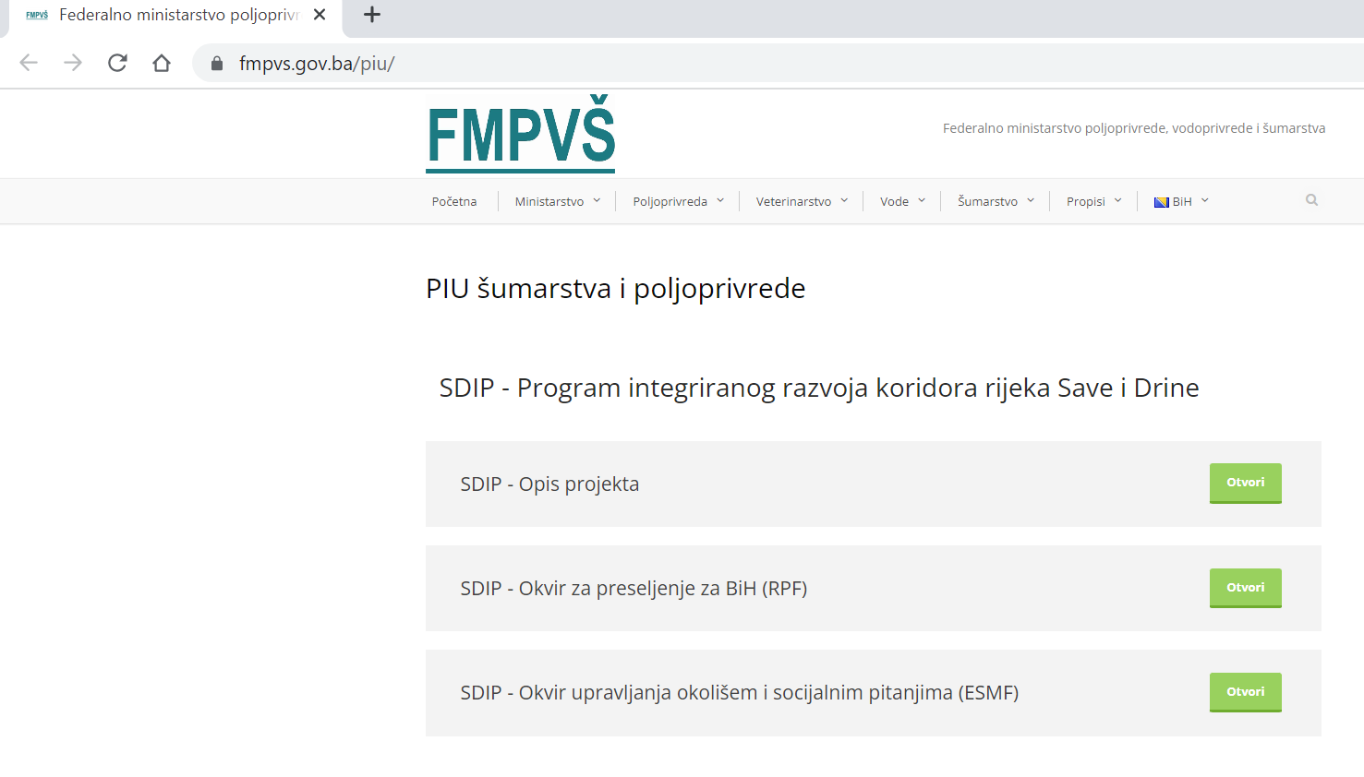

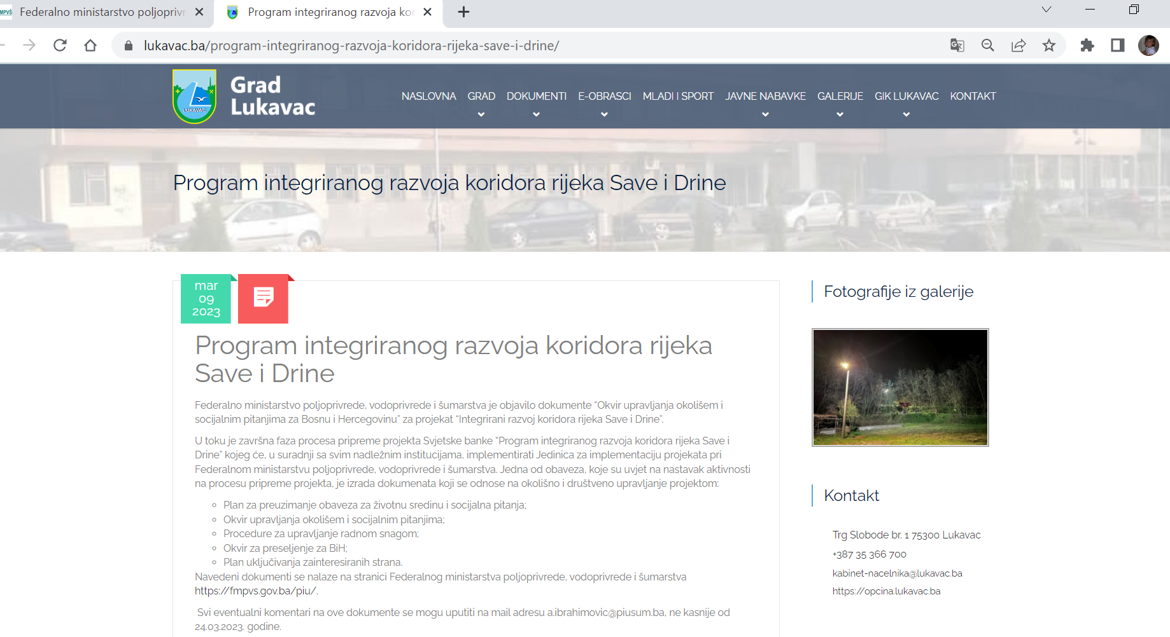

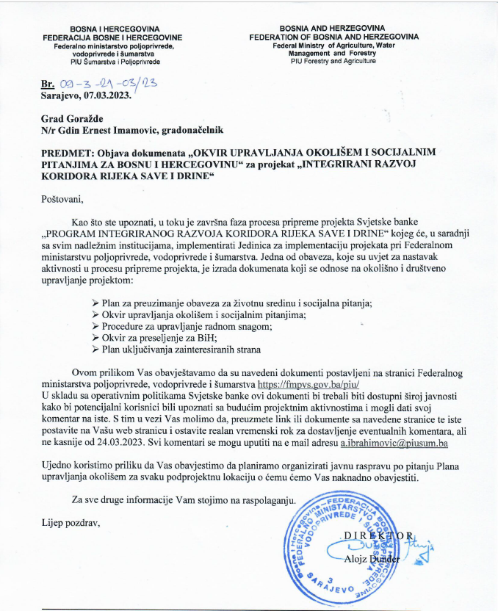

**Venue:** Hall of the Assembly of the Brčko District of BiH

**Date:** March 16, 2023

**Time:** 10:00 hr

**Organizer:** The unit for the implementation of projects financed from international funds of the Development and Guarantee Fund of the Brčko District of BiH

REPORT ON THE PUBLIC HEARING

The unit for the implementation of projects financed from international funds of the Development and Guarantee Fund of the Brčko District of BiH, for the needs of the "Project of Integrated Development of the Sava and Drina River Corridor", financed by the World Bank, is on March 16, 2023, from 10:00 a.m. to 12:00 p.m., in hall of the Assembly of the Brčko District of BiH, organized a public debate on the framework as follows:

1. Environmental and Social Management Framework – ESMF
2. Resettlement Framework – RPF
3. Stakeholder Engagement Plan – SEP
4. Environmental and social commitment plan ESCP
5. Labor Management Procedure – LMP

The aforementioned documents were available to citizens and interest groups on the website of the Government of Brčko District BiH and on the website of the Development and Guarantee Fund of Brčko District BiH www.rgfbd.com from 02.03.2023. years. until March 16, 2023, i.e. 14 days.

Eleven citizens and representatives of institutions (1 woman and 10 men) participated in the public debate, who had suggestions and comments on the documents presented as follows:

1. From BiH MAC, they suggested the accuracy of the data on demined areas of the Sava bank. Of the 9.9 million square meters of mine-contaminated areas of the Sava coast, that area of the BiH coast now amounts to 6,534,000 square meters. The number of unrealized demining projects was reduced from 144 to 94. The area along the Sava coast through the Brčko district includes 7 projects, which cover an area of 553,333 square meters, and whose implementation is scheduled for 2024.

2. From the Institute for Planning, Projecting and Development of the Brčko District, they pointed out the need to clearly state in the documents, in accordance with the Laws in the Brčko District, what is whose jurisdiction. And that the Department for Urbanism and Spatial Planning is the "Worker", while the Institute for Planning, Designing and Development of the District is the "Producer of Spatial Planning Documentation".

The minutes were drawn up by the representatives of the Project Implementation Unit of the Brčko District of Bosnia and Herzegovina.

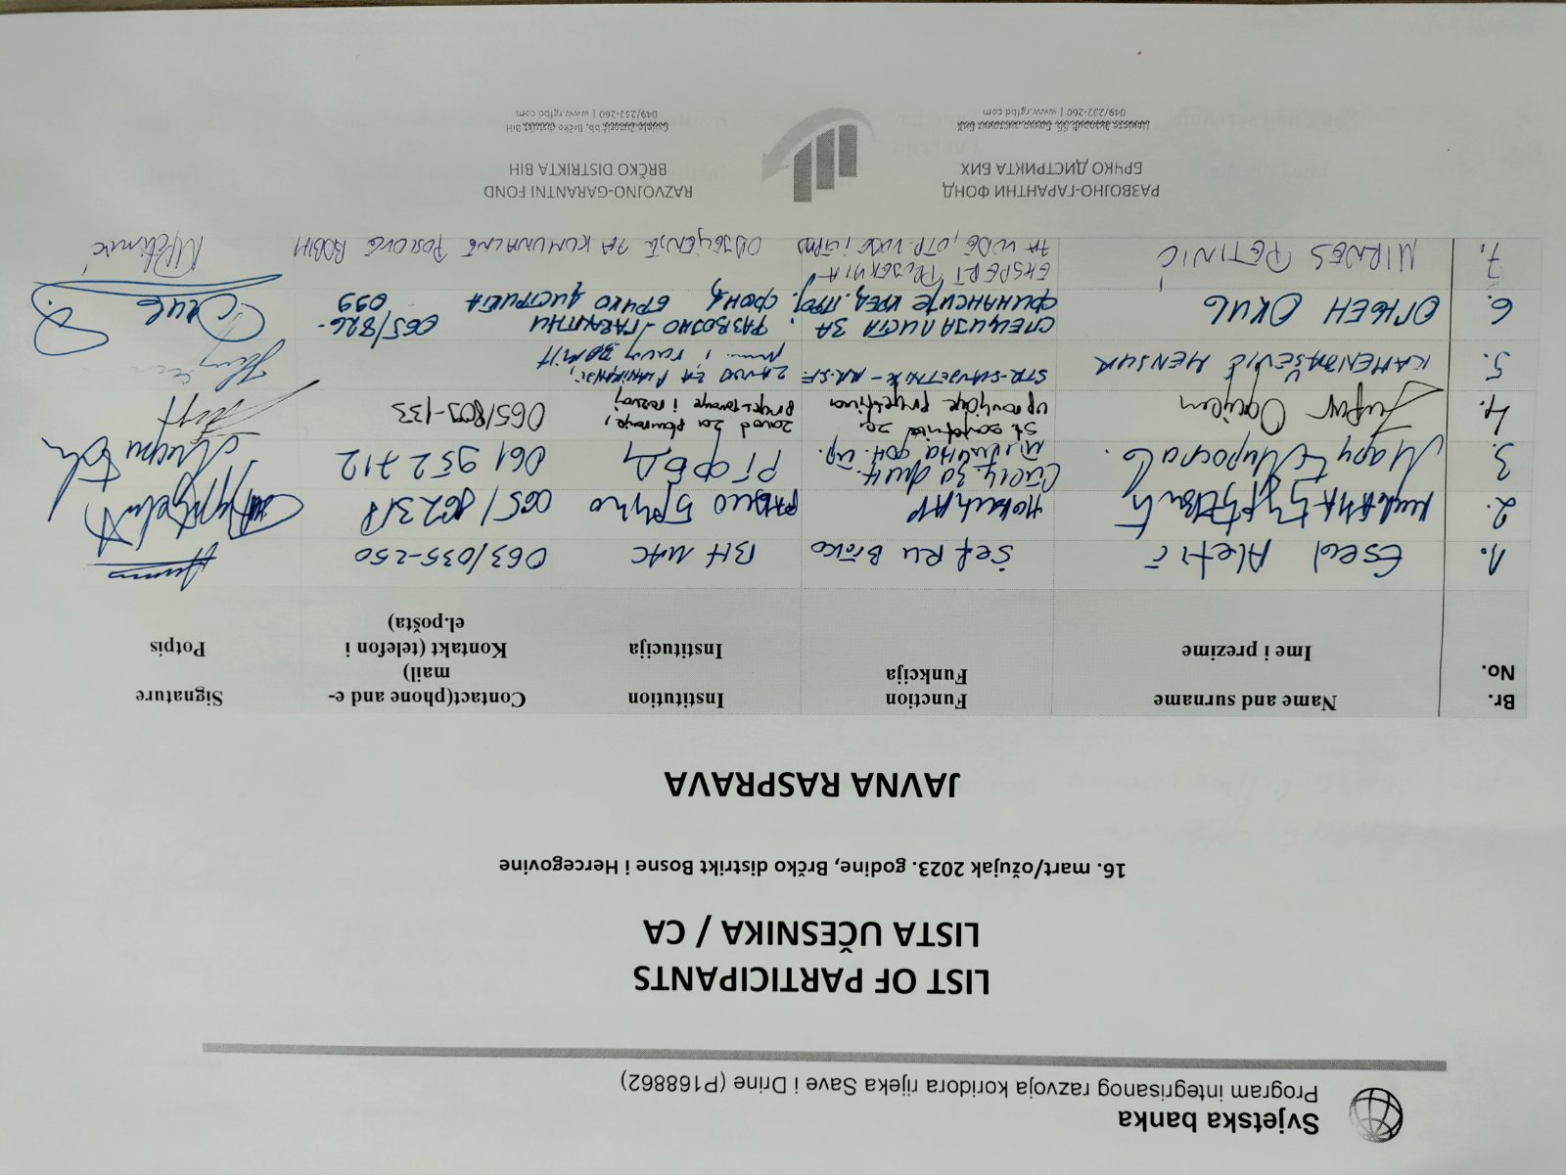

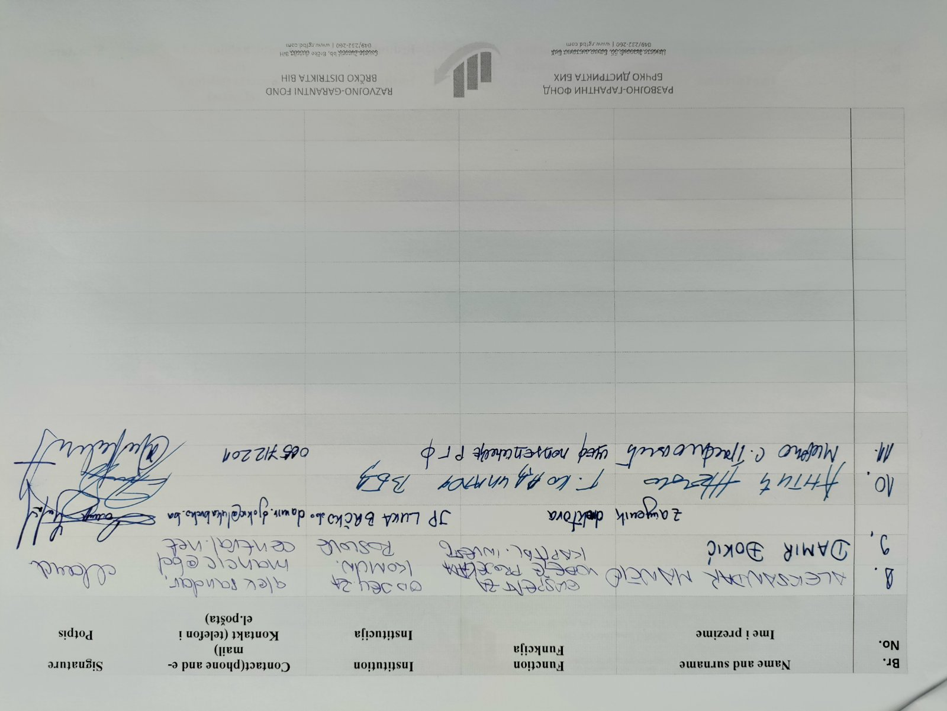

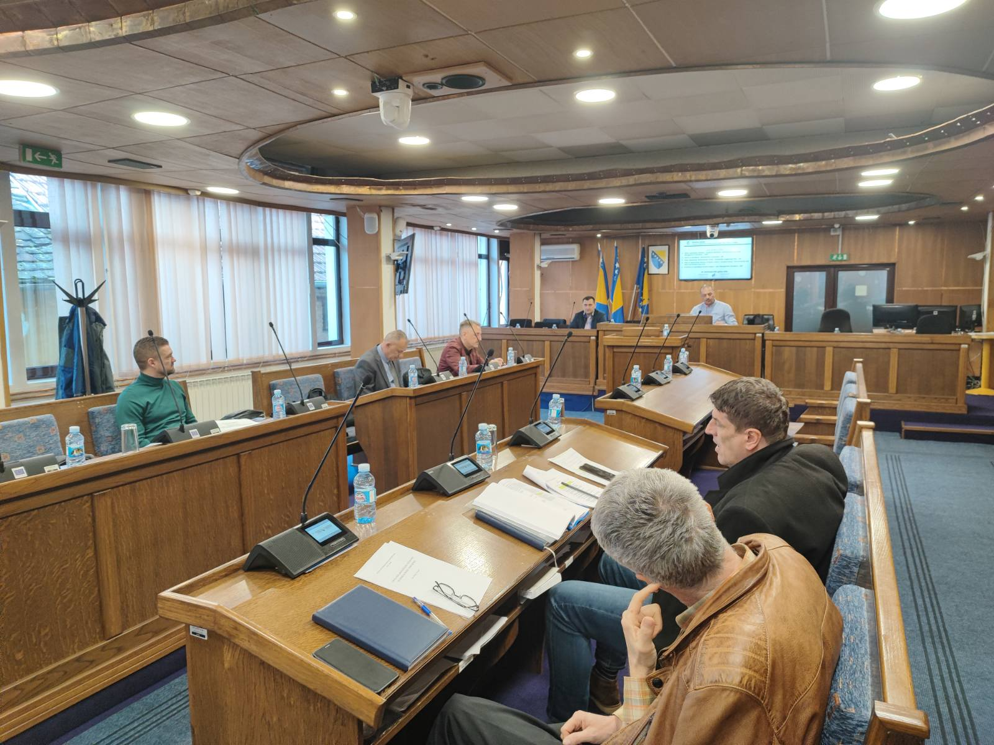

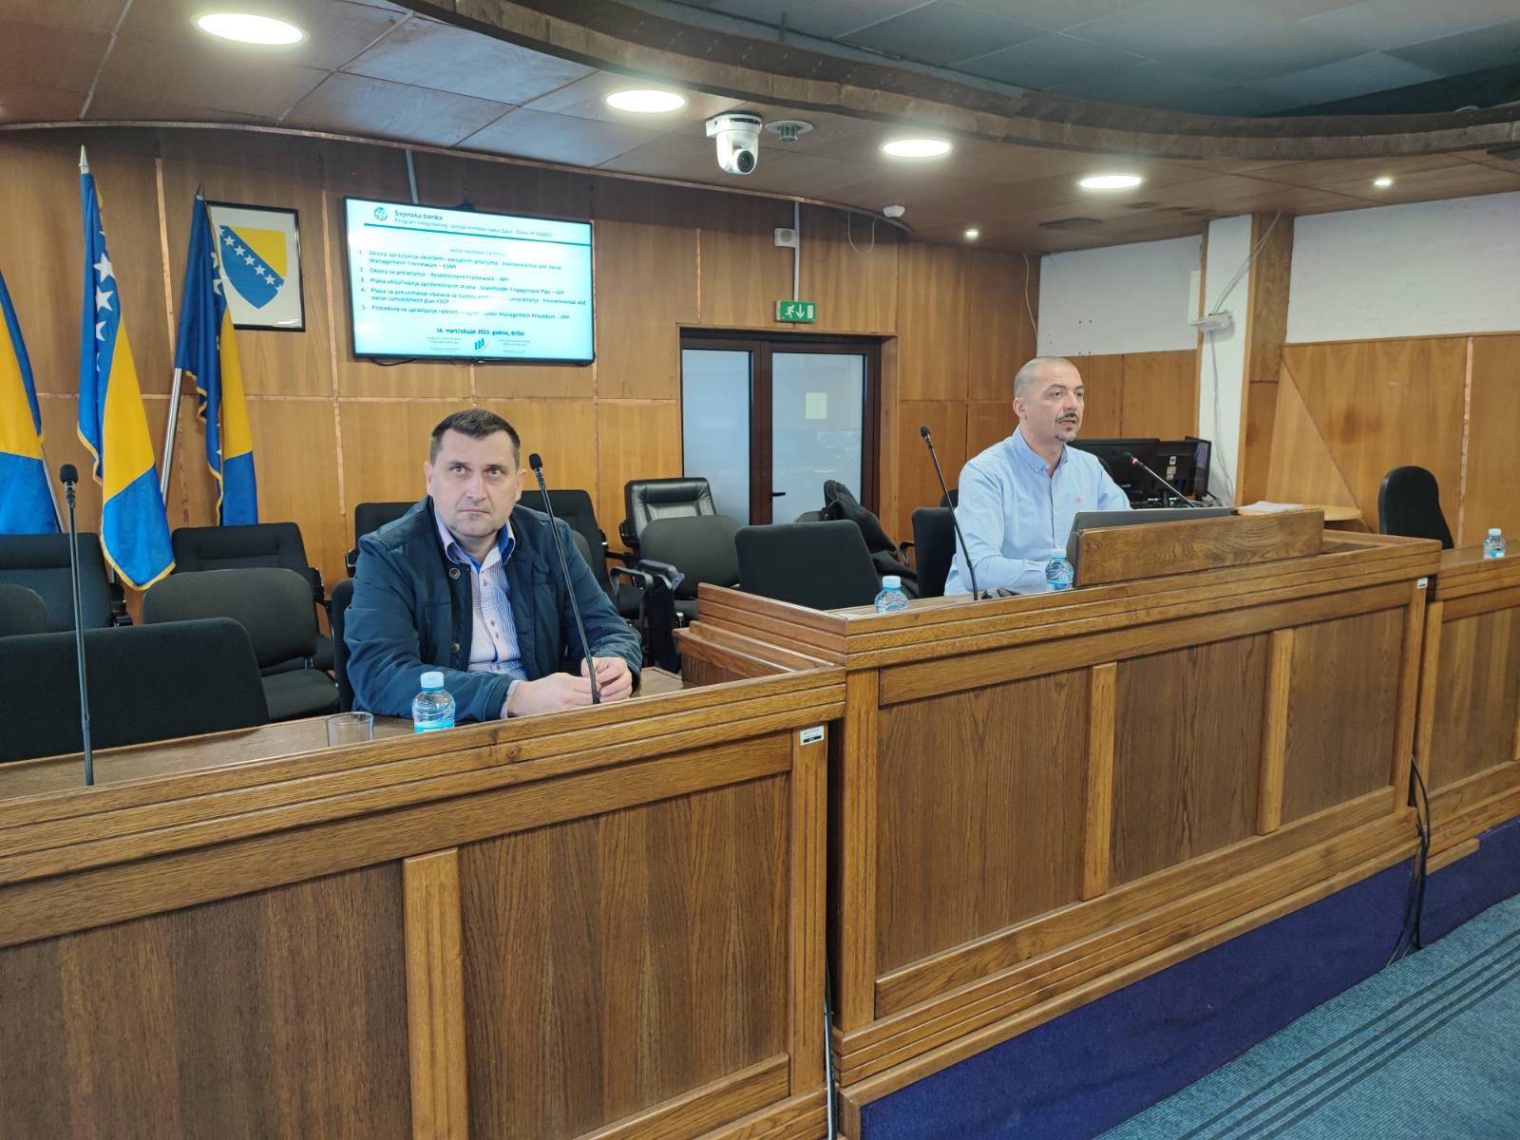

1. This is part of a multiphase programmatic approach with an overall financing envelope of EUR225.4 million US$250.2 million equivalent)
2. In August 2016, the World Bank’s Board of Executive Directors approved the Environmental and Social Framework (ESF), which have come into effect in October 2018
3. The exact number of project workers is currently not known yet. However, based on experience gained from the similar projects in BiH it is estimated that approximate number of workers for rehabilitation of waste landfill (BD) is 50, and for rehabilitation and expansion of cargo and vessel handling infrastructure (BD) also 50. With regard to demining activities it is estimated that the approximate number of workers for demining activities in BD is 10. Regarding a sub-project in Gorazde (FBiH), construction and rehabilitation of embankment, estimated number of contracted workers is 25. In terms of sub-projects in RS, riverbank regulation and rehabilitation of rivers, estimated number of contracted workers for each sub-project is 25.
4. Source: <https://www.ilo.org/dyn/normlex/en/f?p=1000:11200:0::NO:11200:P11200_COUNTRY_ID:102704> [accessed on September 30, 2019.]
5. Source: <https://www.apminebanconvention.org/states-parties-to-the-convention/bosnia-and-herzegovina/> [accessed on 7th January 2020]
6. Official Gazette of FBiH No. 29/16 and 89/18
7. Official Gazette of RS, No. 1/16 and 66/18
8. Official Gazette of BD BiH, 02/21. 06/21 and 15/22– consolidated text available at https://skupstinabd.ba/3-zakon/ba/Zakon%20o%20radu%20Brc--ko%20Distrikta%20BiH/Nesluz--bena%20prec--is--c-ena%20verzija%20Zakona%20o%20radu%20Brc--ko%20distrikta%20BiH%20%20B.pdf
9. Official Gazette of Socialist Republic of BiH, No. 22/90
10. Official Gazette of RS, No.1/08 and 13/10
11. Official Gazette of BD, No. 20/13
12. Official Gazette of FBiH, No. 101/12
13. Official Gazette of RS, No. 102/09
14. Both entity laws enable workers to file written grievances to their employers within a specified timeframe (60 days in FBiH and 30 days in RS). However, this mechanism is not entirely specified in the laws, and thus cannot be considered to be completely in line with WB requirements. Namely, it is not clearly defined that information on the grievance mechanism need to be accessible to all workers in a clear and understandable manner – the employers are not required to inform their workers of the existence of such a mechanism. Furthermore, there are no defined measures to protect workers against any type of retaliation (through, for example, allowing for the possibility of filing anonymous complaints). There is also no obligation to keep records on grievances. In BD, the Labor Law enables workers to file written grievances to their employers, but without specification of a timeframe. The mechanism in this Law is not clearly specified and therefore cannot be considered to be in line with WB requirements.
15. Under entity labor codes, second-instance resolution of labor disputes relates to peaceful resolution of disputes (mediation).
16. The Bidder should mark the appropriate commitment